

**Syrian Private University**

**Faculty of Engineering**

**Department of Software**

**and Information Systems**

**Events and Activities planning platform**

A senior 1 project report- submitted to complete the requirements for obtaining a bachelor's degree in Informatics Engineering - Software Engineering and Information Systems

**Prepared by:**

Helpest Mohamad Mohamad Marwa Ghassan Aljaouni Hiba Ahmad Shawa

**Supervised by:**

Eng. Anas Abdulziz

2025



**الجامعة السورية الخاصة**

**كلية الهندسة**

**قسم البرمجيات و نظم المعلومات**

**منصة لتخطيط الفعاليات**

**والأنشطة**

مشروع تخرج 1 - قدم استكمالاً لمتطلبات الحصول على درجة البكالوريوس في هندسة المعلوماتية

هندسة البرمجيات ونظم المعلومات

**إعداد:**

هبه احمد شاوه مروة غسان الجاعوني هلبست محمد محمد

إ**شراف:**

المهندس أنس عبد العزيز

2025

SUPERVISION CERTIFICATION

Supervisor Certification

I Certify that the preparation of this project entitled

[**Events And Activities Planning Platform**]

Prepared by [Hiba Shawa& Marwa Aljaouni & Helpest Mohamad ] was made under my supervision at Faculty of Informatics Engineering in partial Fulfillment of the Requirements for the Degree of Bachelor of Software and Information system Engineering

Name: Eng.Anas Abdulaziz

Signature:……...…..……….

Date: ….………………………

***Abstract :***

*In a world where our awareness of the planet's importance is growing, and the shift towards renewable energy is accelerating, there's a prominent drive among individuals to improve their energy consumption and maximize the potential of solar power. This trend has led to a significant surge in demand for innovative applications that simplify energy management and provide clear insights into solar energy production and consumption patterns.*

*This project aims to develop a comprehensive system that empowers users to monitor and manage their solar energy usage. The system comprises a user-friendly interface and a robust backend infrastructure, enabling users to track energy production, manage electrical devices, and receive personalized recommendations for energy conservation. Utilizing modern web technologies, the platform ensures accessibility across devices and provides real-time data visualization through an intuitive dashboard. The goal is to create a seamless experience that promotes sustainable energy practices and reduces environmental impact. By providing detailed reports, automatic alerts, and energy-saving tips, the system aims to empower users to make informed decisions and optimize their energy consumption. The application prioritizes security, scalability, and availability, ensuring a reliable and robust solution for a growing user bas*

***الملخص:***

***في عالم يزداد فيه وعينا بأهمية كوكبنا، ويتسارع فيه التحول نحو الطاقة المتجددة، يبرز سعي الأفراد لتحسين استهلاكهم للطاقة والاستفادة القصوى من إمكانيات الطاقة الشمسية. وقد أدى هذا التوجه إلى ارتفاع ملحوظ في الطلب على تطبيقات مبتكرة تُبسط إدارة الطاقة وتمنح رؤى واضحة حول أنماط إنتاج واستهلاك الطاقة الشمسية.***

***يهدف هذا المشروع إلى تطوير نظام شامل يمكّن المستخدمين من مراقبة وإدارة استخدامهم للطاقة الشمسية. يتكون النظام من واجهة سهلة الاستخدام وبنية تحتية خلفية قوية، مما يتيح للمستخدمين تتبع إنتاج الطاقة وإدارة الأجهزة الكهربائية وتلقي توصيات مخصصة للحفاظ على الطاقة. وباستخدام تقنيات الويب الحديثة، تضمن المنصة إمكانية الوصول عبر الأجهزة وتوفر تصورًا للبيانات في الوقت الفعلي من خلال لوحة معلومات بديهية. الهدف هو إنشاء تجربة سلسة تعزز ممارسات الطاقة المستدامة وتقلل من التأثير البيئي. من خلال توفير تقارير مفصلة وتنبيهات تلقائية ونصائح لتوفير الطاقة، يهدف النظام إلى تمكين المستخدمين من اتخاذ قرارات مستنيرة وتحسين استهلاكهم للطاقة. يعطي التطبيق الأولوية للأمن وقابلية التوسع والتوافر، مما يضمن حلاً موثوقًا وقويًا لقاعدة مستخدمين متنامية.***

**List Of Contents:**

Contents

SUPERVISION CERTIFICATION 3

***الملخص:*** 5

**List Of Contents:** 6

**List Of Tables:** 9

**List Of Figures:** 10

**Chapter 1: Introduction** 12

**1.Introduction** 13

**2-problem Definition** 13

**3.project Objectives** 13

**4.Report Organization** 14

**5-Summary** 14

**Chapter 2:Reference Study** 15

**1.Introduction:** 16

**2. Similar Applications:** 16

**1.** **SolarEdge:** 16

**2. Enphase Enlighten:** 17

**3. SMA Sunny Portal:** 18

**4. Tigo Energy:** 19

**5. KACO new energy:** 20

**3. Our System** : 21

**4.Comparison of Systems** 22

**5.Summary** 23

**Chapter 3: Project Management** 24

**1.Project Charter** 25

**2.Methodology:** 27

**3.Statement of work:** 31

**4.Project Timeline** 34

**5.Gantt Chart** 35

**6.Risk management:** 36

**7. Project Development Life Cycle Model:** 38

**8. Hybrid Agile Project Management:** 39

**9.Initial Requirement Trackability Matrix (RTM)(V.1)** 40

**10.Summary:** 41

**Chapter 4:System Analysis** 42

**1.System Initial Analysis** 43

**1. Introduction** 43

**2.Overall Description** 46

**3.High level requirements** 48

**4.Use case diagram:** 50

**4.Activity diagram:** 51

**2.Detailed Analysis** 52

**1.Introduction** 52

**2.purposes** 52

**3.System Requirements:** 52

**3.initial test case:** 75

**4. Requirement Trackability Matrix (RTM) (V.2)** 77

**5.Summary** 79

**Chapter 5: System Design** 80

**1.System Initial Design** 81

**1.Selected Architecture: Layered Architecture with Modularized Services** 81

**2.System Architecture:** 83

**3.Class diagram:** 84

**4.Sequence diagram** 85

**2.Detailed Design** 86

**1.Introduction:** 86

**2.Purpose :** 86

**3.functonal Requirements:** 86

**4.System Class Diagram** 96

**5.** **ERD - Entity-Relationship Diagram** 97

**3.Requirement Trackability Matrix (RTM) (V.3)** 98

**7.Summary** 100

**Chapter6: Implementation** 101

**1.Introduction** 102

**2.Purpose:** 102

**3.User Interfaces** 103

**4. REST API Documentation – Alternative Energy Management System** 116

**4.1.Introduction** 116

**4.2.Purpose** 116

**4.3.API Structure Overview** 116

**4.4.Detailed Table of REST API Endpoints** 128

**5.Execution Test case** 130

**6. Requirement Trackability Matrix (RTM) (V.4)** 134

**7.Summary:** 139

**List Of Tables:**

Table 1:Solar Edge 16

Table 2:Enphase Enlighten 17

Table 3:SMA Sunny Portal 18

Table 4:Tigo Energy 19

Table 5: KACO new energy 20

Table 6: comparison of systems 22

Table 7:project charter info 25

Table 8: roles and responsibilities 26

Table 9:schedules 33

Table 10:timeline 34

Table 11:risk management 37

Table 12:RTM(V.1) 40

Table 13:high level requirements 49

Table 14:UM functional requirements 53

Table 15:use case specification 1 54

Table 16:SPM functional requirements 56

Table 17:use case specification 2 58

Table 18:EDM functional requirements 60

Table 19 :use case specification 3 62

Table 20:SED functional requirements 64

Table 21:use case specification 4 66

Table 22:use case specification 5 67

Table 23:use case specification 6 68

Table 24:use case specification 7 69

Table 25:UPM functional requirements 71

Table 26:use case specification 8 73

Table 27:initial test cases 76

Table 28:RTM V.2 78

Table 29:RTM V.3 100

Table 30:API Structure 116

Table 31:API 129

Table 32:execution test cases 133

Table 33:RTM V.4 138

**List Of Figures:**

Figure 1 :gantt chart 35

Figure 2:project development life cycle model 38

Figure 3:use case diagram for (AEMS) 50

Figure 4:Activity diagram for (AEMS) 51

Figure 5:use case diagram for signup&login 53

Figure 6:activity diagram for Signup&Login 55

Figure 7:use case for solar management system 57

Figure 8:activity diagram for solar management system 59

Figure 9:use case diagram for electrical device management 61

Figure 10:activity diagram for electrical devices management 63

Figure 11:use case diagram for solar energy dashboard 65

Figure 12:activity diagram for solar energy dashboard 70

Figure 13:use case diagram for user profile management 72

Figure 14:activity diagram for user profile management 74

Figure 15:system architecture 83

Figure 16:class diagram in high level 84

Figure 17:sequence diagram in high level 85

Figure 18:sequence diagram for signup&login 87

Figure 19:sequence diagram for solar energy management 89

Figure 20:sequence diagram for electriacl devices management 91

Figure 21:sequence diagram for solar energy dashboard 93

Figure 22:sequence diagram for user proflie management 95

Figure 23 : class diagram 96

Figure 24:ERD diagram 97

Figure 25:login interface<<1>> 103

Figure 26:Reset password interface<<2>> 103

Figure 27 :new register interface<<3>> 104

Figure 28:main dashboard interface<<4>> 105

Figure 29:main dashboard for device analysis interface<5>> 106

Figure 30 :main dashboard for reports interface <<6>> 107

Figure 31:main dashboard for recommendations &insights interface<<7>> 108

Figure 32 :solar panel management interface<<8>> 109

Figure 33:add solar panel interface<<9>> 110

Figure 34:modify solar panel interface<<10>> 111

Figure 35:delete pane interface<<11>> 111

Figure 36:electrical devices management interface<<12>> 112

Figure 37:add device interface<<13>> 113

Figure 38: modify device interface<<14>> 114

Figure 39:delete device interface<<15>> 114

Figure 40:user profile interface<<16>> 115

**Chapter 1: Introduction**

**1.Introduction**

This chapter provides an overview of the Events and Activities planning Platform project by outlining the problems we aim to address, the objectives we hope to achieve, and the structure of the report. It also serves as a guide to help you understand how the project was developed and the content of each section of the report.

**1.1 Problem Definition**

Today, the event industry faces a major challenge where everyone works separately, creating inefficiencies for all involved. Attendees struggle to find and book events across multiple websites with unclear pricing and availability information. Organizers waste time managing bookings manually, juggling different tools to communicate with suppliers, and lacking clear visibility into their event performance. Suppliers spend heavily on advertising just to get noticed by potential clients without a central platform to showcase their services. Our platform solves these problems by creating one unified space where attendees can discover and book events easily, organizers can manage everything through a simple dashboard with real-time insights, and suppliers can create profiles to connect directly with customers, making the entire event experience smoother and more efficient for everyone.

**1.2 Project Objectives**

Our platform is designed to serve three main user groups—attendees, organizers, and suppliers—each with features tailored to their needs. Attendees can securely manage their accounts, browse events using smart filters for date, location, price, and type, book tickets for existing events, or reserve ready-made packages to host their own, while receiving email confirmations and maintaining a full booking history. Organizers can create both public events and customizable host packages, add detailed event information including titles, descriptions, locations, dates, prices, and photos, track bookings in real time, view attendee lists, and control booking availability through a simple dashboard.Suppliers can create detailed profiles showcasing their services, locations, and contact information, making it easy for organizers and users to find them through searchable directories while building trust with clear information and future rating systems .

The platform also ensures smooth operation and organization by providing unique booking references, tracking the status of bookings, sending automated email notifications, and maintaining robust data security. Overall, our goal is to transform the platform from a basic booking system into a full-fledged event marketplace where attendees, organizers, and suppliers can collaborate efficiently and seamlessly.

**4.Report Organization**

The report is structured as follows:

This report is divided into the following chapters:

**Chapter 1: Introduction**

* What the project is about and why it matters

**Chapter 2: Reference Study**

* Looking at other similar platforms
* What's already out there and what we can learn from it

**Chapter 3: Project Management**

* How we planned and organized the work
* Timeline and responsibilities

**Chapter 4: System Analysis and Design**

* What the system needs to do
* How we designed the database and user interface
* Diagrams and mockups

**Chapter 5: Implementation**

* The technology we used
* How we built the main features
* User interfaces and Apis

**5-Summary**

This chapter introduces our Events and Activities planning platform It outlines the challenges people face when planning or attending events, the goals we hope to achieve with the platform, and how this report is structured. The main idea is simple: bring attendees, organizers, and suppliers together on a single platform, making it easy for everyone to find what they need. In the upcoming chapters, we will go deeper into how we researched, planned, designed, and built the system.

**Chapter 2:Reference Study**

**1.Introduction:**

This chapter presents the reference studies we have conducted. The reference study is a process of reviewing, analysing, and summarizing previous sources and studies related to similar applications. This step has helped us identify areas that can be improved and developed.

**2. Similar Applications:**

**1.**  **Eventbrite:**

Description: Eventbrite is a leading global platform for organizing and selling event tickets online. It allows users to create professional event pages, set ticket prices, manage registrations, and track sales through an easy-to-use interface. It is widely used for public events such as conferences, concerts, and workshops.

|  |  |
| --- | --- |
| **Disadvantages** | **Advantages** |
| 1. Charges commissions and fees on every ticket sold, reducing organizer profits. | 1. Simple and user-friendly interface for beginners and small organizers. |
| 2. Limited customization options for event page designs. | 2. Provides integrated tools for ticket booking and instant email confirmations. |
| 3. Limited support for locally based or multi-service events (e.g., vendor collaboration). | 3. Allows integration with social media platforms to boost engagement. |
| 4. Analytical tools are basic compared to large enterprise platforms. | 4. Offers basic marketing tools and statistical reports on attendance and sales. |

**2. Cvent:**

Description: Cvent is a comprehensive professional platform used for managing large-scale events, particularly conferences and exhibitions. It provides tools for registration management, venue coordination, vendor handling, badge printing, and advanced analytical reporting.

|  |  |
| --- | --- |
| **Disadvantages** | **Advantages** |
| 1. The interface is relatively complex and requires training for new users. | 1. A fully integrated system that covers all stages of event management, from booking to evaluation. |
| 2. High cost makes it less suitable for small projects or individuals. | 2. Provides professional tools for managing vendors, budgets, and participant communication. |
| 3. Not ideal for personal or simple events. | 3. Offers precise analytics and interactive dashboards to support decision-making. |
| 4. Requires a longer setup and configuration time initially. | 4. Reliable and trusted by large institutions, universities, and global corporations and Highly customizable to fit different event types (in-person or virtual). |

**3. Bizzabo:**

Description: Bizzabo focuses on enhancing attendee experience and engagement in professional events. It provides solutions for registration management and event marketing (virtual or in-person) while offering detailed reports to measure ROI and event impact.

|  |  |
| --- | --- |
| **Disadvantages** | **Advantages** |
| 1. Subscription plans are relatively expensive compared to traditional platforms. | 1. Modern, flexible, and easily customizable user interface. |
| 2. May not be ideal for small or local events. | 2. Strong reporting and analytics to measure event performance and business impact. |
| 3. Customization of registration designs can be limited. | 3. Excellent support for virtual and hybrid events. |
| 4. Requires some technical experience for efficient management. | 4. Provides marketing tools and personalized content for different attendee types and Emphasis on attendee networking and relationship building. |

**4.Splash:**

Description: Splash is a platform specialized in designing visually appealing event pages and promoting them as part of marketing campaigns. It is used by major companies to organize brand events and manage invitations and marketing analytics.

|  |  |
| --- | --- |
| **Disadvantages** | **Advantages** |
| 1. Not designed for ticket sales or logistical event management. | 1. Professional design interface for creating visually striking event pages. |
| 2. Full features require high-cost paid subscriptions. | 2. Strong focus on marketing aspects and audience data collection. |
| 3. Limited suitability for non-marketing or non-commercial events. | 3. Automated and well-coordinated tools for invitation and attendance management. |
| 4. Analytical tools are less comprehensive than those of professional conference platforms like Cvent. | 4. Integrates with marketing tools like Mailchimp and CRM systems and Ideal for brand-focused corporate events emphasizing visual identity. |

**5.Faaliyeh App_ Syria:**

Description: it is the official platform in Syria for organizing and managing exhibitions, projects, and events

It aims to support economic and cultural activities by bringing together government entities, organizers, and companies on a single digital platform.

It allows users to explore local events, register, and officially participate, while enabling organizers to manage requests and schedule exhibitions electronically, thus contributing to the digitization of the events sector and enhancing communication between participants and visitors.

|  |  |
| --- | --- |
| **Disadvantages** | **Advantages** |
| 1. Lacks ticketing tools or direct electronic payment. | 1. A simple and user-friendly Arabic interface for local users. |
| 2. Lacks interactive features such as event or supplier ratings. | 2. It encompasses various types of events (economic, cultural, social, and educational). |
| 3. Does not allow users to create custom events or hostable packages. | 3. It allows for application and participation in exhibitions through a unified electronic form. |
| 4. Limited analytics and reporting, focusing on administrative rather than marketing aspects. | 4. It helps promote local national projects. |

**3. Our System** :

it offers a comprehensive solution connecting event organizers, attendees, and suppliers within a single, unified digital environment. Our vision is to provide a dynamic marketplace for event management, from discovery to execution. Users can register, edit their profiles, and search for and filter events by date, location, price, and type. For organizers, the platform offers comprehensive management features, including a shared dashboard, the ability to create and manage public events or hostable packages for their own events (such as wedding packages, birthday parties, or private gatherings), and track booking status (active, canceled, completed). We also facilitate collaboration by creating a searchable supplier directory by type and city. Our primary goal is to enhance usability. Each booking generates a unique, trackable reference, and the system is supported by instant automated email notifications for new registrations, ensuring high efficiency and a seamless user experience for both attendees and hosts.

|  |  |  |  |  |  |  |
| --- | --- | --- | --- | --- | --- | --- |
| **Feature** | **Splash** | **Bizzabo** | **Cvent** | **Eventbrite** | **Faaliyeh** | **Our system** |
| **User-Friendly Interface** |  |  |  |  |  |  |
| **Ticket sales & automated confirmations** |  |  |  |  |  |  |
| **Hostable/custom packages** |  |  |  |  |  |  |
| **Creating Special Events** |  |  |  |  |  |  |
| **Affordable for small/local events** |  |  |  |  |  |  |
| **Supporting Commercial Events** |  |  |  |  |  |  |
| **Collaborative**  **Dashboard** |  |  |  |  |  |  |

**4.Comparison of Systems**

**5.Summary**

We compared our system with popular event management platforms such as Eventbrite, Cvent, Bizzabo, Splash, and Faaliyeh App, focusing on key features like a user-friendly interface, ticket sales with automated confirmations, hostable or customizable event packages, the ability to create special events, suitability for small or local projects, support for commercial events, collaboration among users, and an event management dashboard. These platforms are effective in managing events and providing essential tools for users, but they face challenges such as high costs, limited customization, complex setup, and limited support for local events.

Table 6: comparison of systems

**Chapter 3: Project Management**

**1.Project Charter**

|  |
| --- |
| **Project tittle:** Alternative Energy Management System. |
| **Project start date:** October_ 1 _2025 |
| **Project finish date:** January _ 21 _ 2026 |
| **Project manager**: Eng. Anas Abdulaziz. |

Table 7:project charter info

**Project objectives:**

* Develop a unified event management platform that integrates attendees, organizers, and suppliers.
* Provide seamless event discovery with advanced filtering capabilities (date, location, price, event type).
* Enable dual booking functionality: booking tickets for public events and booking packages to host private events.
* Implement a comprehensive organizer dashboard with real-time analytics (bookings, revenue, available seats).
* Allow organizers to create and manage both public events and customizable host packages with full event details.
* Enable organizers to tag basic supplier notes for each event or package for internal reference.
* Create a supplier directory that connects service providers with organizers and users through searchable profiles.
* Manage bookings with unique reference numbers, status tracking (confirmed, canceled), and email notifications.
* Build a scalable foundation for future marketplace features including ratings, reviews, and direct supplier integrations.
* Create a supplier directory that connects service providers with organizers and users through searchable profiles.

**Approach:**

* Define the project scope and requirements.
* Conduct system analysis and design for all user roles (attendees, organizers, suppliers).
* Design system architecture including user authentication, event management, and booking systems.
* Develop user interface for event discovery, filtering, and dual booking options (public events and host packages).
* Implement a real-time notification system for booking confirmations and updates.
* Create a supplier directory with search and filter functionality.
* Deploy the platform and provide user documentation.

**Roles and Responsibilities:**

|  |  |  |
| --- | --- | --- |
| **Name** | **Role** | **Responsibility** |
| Eng. Anas Abdulaziz | Project Supervisor | Provides guidance and evaluates project progress. |
| Helpest Mohamad | Project Member | Responsibility for Project Management and overseeing all SDLC phases. |
| Hiba Shawa | Project Member | Responsibility for Project Management and overseeing all SDLC phases. |
| Marwa Aljaouni | Project Member | Responsibility for Project Management and overseeing all SDLC phases. |

Table 8: roles and responsibilities

**2.Methodology:**

**1.Introduction**

This section aims to explain and justify the chosen methodology for developing the events and activities planning platform. Based on the project's nature and requirements, this document proposes adopting a hybrid Agile methodology combining the Scrum and Kanban frameworks to achieve the optimal balance between the necessary structure and flexibility.

**2.Description of the Selected Methodology**

Detailed description of the selected methodology: Hybrid Agile (Scrum and Kanban): Core Principles and Values: This methodology is based on Agile principles, such as focusing on the customer and their needs, early and continuous delivery of functional value, welcoming changes in requirements, close collaboration between stakeholders and developers, motivating individuals and trusting them to accomplish their tasks, sustainable work that maintains a constant development pace, attention to technical details and quality, simplifying processes, encouraging team self-organization, and regular reflection on ways to continuously improve.

**2.1 Framework and Key Processes:**

Scrum: Scrum will be used to organize development cycles into short, fixed-duration time units called "Sprints." Scrum events will include Sprint Planning meetings, the Daily Scrum, the Sprint Review meeting, and the Sprint Retrospective meeting. System requirements will be documented and managed in the "Product Backlog" and prioritized by the "Product Owner."

Kanban: Kanban principles will be applied to visualize the workflow within each Sprint and across different development stages. A "Kanban board" will be used to track the status of different tasks and limit "Work in Progress" (WIP) to ensure a smooth flow of work and reduce potential bottlenecks.

**2.2 Key Roles and Responsibilities:**

* **Product Owner:** Responsible for defining the product vision and managing and prioritizing the Product Backlog: Eng. Anas Abdulaziz
* **Scrum Master**: Responsible for facilitating the Scrum process and ensuring the team understands and applies Scrum and Kanban principles and practices correctly: Hiba Shawa
* **Development Team:** A multidisciplinary team responsible for analyzing, designing, developing, testing, and delivering the solar energy management system: Marwa AlJaouni, Helpest Mohamad, Hiba Shawa

**2.3 Expected Deliverables:** There will be shippable software increments at the end of each Sprint, in addition to a visible Kanban board to track work progress, and a managed and continuously updated Product Backlog.

**3.Justifications for Choosing the Methodology**:

Adopting a hybrid Agile methodology combining Scrum and Kanban is considered the most suitable option for developing the solar energy management system for the following reasons:

**3.1 Project Nature and Requirements:**

**Complexity and Flexibility:** The solar energy management system may involve integration with various devices, analysis of complex data, and different user interfaces. These complexities require a high degree of flexibility in dealing with requirements that may become fully apparent during the development process.

**Expected Changes:** Changes in system requirements are likely to occur based on continuous developments in solar energy technology or based on user feedback.

**Gradual Delivery of Value:** Using Scrum allows for the frequent delivery of functional parts of the system at the end of each Sprint, allowing stakeholders to provide early feedback and obtain tangible value early in the project lifecycle.

**Risk Mitigation**: Through frequent delivery and regular reviews, potential problems and risks can be identified early and addressed effectively.

**Team Characteristics:** Given that the team size is only 3 people, Scrum promotes effective collaboration and communication within small and cross-functional teams.

**3.2 Project Constraints:**

Timeline and Early Delivery: Frequent delivery in Scrum allows for providing basic parts of the system early, which may meet some urgent stakeholder needs.

**3.3 Stakeholder Requirements:**

Active Participation: Scrum events such as Sprint Review meetings encourage stakeholders to participate and provide their feedback regularly, ensuring that the system is developed in accordance with their needs and expectations.

Clear Vision of Progress: Shippable software increments and the Kanban board provide a clear view of the progress made in developing the system.

**4. Specific Application of the Methodology to This Project:**

**4.1.Methodology Customization:**

The Scrum framework will be applied with the integration of a Kanban board to visualize the flow of Sprint tasks. The Sprint length will initially be set at two weeks, and this duration can be adjusted based on the team's experience and project needs. The focus will be on applying Work in Progress (WIP) limits to specific development stages within the Sprint to improve workflow and reduce task accumulation.

**4.2 Tools and Technologies:**

An Agile project management tool (such as Jira) will be used to support the management of the Product Backlog, Sprint Backlog, and visualization of the Kanban board. Online communication and collaboration tools will also be used to ensure effective communication between team members and stakeholders.

**4.3 Communication Processes:**

Communication processes will include the Daily Scrum for the development team, Sprint Planning, Review, and Retrospective meetings, as well as periodic meetings with stakeholders to present progress and gather feedback and guidance. Digital communication channels (such as email and instant messaging platforms) will be used for asynchronous communication.

**5.Change Management Processes within the Selected Methodology**:

Changes in requirements or unforeseen circumstances will be handled through the following mechanisms:

**Daily Scrum:** The team can use the Daily Scrum to discuss any emerging changes or new challenges and how they affect the current work, and to plan how to respond to these changes effectively.

**Sprint Review:** The Sprint Review will be an important opportunity for stakeholders to provide feedback on the work done and suggest changes or new priorities that can be added to the Product Backlog to be addressed in the next Sprint.

**Product Backlog Refinement:** Regular Product Backlog Refinement sessions will be held to review, clarify, and estimate requirements, allowing for the integration of new changes or modification of existing requirements based on new priorities set by the Product Owner.

**6.Summary:**

Based on the analysis of the nature of the solar energy management system project and its requirements, team characteristics, project constraints, and stakeholder requirements, we confirm that adopting a hybrid Agile methodology combining the Scrum and Kanban frameworks is the optimal choice for this project. This methodology provides the necessary flexibility to deal with complexities and potential changes, promotes effective collaboration and communication, allows for the gradual delivery of functional value, and helps mitigate potential risks.

**3.Statement of work:**

**1.Project title:** Events And Activities Planning platform.

**2.project description and objectives:**

This document specifies the software requirements and design for the Event Management Platform, a unified solution designed to connect event attendees, organizers, and suppliers in one seamless ecosystem. The system enables users to discover and book tickets for existing events or host their own events using pre-configured packages, organizers to create and manage events efficiently with real-time analytics, and suppliers to showcase their services, ultimately creating a dynamic event marketplace.

**3.Project Scope**

**Scope:** The Event Management Platform is a web-based application that brings together three key stakeholders in the event industry. The system allows attendees to browse and book events or host their own using pre-configured packages, provides organizers with comprehensive management tools and analytics dashboards, and offers suppliers a platform to connect directly with potential clients through searchable profiles.

**4. project goals:**

- Develop a user-friendly platform that simplifies event discovery, booking, and hosting for attendees.

- Create powerful management tools for organizers to handle multiple event types with real-time tracking and insights.

- Build a supplier directory that connects service providers with organizers and users transparently.

- Implement secure authentication and booking management systems.

- Provide users with:

* Advanced event filtering and search capabilities
* Automated booking confirmations and notifications
* Real-time dashboards showing bookings, revenue, and performance metrics
* Booking history and status tracking

**5.Deliverables:**

▪ Project plan and charter

▪ SRS (Software Requirements Specification) documentation

▪ System design documents (database schema, architecture diagrams)

▪ Final project report

▪ Backend and frontend system components – the complete platform

**6. Project Requirements:**

**Technology and Tools:**

**Frontend:** React.js – For user interfaces, dashboards, and interactive components

**Backend:** Spring Boot )java)– For API management and business logic

**Database:** PostgreSQL / Firebase Firestore – For storing users, events, bookings, and supplier data

**Authentication:** Firebase Auth – For secure user login and session management

**Email Service:** SendGrid or Nodemailer – For booking confirmations and notifications

**Hosting:** AWS, Heroku, or Vercel – For deployment

**7. Assumptions:**

Organizers will provide accurate event information (dates, locations, pricing).

Suppliers will maintain updated profile information.

Email addresses provided by users are valid for receiving notifications.

Continuous availability of project team members throughout development.

Regular supervision and feedback from the project supervisor.

**8. Project Resources:**

**Human Resources:**

Eng. Anas Abdulaziz : Project Manager

Hiba Shawa : SE Developer

Marwa Aljaouni : SE Developer

Helpest Mohamad : SE Developer

**9. Schedules:**

|  |
| --- |
| **Project Start Date:** 25\10\2025 |
| **First project Seminar:** 16\11\2025 |
| **Second project Seminar:** 20\12\2025 |
| **Project Finish Date**: 21\01\2026 |

Table 9:schedules

**4.Project Timeline**

**1. Basic Project Information**

* **Project Name:** Events And Activities Planning Platform
* **Project Manager**: Eng.Anas Abdulaziz
* **Start Date:** 25/10/2025
* **Expected End Date:** 21/01/2026
* **Total Duration :** Approximately 3 months

|  |  |  |  |  |
| --- | --- | --- | --- | --- |
| **Main phase** | **sub-task** | **approximate start date** | **approximate end date** | **approximate** |
| **sprint 1:** | 1.1 Requirements Analysis | 25/10/2025 | 31/10/2025 | 1 wk |
| 1.2 System Architecture Design | 01/11/2025 | 07/11/2025 | 1 wk |
| 1.3 Database Schema Design | 08/11/2025 | 15/11/2015 | 1 wk |
| **sprint 2:** | 2.1 Actors Authentication | 16/11/2015 | 29/11/2025 | 2 wks |
| 2.2 User Module (Event Browsing & Booking) | 21/11/2025 | 05/12/2025 | 2 wks |
| **sprint 3:** | 3.1 Organizer Module (Dashboard & Event Management) | 06/12/2025 | 20/12/2025 | 2 wks |
| 3.2 Provider Module (Directory & Profile Management) | 12/12/2025 | 24/12/2025 | 1.5 wks |
| **sprint 4:** | 4.1 Dashboard Implementation | 25/12/2025 | 08/01/2026 | 2 wks |
| 4.2 Booking Management | 31/12/2025 | 13/01/2026 | 2 wks |
| 4.3 Notification System | 25/12/2025 | 10/01/2026 | 3 wks |
| **sprint 5:** | 5.2 Testing | 03/01/2026 | 15/01/2026 | 2 wks |
| 5.3 Submission | 10/01/2026 | 20/01/2026 | 1.5 wks |
| **Project Completion** |  |  | **21/01/2026** |  |

Table 10:timeline

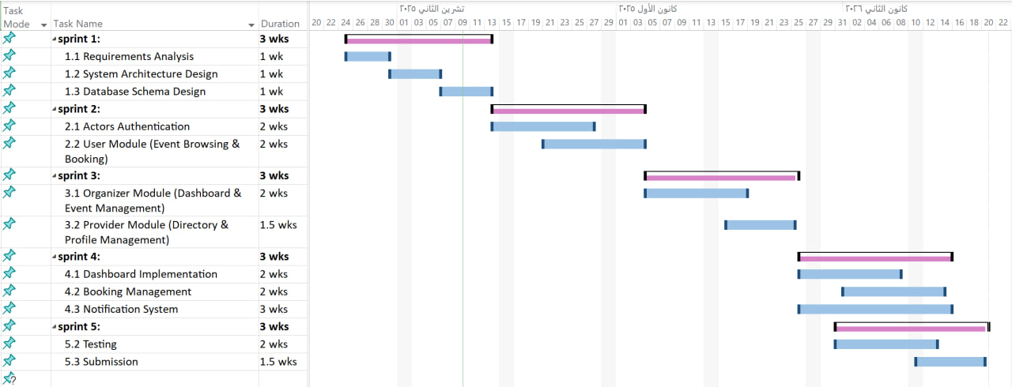**5.Gantt Chart**

Figure 1 :gantt chart

**6.Risk management:**





Table 11:risk management

**7. Project Development Life Cycle Model:**

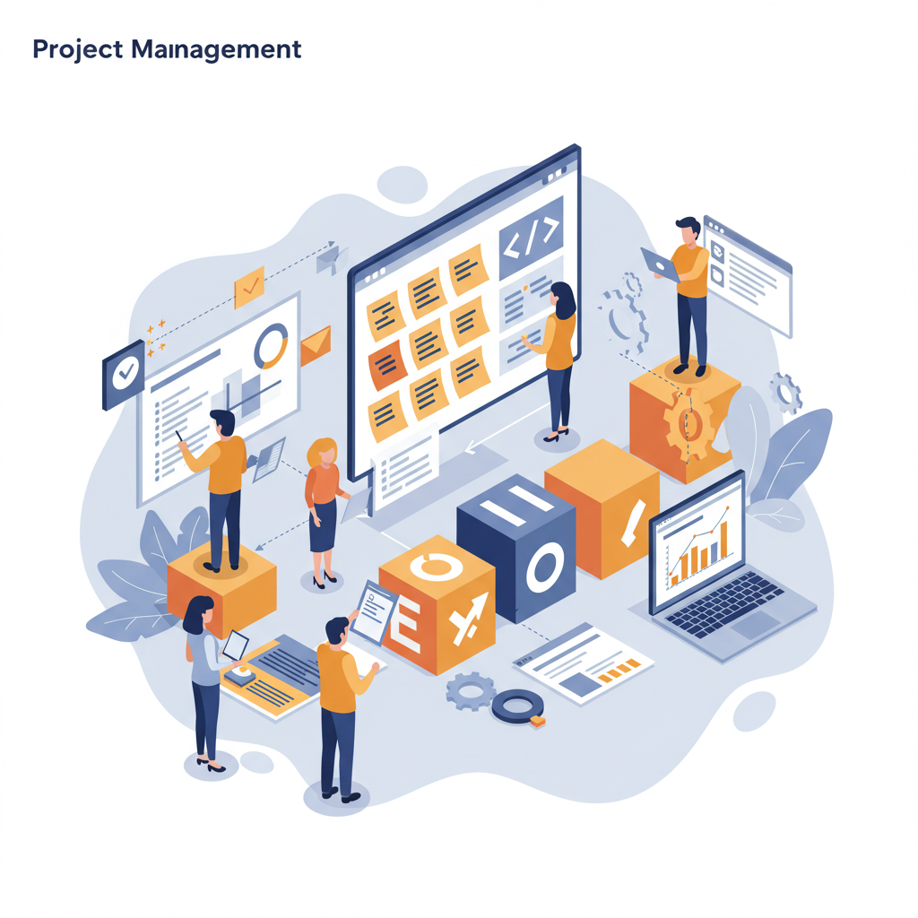5.1 Determine development model based on system requirements and structure: This section explains the process of selecting the appropriate software development model for the project. After conducting a thorough analysis and extracting the system requirements, as well as breaking down the system into its core components, the next step is to choose the most suitable software development process for our system. Given the nature of the system and its requirements, which necessitate flexibility and continuous adaptation, a Hybrid Agile methodology that combines Agile principles with specific frameworks, namely Scrum and Kanban, has been adopted as the best approach for development

Figure 2:project development life cycle model

Software development model

**8. Hybrid Agile Project Management:**

This section adopts a flexible approach to project management that differs from traditional models requiring comprehensive and detailed upfront planning. Hybrid Agile project management relies on adaptive and iterative planning and execution, integrating elements from Scrum and Kanban to achieve maximum efficiency and effectiveness. This approach focuses on delivering business value and providing benefits to clients through: Iterative and Incremental Planning ,Visualize Workflow and Limit Work in Progress ,Regular Meetings and Continuous Communication ,Regular and Transparent Reporting and Sending alerts.

**9.Initial Requirement Trackability Matrix (RTM)(V.1)**

|  |  |  |  |  |  |  |  |
| --- | --- | --- | --- | --- | --- | --- | --- |
| **Requirement id** | **Title** | **Use case** | **System Design** | **Analysis** | **Detaied Design** | **Coding** | **Test Cases** |
| PM-01 | Assign roles and responsibilities to team members |  |  |  |  |  |  |
| PM-02 | Prepare and monitor a detailed project schedule |  |  |  |  |  |  |
| PM-03 | Hold weekly meetings to review project progress |  |  |  |  |  |  |
| PM-04 | Conduct risk assessments and develop mitigation plans |  |  |  |  |  |  |
| PM-05 | Keep track of resources (team time, skills, tools) to use them well and finish the project on time |  |  |  |  |  |  |
| PM-06 | Ensure quality assurance checkpoints are in place |  |  |  |  |  |  |
| PM-07 | Perform final project closure and evaluation |  |  |  |  |  |  |
| PM-08 | Document and approve the chosen project methodology |  |  |  |  |  |  |
| PM-09 | Periodically review the application of the project methodology |  |  |  |  |  |  |
| PM-10 | Document all project changes and approvals |  |  |  |  |  |  |

Table 12:RTM(V.1)

**10.Summary:**

This chapter outlined the project management plan for the **"Events and activities planning platform"** It began with the project charter, which defined the main objectives, team roles, and responsibilities. The chosen methodology  **)Hybrid Agile, combining Scrum and Kanban**( was selected for its flexibility and suitability to the project's evolving requirements. The development process was broken down into clearly defined stages, from requirements analysis to final delivery, all organize within a detailed project timeline. The chapter also covered the project scope, required resources, and selected development tools, along with the apprpriate software development life cycle model. Overall, the plan emphasizes that flexible management and effective organization are key to delivering a high-quality system on time.

**Chapter 4:System Analysis**

**1.System Initial Analysis**

This section presents the initial analysis and key features identified during the

early stages of project planning and development.

**1. Introduction**

**1.1 Purpose**

This document specifies the software requirements and design for the Event Management Platform, a comprehensive solution designed to facilitate event discovery, booking, and management. The platform connects three key stakeholders: attendees seeking events to join or host, organizers managing events and packages, and suppliers offering event-related services. The system provides an intuitive marketplace that simplifies event participation, creation, and collaboration.

**1.2 Project Scope**

This system is an effective and user-friendly platform for managing the complete event lifecycle—from discovery and booking to hosting and supplier collaboration. It relies on organizer-created events and supplier services to provide a seamless experience for all stakeholders, enabling efficient event operations and enhanced user satisfaction.

**Key Features:**

- Unified platform for attending and hosting events

- Comprehensive organizer dashboard with analytics

- Integrated supplier directory for service discovery

- Real-time booking management and notifications

- Scalable architecture supporting multiple user roles

**1.2.1 High-Level Requirements:**

**1.2.1 User Management & Authentication**

- User registration and login

- Profile management

- Password recovery

- Account deletion

**1.2.2 Event Discovery & Browsing**

- Browse available events

- Search and filter events

- View event details

- Display event availability

**1.2.3 Booking Management**

- Book tickets for public events (Attend)

- Book host packages (Host)

- View booking history

- Cancel bookings

- Receive booking confirmations

**1.2.4 Organizer Management**

- Create and manage public events

- Create and manage host packages

- Enable/disable bookings

- Track event status

**1.2.5 Organizer Dashboard & Analytics**

- View booking statistics

- Monitor revenue

- Track event performance

- Access recent bookings

**1.2.6 providers Directory**

-provider registration

- provider categorization

- Display provider profiles

**1.2.7 Notification System**

- Registration notifications

- Password recovery notifications

- Booking confirmations and cancellations

- Event update notifications

- Event reminders

- Organizer alerts

**1.2.8 Visitor Access**

- Browse events without registration

- Search and filter functionality

- View event and provider information

- Access registration when attempting to book

**1.2.9 Security & Validation**

- Data validation

- Secure authentication

- Password encryption

- Input sanitization

**1.2.2 Actors:**

**1.3.1 Visitor (Non-registered User)**

**Responsibilities:**

* Browse available events
* Search and filter events
* View event details
* View supplier directory
* Explore platform features before registration

**Privileges:**

* Read-only access to public content
* No booking capabilities
* No profile management

**1.3.2 User / Attendee (Registered User)**

**Responsibilities:**

* Register and maintain profile
* Browse and search events
* Book tickets for public events (Attend)
* Book host packages for personalized events (Host)
* Manage personal bookings
* Cancel bookings when needed
* Receive notifications

**Privileges:**

* Access to personal dashboard
* View booking history
* Modify personal profile data
* Receive booking confirmations
* Access full event details
* Cancel own bookings

**1.3.3 Organizer**

**Responsibilities:**

* Create and manage public events
* Create and manage host packages
* Define event details and pricing
* Enable/disable bookings per event
* Monitor event performance
* Tag suppliers to events
* Respond to booking notifications
* Manage event capacity

**Privileges:**

* Access to organizer dashboard
* Create/edit/delete events
* View detailed analytics and revenue reports
* Access to all booking information
* Filter and search own events
* Receive organizer-specific notifications
* Tag providers to events

**1.3.4 provider**

**Responsibilities:**

* Register and maintain business profile
* Provide service information
* Update contact details
* Maintain service quality for visibility

**Privileges:**

* Create public supplier profile
* Display business information
* Be discoverable by users and organizers
* Static presence in directory

**2.Overall Description**

**2.1 Product Perspective**

**Product Perspective**

The Event Management Platform is a standalone web-based product designed to revolutionize event discovery, participation, and management. It is not part of an existing product family nor a replacement for any current system. The platform serves as a comprehensive marketplace connecting three distinct user groups: attendees seeking engaging events, organizers creating memorable experiences, and suppliers providing essential event services.

The system operates as a centralized hub where:

- Users discover events that match their interests and location

- Organizers manage event logistics and track performance

- Suppliers gain visibility and connect with potential clients

The platform is designed with scalability in mind, allowing for future enhancements such as payment gateway integration and advanced supplier interactions.

**2.2 Product Features**

**1. Event Management**

- Create and manage public events and host packages

- Enable/disable bookings

- Track event status and performance

**2. Booking System**

- Book tickets for public events

- Book host packages

- Manage bookings and cancellations

**3. Organizer Dashboard**

- View bookings and revenue analytics

- Monitor event performance

- View booking statistics

**4. Provider Directory**

- Browse service providers

- Search by category and location

- Tag providers to events

**5. Notification System**

- Automated email notifications

- Booking confirmations and reminders

- Event updates and alerts

**6. User Management**

- Registration and authentication

- Profile management

- Role-based access

**2.3 User Categories and Their Characteristics**

**2.3.1 Visitor (Non-registered User)**

**Responsibilities:**

- Browse events

- Search and filter events

- View event and supplier details

**Privileges:**

- Read-only access to public content

- Cannot make bookings

**2.3.2 User/Attendee (Registered User)**

**Responsibilities:**

- Manage profile

- Book events (Attend or Host)

- Manage bookings

- Cancel bookings

**Privileges:**

- Access personal dashboard

- View booking history

- Modify profile

- Receive email notifications

**2.3.3 Organizer**

**Responsibilities:**

- Create and manage events

- Create and manage host packages

- Enable/disable bookings

- Monitor event performance

- Tag suppliers to events

**Privileges:**

- Access organizer dashboard

- Create/edit/delete events

- View booking details and analytics

- Filter and search events

- Receive organizer notifications

**2.3.4 Provider**

**Responsibilities:**

- Register and maintain business profile

- Provide service information

- Update contact details

**Privileges:**

- Create and edit business profile

- Public directory listing

- Display contact information

**3.High level requirements**





Table 13:high level requirements

**4.Use case diagram:** 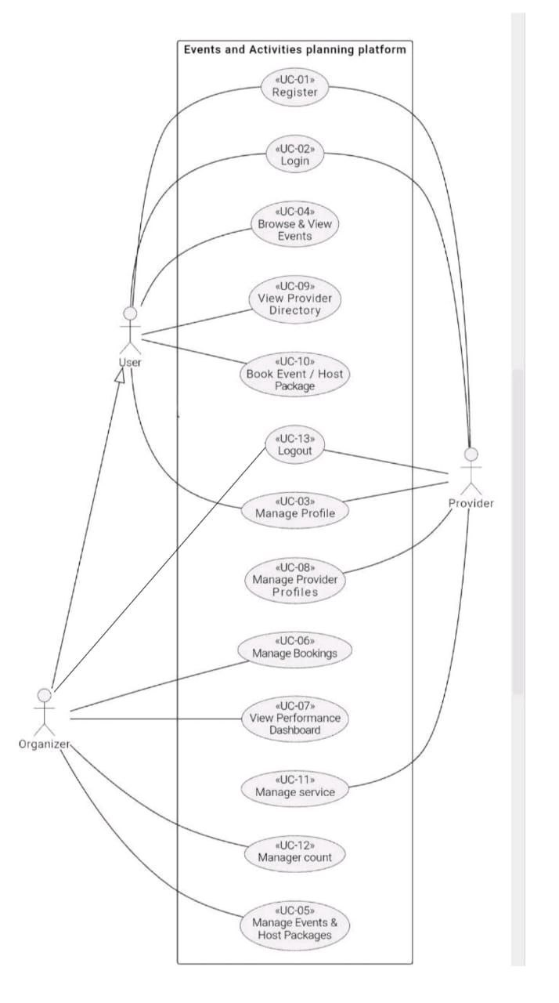

Figure 3:use case diagram for (AEMS)

**4.Activity diagram:**

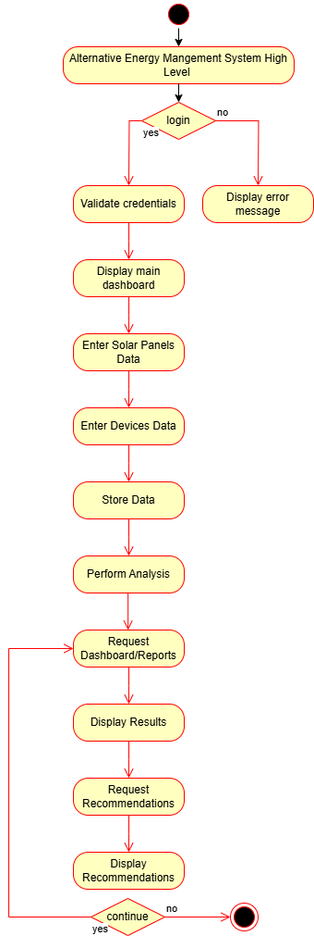

Figure 4:Activity diagram for (AEMS)

**2.Detailed Analysis**

**1.Introduction**

This chapter aims to transform the functional requirements identified during the preliminary analysis phase into precise engineering designs. Utilizing UML modeling to illustrate system interactions, this section will establish the technical framework to be adopted by the development team in subsequent stages

**2.purposes**

we will:

* Formalize system behavior through state diagrams capturing entity lifecycles
* Map operational workflows via activity diagrams
* Define interaction patterns using sequence diagrams
* Establish validation protocols for data integrity
* Model the static structure of the system using class diagrams, defining key entities (classes), their attributes, operations, and the relationships between them. This will provide a blueprint for the system's architecture and data organization.

**3.System Requirements:**

**1. User Management Functional Requirements:**

|  |  |  |  |  |
| --- | --- | --- | --- | --- |
| **Requirements ID** | **Description** | **Module** | **Priority** | **Detailed Specification** |
| **REQ-FR-UM-01** | New user account creation | User Management | High | • Collects user name and email • Validates email format • Enforces strong password policy (8+ chars, upper/lower case, numbers) |
| **RQ-FR-UM-02** | User login | User Management | High | •Verifies email and password • Authenticates credentials against stored data |

Table 14:UM functional requirements

**3.1Requirements Modeling**

3.3.1.1 use case diagram for login &signup

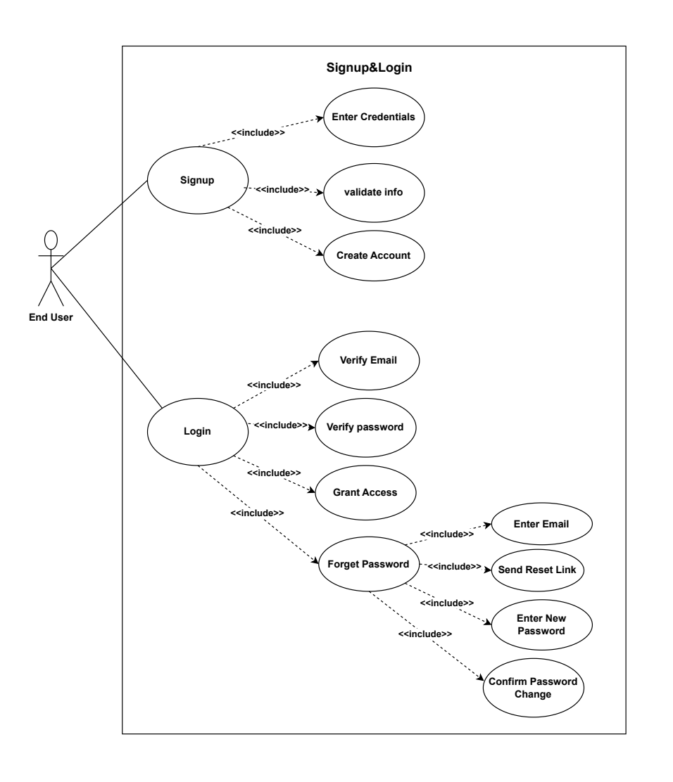

Figure 5:use case diagram for signup&login

3.3.1.2**Use Case specification**

|  |  |
| --- | --- |
| **Use case name:** | User Registration System |
| **Participating Actors:** | User/attendee |
| **The flow of events:** | 1-User accesses registration page  2-System displays registration form  3-User enters registration data:   * Full Name * Email * Password * Confirm Password * Phone Number (starts with +, 13 digits) * Role (User/Provider)   4-User clicks "Register"  5-System validates:  a) All fields filled → Continue  b) Missing fields → Show error "Please fill all required fields"  6-System validates email format  a) Valid format → Continue  b) Invalid → Show error "Invalid email format"  7-System validates phone number  a) Valid (+13 digits) → Continue  b) Invalid → Show error "Phone must start with + and contain 13 digits"  8-System validates password strength  a) Valid (8+ chars, 1 uppercase, 1 number) → Continue  b) Invalid → Show error "Password must meet requirements"  9-System checks password confirmation match  a) Passwords match → Continue  b) Don't match → Show error "Passwords do not match"  10-System checks email availability in database  a) Available → Continue  b) Already exists → Show error "Email already exists"  11-System creates user account  12-System sends welcome email |
| **Alternative flows:** | A1: Invalid email format during registration  A2: Weak password entered  A3: Phone number format incorrect  A4: Passwords don't match  A5: Email already registered  A6: Welcome email fails to send (user still created) |
| **Entry condition** | 1-User opens the application/system  2-System displays the registration screen  3-User is not logged in |
| **Exit conditions** | **Success:**  User account created, logged in, redirected to home page  **Failure:**  Error messages displayed, user remains on registration page |

Table 15:use case specification 1

**3.3.1.3 Activity Diagram for User Registration System**

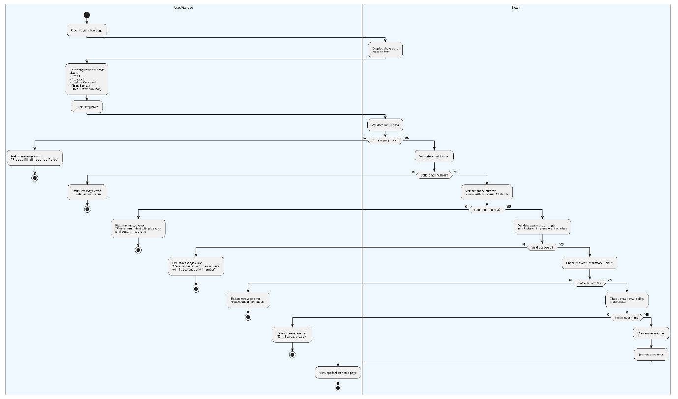

**2.Solar Panel Management - Functional Requirements**

**Solar Panel CRUD Operations**

|  |  |  |  |  |
| --- | --- | --- | --- | --- |
| **Requirements ID** | **Description** | **Module** | **Priority** | **Detailed Specification** |
| REQ-FR-SPM-03 | Add new solar panel | Solar Panel Management | High | **Input Fields:** • Panel type (dropdown) • Technical specs (voltage, current, efficiency, quantity, tilt/direction) • Location (dropdown) |
| REQ-FR-SPM-04 | Modify solar panel data | Solar Panel Management | High |  |
| REQ-FR-SPM-05 | Delete solar panel | Solar Panel Management | High | **Confirmation:** • System shall show a confirmation dialog before deletion |

Table 16:SPM functional requirements

**3.3.2.1 use case diagram for solar panels management**

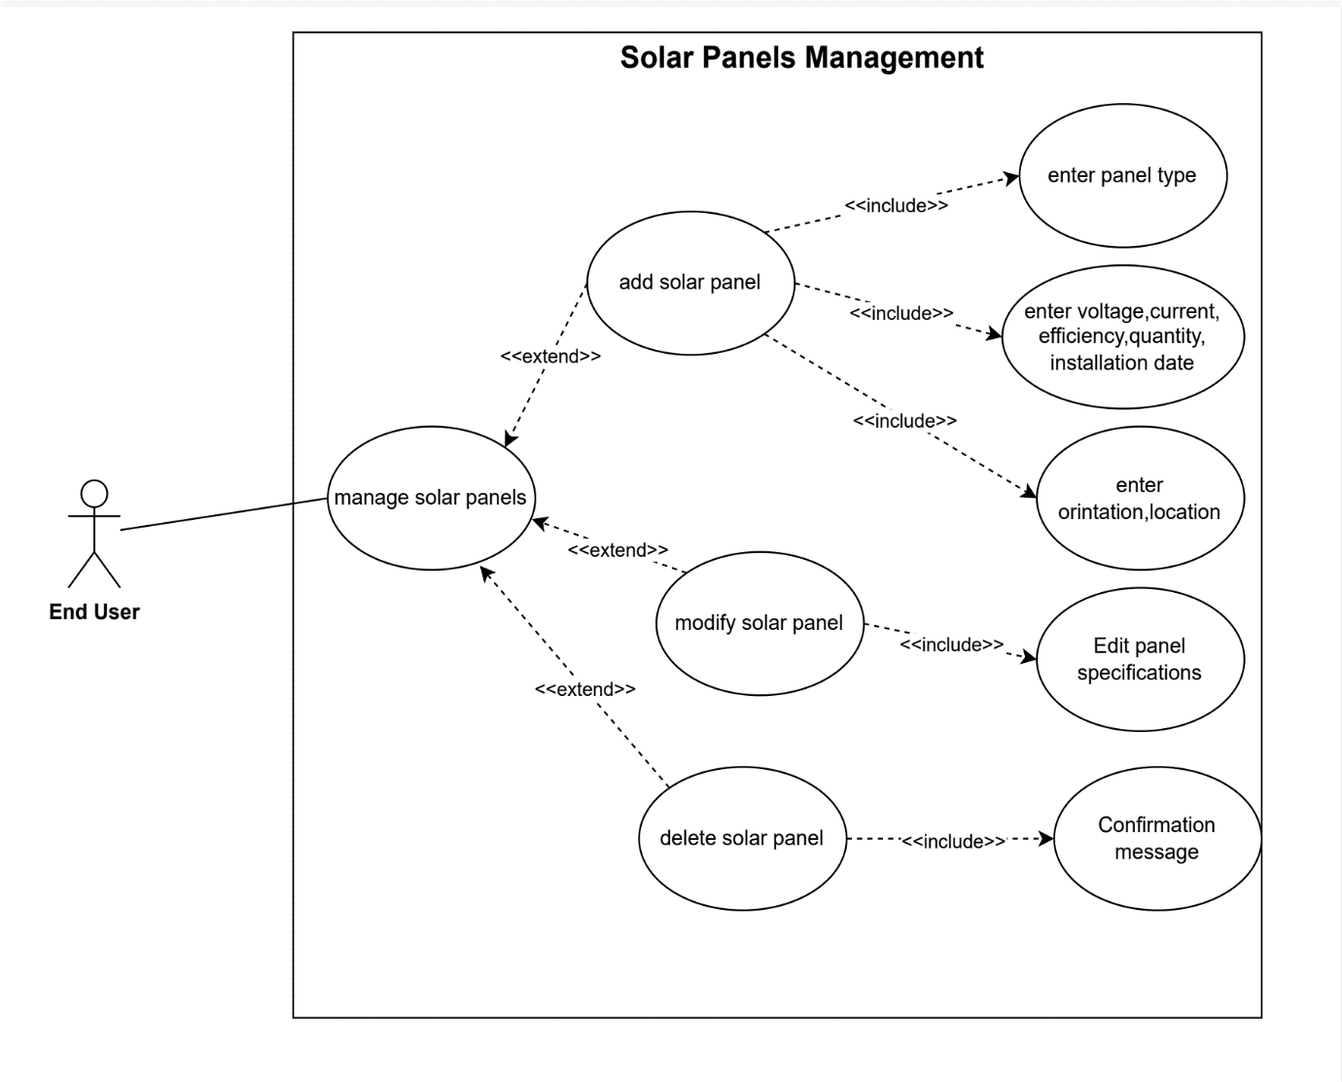

Figure 7:use case for solar management system

: **Use 3.3.2.2 Case specification**

|  |  |
| --- | --- |
| **Use case name:** | Login and Forgot Password |
| **Participating Actors:** | User/Attendee |
| **The flow of events:** | 1. **Main Flow (Login):** 2. User accesses the login page 3. System displays login page 4. User enters email and password 5. User clicks "Login" button 6. System validates credentials 7. System authenticates user and creates session 8. User accesses dashboard 9. **Alternative Flow (Forgot Password):** 10. User is on login page 11. User clicks "Forget password" link 12. System displays email input form 13. User enters email address 14. User clicks "Send Reset Instructions" button 15. System displays message: "Check your email" 16. User clicks "Back to login" 17. System returns to login page |
| **Alternative flows:** | A1. Invalid credentials (Login):   * System displays error message * User remains on login page   A2. Empty fields (Login):   * System prompts user to fill required fields   A3. Empty email field (Forgot Password):   * **System prompts user to enter email address**   **A4. User cancels password reset:**   * **User clicks "Back to login"** * **System returns to login page** |
| **Entry condition** | 1- System is operational  2- User is on login page |
| **Exit conditions** | **Success (Login):**   * User authenticated successfully * Session created * User redirected to dashboard   **Success (Forgot Password):**   * Confirmation message displayed * User returned to login page   **Failure:**   * Error/validation message displayed * User remains on current page |

Table 17:use case specification 2

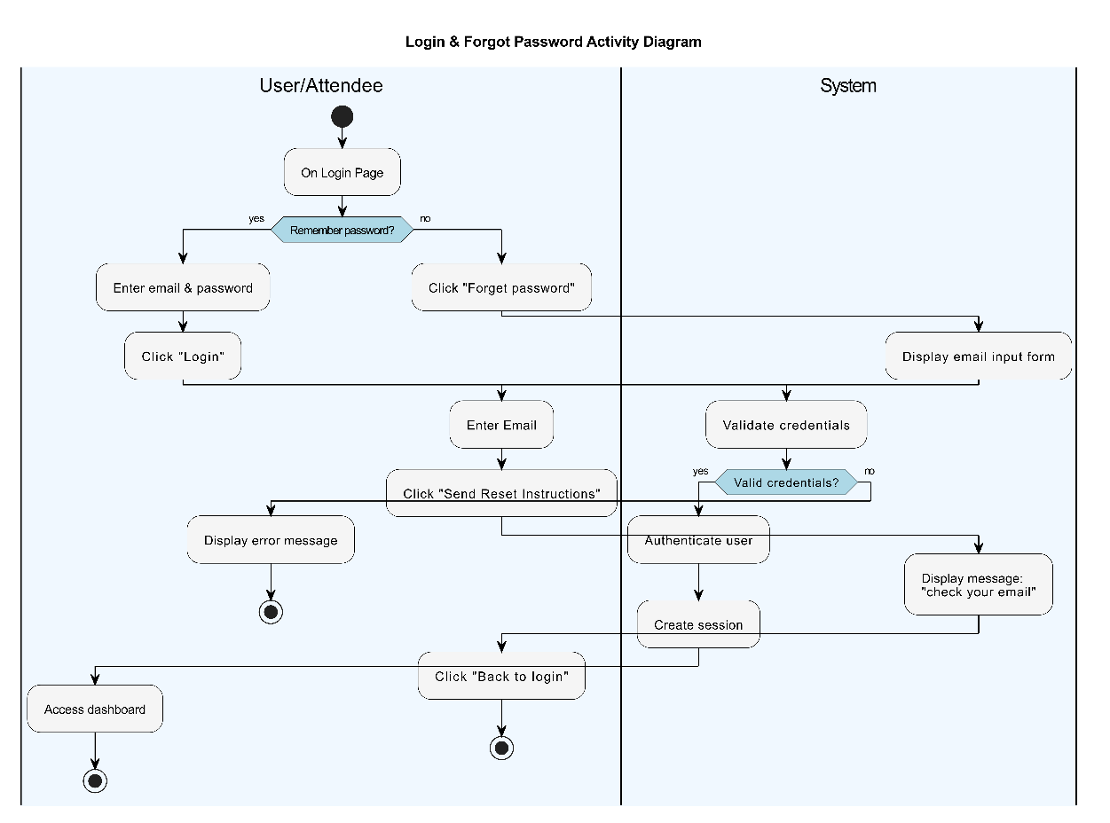

**3.3.2.3Activity Diagram for solar panels management**

Figure 8:activity diagram for solar management system

**3.Electrical Device Management - Functional Requirements**

**Solar Panel CRUD Operations**

|  |  |  |  |  |
| --- | --- | --- | --- | --- |
| **Requirements ID** | **Description** | **Module** | **Priority** | **Detailed Specification** |
| **REQ-FR-EDM-06** | Add new electrical device | Electrical Device Management | High | **Input Fields:** • Category (dropdown) • Technical specs (Brand& Model, power, usage hours) • priority (dropdown) |
| **REQ-FR-EDM-07** | Modify electrical device | Electrical Device Management | High |  |
| **REQ-FR-EDM-08** | Delete electrical device | Electrical Device Management | High | **Confirmation:** • System shall show a confirmation dialog before deletion |

Table 18:EDM functional requirements

**3.3.3.1Use case diagram for Electrical Devices Management**

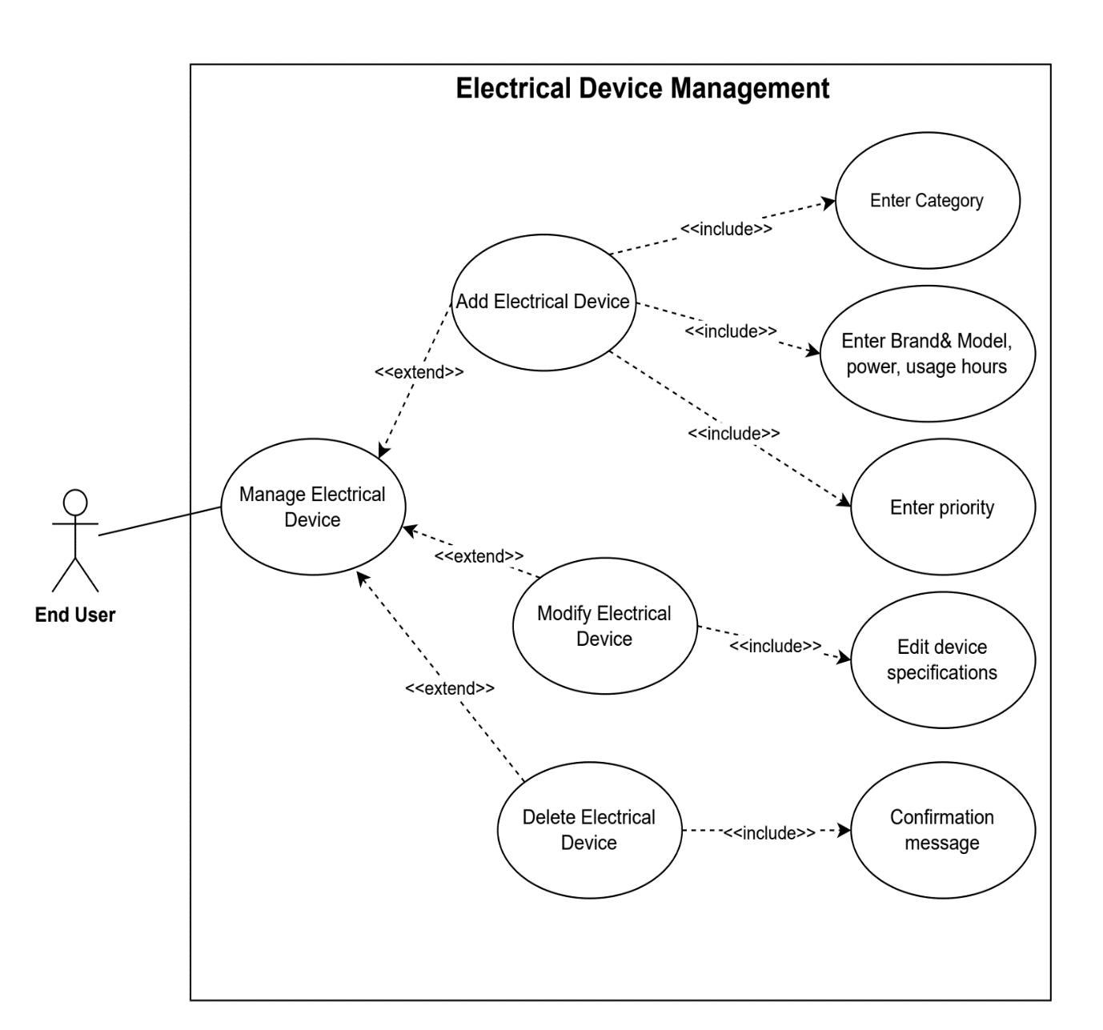

Figure 9:use case diagram for electrical device management

**3.3.2.2Use Case specification**

|  |  |
| --- | --- |
| **Use case name:** | Event Discovery and Booking |
| **Participating Actors:** | End User |
| **The flow of events:** | **Main Flow:**   1. User accesses the system 2. User clicks on "Browse Events" 3. System displays Discover Events page containing:    * Search & filter controls (search field, city, type, date, price)    * Event listings (event name, type, date, location, spots, price, capacity status) 4. User clicks on "search & Select status filter" 5. System displays the related results 6. User clicks on "View Package/Event" 7. System displays details of the selected event:    * Description, images, capacity, availability    * Ticket price, supplier information (if tagged) 8. User clicks on "Book package/event" 9. System checks if capacity is available 10. System checks if user is logged in 11. System confirms booking 12. System generates unique booking reference number 13. System reduces available capacity immediately 14. System sends booking confirmation email with reference number 15. User chooses to view bookings or browse more events   **Alternative Flow A (View My Bookings):**   1. User clicks on "View my bookings" 2. System displays user bookings with details (upcoming & past bookings) 3. User selects a booking 4. User decides to cancel or return 5. If cancel:    * System cancels booking    * System restores event capacity    * System sends cancellation confirmation message   **Alternative Flow B (Browse More Events):**   1. System returns to browse more events page |
| **Alternative flows:** | A1. Event capacity exceeded:   * System shows error message: "Event capacity exceeded" * User cannot proceed with booking   A2. User not logged in:   * System shows error message: "Please login first" * User redirected to login page   A3. Empty search/filter:   * System displays all available events   A4. No events match filter criteria:   * System displays "No events found" message   A5. Booking cancellation:   * User cancels booking from "My Bookings" * System restores event capacity * System sends cancellation confirmation |
| **Entry condition** | 1- System is operational  2-Events are available in the system  3- User has access to the system |
| **Exit conditions** | **Success:**   * Event booking confirmed successfully * Unique reference number generated * Confirmation email sent * Event capacity updated * User can view booking in "My Bookings"   **Success (Cancel Booking):**   * Booking canceled successfully * Event capacity restored * Cancellation confirmation sent   **Failure:**   * Error message displayed (capacity exceeded / not logged in) * User remains on current page * No changes to event capacity or booking status |

Table 19 :use case specification 3

**3.3.2.3Activity Diagram for Electrical Devices Management**

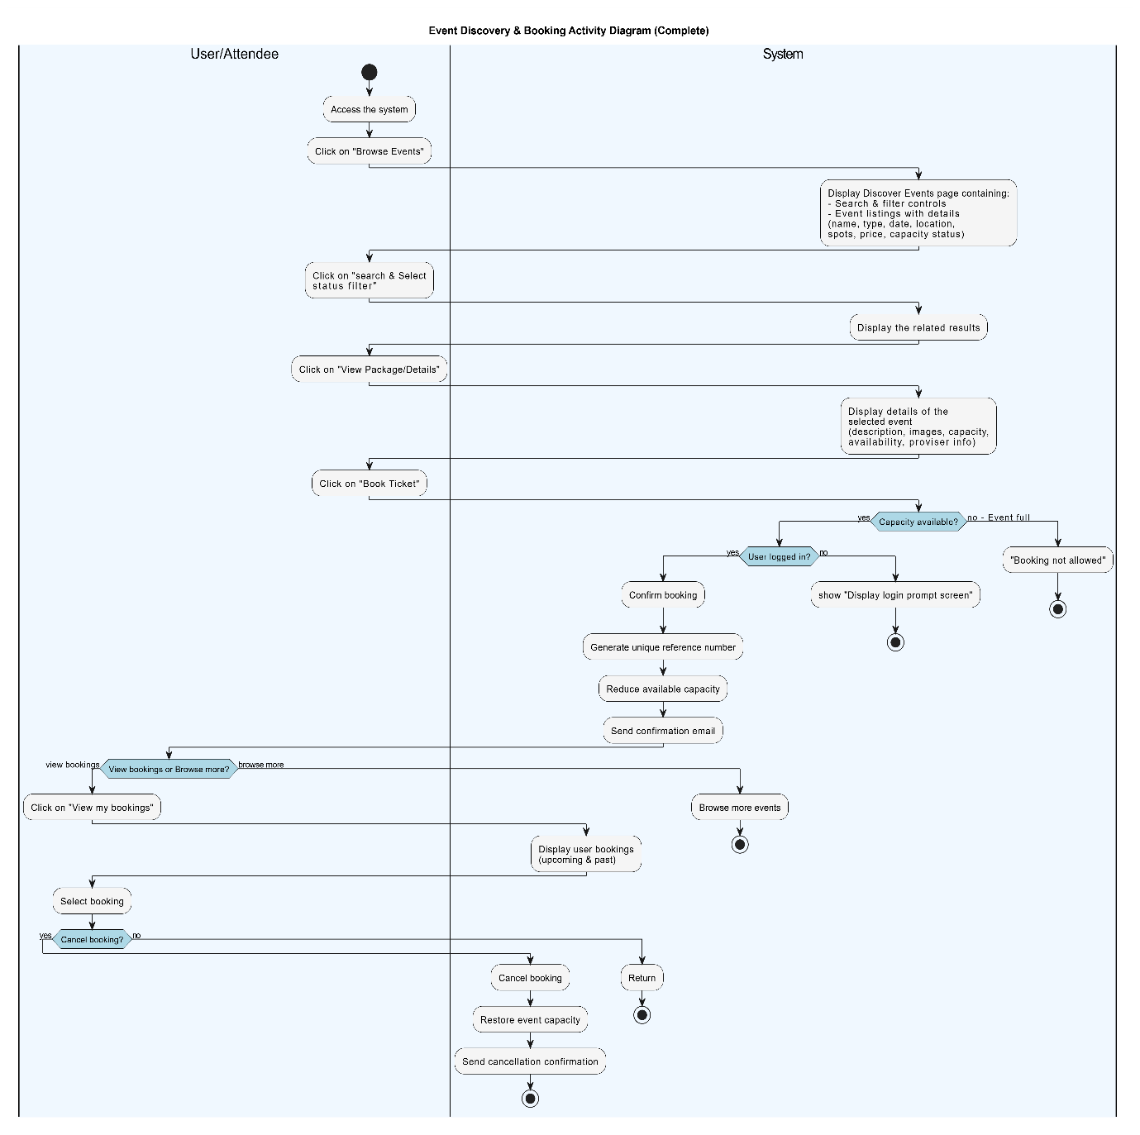

Figure 10:activity diagram for electrical devices management

**4. Solar Energy Dashboard - Functional Requirement**

|  |  |  |  |  |
| --- | --- | --- | --- | --- |
| **Requirements ID** | **Description** | **Module** | **Priority** | **Detailed Specification** |
| REQ-FR-SED-01 | Display energy production vs consumption chart | Solar Energy Dashboard | High | System shall display a comparative chart of energy production and consumption when the user accesses the dashboard. |
| REQ-FR-SED-02 | Select time filter for energy chart | Solar Energy Dashboard | Medium | User can click to filter the chart by: daily, weekly, or monthly. System updates the chart accordingly. |
| REQ-FR-SED-03 | Display top energy consuming devices | Analysis | High | When user selects "analysis devices", system shall display the devices with the highest consumption. |
| REQ-FR-SED-04 | Generate energy saving recommendations | Recommendation & Insight | Medium | System shall generate personalized energy saving tips when the user selects the recommendation & insight option. |
| REQ-FR-SED-05 | View consumption reports | Reports | High | User selects daily/weekly/monthly report, and system displays report accordingly. |
| REQ-FR-SED-06 | Allow user to continue operations | System Navigation | Low | After completing any action, user can continue to perform other operations in the system. |

Table 20:SED functional requirements

**4.3.3.1Use case diagram for Solar Energy Dashboard**

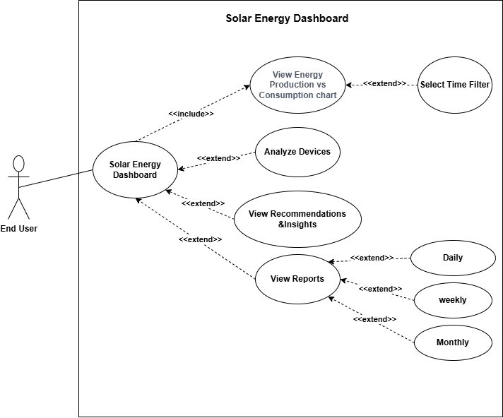

Figure 11:use case diagram for solar energy dashboard

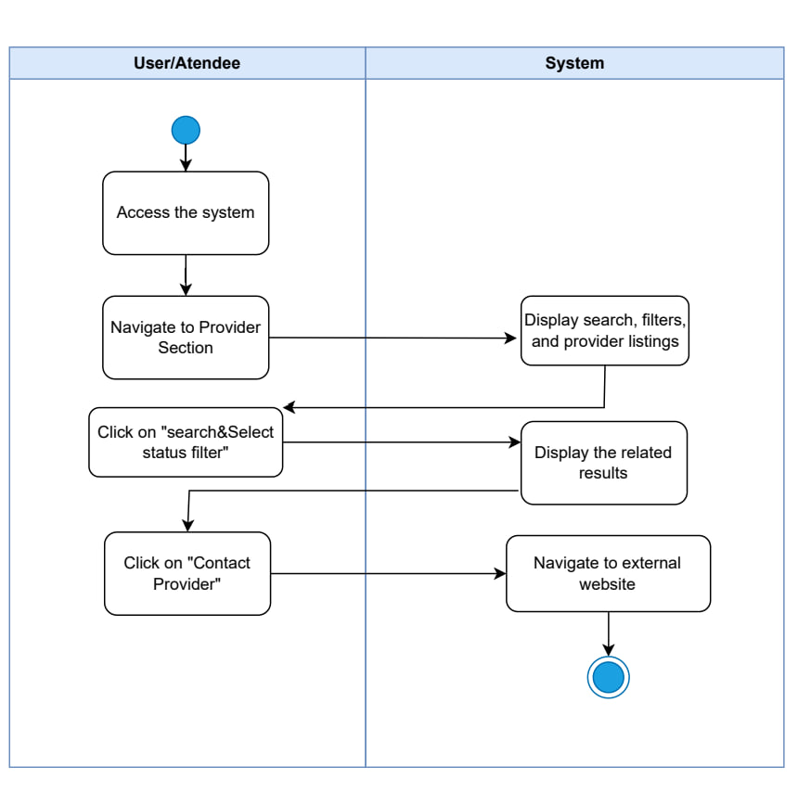

**4.3.2.2Use Case specification**

**Use case for Solar Energy Dashboard**

**Use Case 1: Provider Discovery and Contact**

|  |  |
| --- | --- |
| **Use case name:** | Browse Providers and Contact Provider |
| **Participating Actors:** | End User |
| **The flow of events:** | **Main Flow:**   1. User accesses the system 2. User navigates to Provider Section 3. System displays search, filters, and provider listings containing:    * Search functionality    * Filter controls    * Provider cards/listings 4. User clicks on "search & Select status filter" 5. System displays the related results based on selected filters 6. User clicks on "Contact Provider" 7. System navigates to external website (provider's website) 8. Process ends |
| **Alternative flows:** | A1. Empty search/filter:   * System displays all available providers   A2. No providers match filter criteria:   * System displays "No providers found" message   A3. User cancels navigation:   * System remains on provider listing page   A4. External website unavailable:   * System shows error message * User remains on provider section |
| **Entry condition** | 1-System is operational  2-Providers are registered in the system  3-User has access to the system |
| **Exit conditions** | **Success:**   * User successfully navigated to provider's external website * User can contact provider directly   **Failure:**   * Error message displayed (no providers found / website unavailable) * User remains on provider section page |

Table 21:use case specification 4

**Use Case 2: Analyze Top Consuming Devices**

|  |  |
| --- | --- |
| **Use case name:** | Device Consumption Analysis |
| **Participating Actors:** | End User |
| **The flow of events:** | 1.User accesses Solar Energy Dashboard  2.System displays energy production vs consumption chart  3.User selects analysis devices option  4.System displays top energy consuming devices |
| **Alternative flows:** | A1. No data available (System shows message) |
| **Entry condition** | User is authenticated  Consumption data is available |
| **Exit conditions** | **Success:**  - Devices are listed **Failure:**  - Error message is shown |

Table 22:use case specification 5

**Use Case 3: Get Recommendations & Insights**

|  |  |
| --- | --- |
| **Use case name:** | Get Energy Recommendations |
| **Participating Actors:** | End User |
| **The flow of events:** | 1.User accesses Solar Energy Dashboard  2.System displays energy production vs consumption chart  3.User selects "Recommendations & Insights"  4.System generates energy saving tips  5.User continues to other operations |
| **Alternative flows:** | A1. Recommendation service unavailable (System shows error) |
| **Entry condition** | User is authenticated  System recommendation module is active |
| **Exit conditions** | **Success:**  - Tips are shown  -**Failure:**  - Error message shown |

Table 23:use case specification 6

**Use Case 4: View Reports**

|  |  |
| --- | --- |
| **Use case name:** | View Energy Reports |
| **Participating Actors:** | End User |
| **The flow of events:** | 1.User accesses Solar Energy Dashboard  2.System displays energy production vs consumption chart  3.User selects Reports option  4.User chooses report type (daily/weekly/monthly)  5.System displays the corresponding report |
| **Alternative flows:** | A1. Report data unavailable (System shows message) |
| **Entry condition** | -User is authenticated  -System has report data |
| **Exit conditions** | **Success:**  - Report displayed  -**Failure:**  - Error message shown |

Table 24:use case specification 7

**4.3.2.3Activity Diagram for Solar Energy Dashboard**

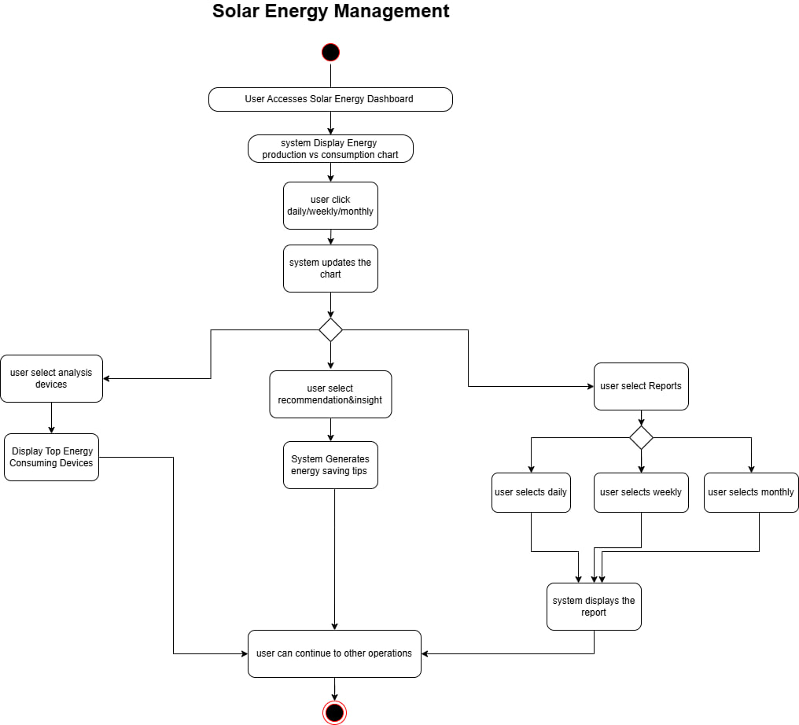

Figure 12:activity diagram for solar energy dashboard

**5. User Profile Management- Functional Requirement**

|  |  |  |  |  |
| --- | --- | --- | --- | --- |
| **Requirements ID** | **Description** | **Module** | **Priority** | **Detailed Specification** |
| **REQ-FR-UPM-01** | View user profile dashboard | User Profile Management | High | Upon accessing the profile, the system shall display a dashboard with three main sections:  -Personal Information  - Security Settings  - Notification Preferences |
| **REQ-FR-UPM-02** | Update personal information | User Profile Management | High | **Fields to display:**  -Full name  - Email  - Location(dropdown) |
| **REQ-FR-UPM-03** | Update password | User Profile Management | High | **Fields:**  - Current password  - New password  - Confirm new password |
| **REQ-FR-UPM-04** | Manage notification preferences | User Profile Management | Medium | **Options:**  **-**Low production warnings  -Overconsumption alerts  -Weekly energy reports  -Monthly energy reports |

Table 25:UPM functional requirements

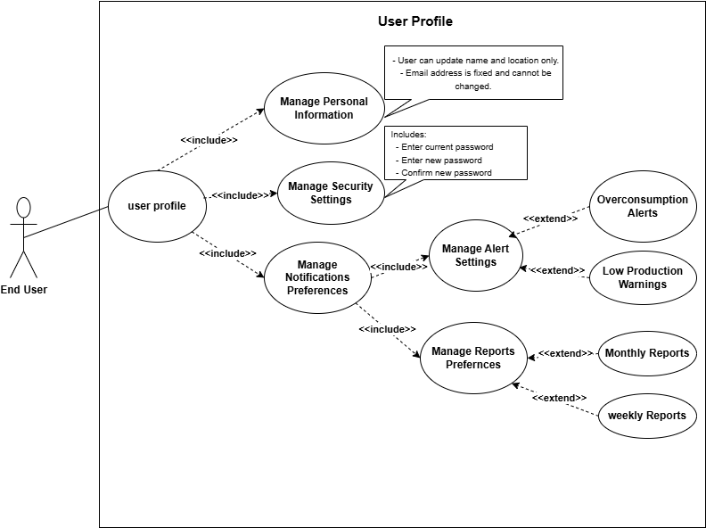**5.3.3.1Use case diagram for User Profile Management**

Figure 13:use case diagram for user profile management

**5.3.2.2Use Case specification**

|  |  |
| --- | --- |
| **Use case name:** | **User Profile** |
| **Participating Actors:** | End User |
| **The flow of events:** | 1. User accesses the user profile  2. System displays dashboard with three options: Personal Information, Security Settings, Notification Preferences  3. User selects one of the options:    - Personal Information : shows full name, email, and location fields    - S*ecurity Settings*: shows current password, new password, confirm password    - Notification Preferences: shows alert and report options (low production warnings, overconsumption alerts, weekly/monthly reports)  4. User fills in the fields and clicks save/change  5. System validates the input and displays either success or error message |
| **Alternative flows:** | A1. Invalid input (System shows message) |
| **Entry condition** | -User is authenticated |
| **Exit conditions** | **Success:**  - User profile updated successfully  -**Failure:**  - Error message shown |

Table 26:use case specification 8

**5.3.2.3Activity Diagram for User Profile Management**

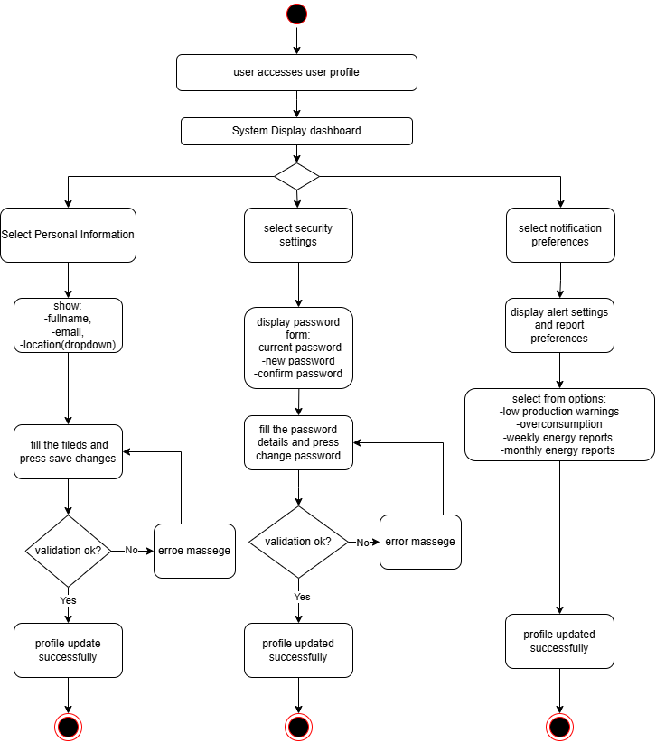

Figure 14:activity diagram for user profile management

**3.initial test case:**

|  |  |  |  |  |  |
| --- | --- | --- | --- | --- | --- |
| **TC ID** | **Req ID** | **Title** | **Preconditions** | **Test Steps** | **Expected Result** |
| **TC-01** | REQ-FR-01 | Create New User Account | User not registered | 1. Open registration page2. Enter valid details3. Submit the form | Account is created and user is redirected to dashboard |
| **TC-02** | REQ-FR-02 | User Login | User account exists | 1. Open login page2. Enter correct credentials3. Click login | User successfully logs in and accesses the system |
| **TC-03** | REQ-FR-03 | Add New Solar Panel | User is logged in | 1. Go to solar panels section2. Click “Add”3. Enter panel info4. Save | Solar panel appears in list |
| **TC-04** | REQ-FR-04 | Edit Solar Panel Data | User has existing solar panels | 1. Click “Edit” on a panel2. Change data3. Save changes | Data is updated successfully |
| **TC-05** | REQ-FR-05 | Delete Solar Panel | At least one panel exists | 1. Click “Delete” on panel2. Confirm deletion | Panel is removed from system |
| **TC-06** | REQ-FR-06 | Add New Electrical Device | User is logged in | 1. Go to devices section2. Click “Add Device”3. Enter info4. Save | Device is added to the list |
| **TC-07** | REQ-FR-07 | Edit Device Data | Device exists in list | 1. Click “Edit”2. Modify info3. Save | Device info is updated |
| **TC-08** | REQ-FR-08 | Delete Electrical Device | Device exists | 1. Click “Delete” on device2. Confirm | Device is deleted successfully |
| **TC-09** | REQ-FR-09 | Validate Numeric Inputs | User is entering values | 1. Enter invalid value (e.g., -100, letters)2. Submit form | System shows validation error message |
| **TC-10** | REQ-FR-10 | Calculate Solar Energy Production | Solar panel has data | 1. Open production dashboard | System shows total production based on data |
| **TC-11** | REQ-FR-11 | Calculate Energy Consumption | Devices have usage data | 1. Open consumption dashboard | System calculates total consumption accurately |

|  |  |  |  |  |  |
| --- | --- | --- | --- | --- | --- |
| **TC-12** | REQ-FR-12 | Compare Production and Consumption | Energy data available | 1. Open comparison screen | System shows chart comparing production and consumption |
| **TC-13** | REQ-FR-13 | Display Main Dashboard | User logged in | 1. Login to account | System displays summary dashboard with all main data |
| **TC-14** | REQ-FR-14 | Generate Reports (Daily/Weekly/Monthly) | User has historical data | 1. Go to reports page2. Select time range3. Generate report | Detailed report with graphs and insights is shown |
| **TC-15** | REQ-FR-15 | Send Automatic Alerts | Alert condition met | 1. Trigger an alert condition (e.g., high consumption) | System sends alert via email or notification |
| **TC-16** | REQ-FR-16 | Display Energy Saving Tips | User is logged in | 1. Open tips section or dashboard | System shows relevant and personalized energy-saving tips |
| **TC-17** | REQ-NFR-01 | Fast Request Processing | System running normally | 1. Perform common actions2. Measure time taken | All actions complete within 1–2 seconds |
| **TC-18** | REQ-NFR-02 | Encrypt Sensitive Data | User provides credentials | 1. Inspect storage or data transmission | Passwords and sensitive data are encrypted |
| **TC-19** | REQ-NFR-03 | Secure Authentication | User attempts login | 1. Enter wrong password2. Attempt injection3. Try brute force | System blocks login and protects against attacks |
| **TC-20** | REQ-NFR-04 | Handle High Load | System under stress test | 1. Simulate high traffic/users | System performs without lag or crash |
| **TC-21** | REQ-NFR-05 | Multilanguage Support | System supports multiple languages | 1. Change language in settings | UI updates and reflects selected language correctly |
| **TC-22** | REQ-NFR-06 | 24/7 Availability | System deployed | 1. Access system any time of day/night | System is online and functional with minimal downtime |

Table 27:initial test cases

**4. Requirement Trackability Matrix (RTM) (V.2)**

|  |  |  |  |  |  |  |  |
| --- | --- | --- | --- | --- | --- | --- | --- |
| **Requirements ID** | **Title** | **Use case** | **System Design** | **Analysis** | **Detailed Design** | **Coding** | **Test Cases** |
| REQ-FR-01 | The system should allow the creation of an account for a new user. | UC-01 |  |  |  |  | TC-01 |
| REQ-FR-02 | The system should allow the user to log in. | UC-01 |  |  |  |  | TC-02 |
| REQ-FR-03 | View user profile page | UC-05 |  |  |  |  |  |
| REQ-FR-04 | Update personal information | UC-05 |  |  |  |  |  |
| REQ-FR-05 | Change password | UC-05 |  |  |  |  |  |
| REQ-FR-03 | The system should allow the user to add new solar panels. | UC-02 |  |  |  |  | TC-03 |
| REQ-FR-04 | The system should allow the user to modify solar panel data. | UC-02 |  |  |  |  | TC-04 |
| REQ-FR-05 | The system should allow the user to delete a solar panel. | UC-02 |  |  |  |  | TC-05 |
| REQ-FR-06 | The system should allow the user to add new electrical devices. | UC-03 |  |  |  |  | TC-06 |
| REQ-FR-07 | The system should allow the user to modify device data. | UC-03 |  |  |  |  | TC-07 |
| REQ-FR-08 | The system should allow the user to delete an electrical device. | UC-03 |  |  |  |  | TC-08 |
| REQ-FR-09 | The system should validate numerical inputs (within reasonable ranges). | UC-02,UC-03 |  |  |  |  | TC-09 |
| REQ-FR-10 | The system should calculate the user’s solar energy production. | UC-02 |  |  |  |  | TC-10 |
| REQ-FR-11 | The system should calculate total energy consumption. | UC-03 |  |  |  |  | TC-11 |
| REQ-FR-12 | The system should compare production/consumption and display it to the user. | UC-04 |  |  |  |  | TC-12 |

|  |  |  |  |  |  |  |  |
| --- | --- | --- | --- | --- | --- | --- | --- |
| REQ-FR-13 | The system should display the main dashboard for the user. | UC-04 |  |  |  |  | TC-13 |
| REQ-FR-14 | The system should generate detailed daily/weekly/monthly reports. | UC-04 |  |  |  |  | TC-14 |
| REQ-FR-15 | The system should send automatic alerts to the user. |  |  |  |  |  | TC-15 |
| REQ-FR-16 | The system should provide the user with recommendations and tips for saving energy. | UC-04 |  |  |  |  | TC-16 |
| REQ-NFR-01 | The system should be capable of processing requests quickly. |  |  |  |  |  |  |
| REQ-NFR-02 | The system should encrypt sensitive information such as passwords and user data. |  |  |  |  |  |  |
| REQ-NFR-03 | The system should enforce secure authentication and require users to log in with passwords. |  |  |  |  |  |  |
| REQ-NFR-04 | The system should be capable of handling an increasing number of users and events without affecting performance. |  |  |  |  |  |  |
| REQ-NFR-05 | The system should be scalable to support multiple languages. |  |  |  |  |  |  |
| REQ-NFR-06 | The website should be available 24/7 with minimal downtime. |  |  |  |  |  |  |

Table 28:RTM V.2

**5.Summary**

In this chapter, we thoroughly analyzed the Alternative Energy Management System, starting from the initial phase of understanding the general requirements to identifying the main functions the system needs to fulfill. We focused on the key points that matter to the end user, such as monitoring solar panel performance, tracking electrical device consumption, and providing recommendations to improve energy efficiency.

We clarified the most important use cases where users interact with the system, including login, device management, displaying data on the dashboard, and updating user profiles. Activity diagrams were also created to visualize how processes flow within each part of the system.

Next, we specified the functional requirements for each system module, detailing the operations involved. We also prepared initial test cases to ensure these requirements are properly met.

Finally, we developed a Requirements Traceability Matrix (RTM) to link each requirement with the corresponding analysis, design, and implementation stages. This helps ensure the work covers all aspects and nothing important is overlooked in the upcoming development phases.

**Chapter 4:System Analysis**

**1.System Initial Analysis**

This section presents the initial analysis and key features identified during the

early stages of project planning and development.

**1. Introduction**

**1.1 Purpose**

This document specifies the software requirements and design for the Event Management Platform, a comprehensive solution designed to facilitate event discovery, booking, and management. The platform connects three key stakeholders: attendees seeking events to join or host, organizers managing events and packages, and suppliers offering event-related services. The system provides an intuitive marketplace that simplifies event participation, creation, and collaboration.

**1.2 Project Scope**

This system is an effective and user-friendly platform for managing the complete event lifecycle—from discovery and booking to hosting and supplier collaboration. It relies on organizer-created events and supplier services to provide a seamless experience for all stakeholders, enabling efficient event operations and enhanced user satisfaction.

**Key Features:**

- Unified platform for attending and hosting events

- Comprehensive organizer dashboard with analytics

- Integrated supplier directory for service discovery

- Real-time booking management and notifications

- Scalable architecture supporting multiple user roles

**1.2.1 High-Level Requirements:**

**1.2.1 User Management & Authentication**

- User registration and login

- Profile management

- Password recovery

- Account deletion

**1.2.2 Event Discovery & Browsing**

- Browse available events

- Search and filter events

- View event details

- Display event availability

**1.2.3 Booking Management**

- Book tickets for public events (Attend)

- Book host packages (Host)

- View booking history

- Cancel bookings

- Receive booking confirmations

**1.2.4 Organizer Management**

- Create and manage public events

- Create and manage host packages

- Enable/disable bookings

- Track event status

**1.2.5 Organizer Dashboard & Analytics**

- View booking statistics

- Monitor revenue

- Track event performance

- Access recent bookings

**1.2.6 providers Directory**

-provider registration

- provider categorization

- Display provider profiles

**1.2.7 Notification System**

- Registration notifications

- Password recovery notifications

- Booking confirmations and cancellations

- Event update notifications

- Event reminders

- Organizer alerts

**1.2.8 Visitor Access**

- Browse events without registration

- Search and filter functionality

- View event and provider information

- Access registration when attempting to book

**1.2.9 Security & Validation**

- Data validation

- Secure authentication

- Password encryption

- Input sanitization

**1.2.2 Actors:**

**1.3.1 Visitor (Non-registered User)**

**Responsibilities:**

* Browse available events
* Search and filter events
* View event details
* View supplier directory
* Explore platform features before registration

**Privileges:**

* Read-only access to public content
* No booking capabilities
* No profile management

**1.3.2 User / Attendee (Registered User)**

**Responsibilities:**

* Register and maintain profile
* Browse and search events
* Book tickets for public events (Attend)
* Book host packages for personalized events (Host)
* Manage personal bookings
* Cancel bookings when needed
* Receive notifications

**Privileges:**

* Access to personal dashboard
* View booking history
* Modify personal profile data
* Receive booking confirmations
* Access full event details
* Cancel own bookings

**1.3.3 Organizer**

**Responsibilities:**

* Create and manage public events
* Create and manage host packages
* Define event details and pricing
* Enable/disable bookings per event
* Monitor event performance
* Tag suppliers to events
* Respond to booking notifications
* Manage event capacity

**Privileges:**

* Access to organizer dashboard
* Create/edit/delete events
* View detailed analytics and revenue reports
* Access to all booking information
* Filter and search own events
* Receive organizer-specific notifications
* Tag providers to events

**1.3.4 provider**

**Responsibilities:**

* Register and maintain business profile
* Provide service information
* Update contact details
* Maintain service quality for visibility

**Privileges:**

* Create public supplier profile
* Display business information
* Be discoverable by users and organizers
* Static presence in directory

**2.Overall Description**

**2.1 Product Perspective**

**Product Perspective**

The Event Management Platform is a standalone web-based product designed to revolutionize event discovery, participation, and management. It is not part of an existing product family nor a replacement for any current system. The platform serves as a comprehensive marketplace connecting three distinct user groups: attendees seeking engaging events, organizers creating memorable experiences, and suppliers providing essential event services.

The system operates as a centralized hub where:

- Users discover events that match their interests and location

- Organizers manage event logistics and track performance

- Suppliers gain visibility and connect with potential clients

The platform is designed with scalability in mind, allowing for future enhancements such as payment gateway integration and advanced supplier interactions.

**2.2 Product Features**

**1. Event Management**

- Create and manage public events and host packages

- Enable/disable bookings

- Track event status and performance

**2. Booking System**

- Book tickets for public events

- Book host packages

- Manage bookings and cancellations

**3. Organizer Dashboard**

- View bookings and revenue analytics

- Monitor event performance

- View booking statistics

**4. Provider Directory**

- Browse service providers

- Search by category and location

- Tag providers to events

**5. Notification System**

- Automated email notifications

- Booking confirmations and reminders

- Event updates and alerts

**6. User Management**

- Registration and authentication

- Profile management

- Role-based access

**2.3 User Categories and Their Characteristics**

**2.3.1 Visitor (Non-registered User)**

**Responsibilities:**

- Browse events

- Search and filter events

- View event and supplier details

**Privileges:**

- Read-only access to public content

- Cannot make bookings

**2.3.2 User/Attendee (Registered User)**

**Responsibilities:**

- Manage profile

- Book events (Attend or Host)

- Manage bookings

- Cancel bookings

**Privileges:**

- Access personal dashboard

- View booking history

- Modify profile

- Receive email notifications

**2.3.3 Organizer**

**Responsibilities:**

- Create and manage events

- Create and manage host packages

- Enable/disable bookings

- Monitor event performance

- Tag suppliers to events

**Privileges:**

- Access organizer dashboard

- Create/edit/delete events

- View booking details and analytics

- Filter and search events

- Receive organizer notifications

**2.3.4 Provider**

**Responsibilities:**

- Register and maintain business profile

- Provide service information

- Update contact details

**Privileges:**

- Create and edit business profile

- Public directory listing

- Display contact information

**High-Level Requirements Table**

|  |  |  |  |
| --- | --- | --- | --- |
| **HLR ID** | **High-Level Requirement** | **Description** | **Priority** |
| **HLR-1** | User Management | System shall provide complete user account management including registration, authentication, profile management, and session handling | High |
| **HLR-2** | Event Discovery & Browsing | System shall allow users and visitors to discover, search, filter, and view event details | High |
| **HLR-3** | Event Booking System | System shall enable users to book events and host packages with capacity management and booking confirmation | High |
| **HLR-4** | Booking Management | System shall allow users to view booking history and cancel bookings with automatic capacity restoration | High |
| **HLR-5** | Event Management (Organizer) | System shall allow organizers to create, edit, delete, and manage public events and host packages | High |
| **HLR-6** | Organizer Dashboard & Analytics | System shall provide organizers with dashboard displaying event management tools, statistics, and revenue tracking | High |
| **HLR-7** | Supplier Directory | System shall provide supplier registration, directory browsing, and search functionality | Medium |
| **HLR-8** | Notification System | System shall send email notifications for registration, booking actions, event updates, reminders, and organizer alerts | High |
| **HLR-9** | Visitor Access | System shall allow non-registered visitors to browse events and suppliers with restricted booking access | High |
| **HLR-10** | Security & Validation | System shall enforce data validation, password security, session management, and access control | High |

**Use case diagram:**

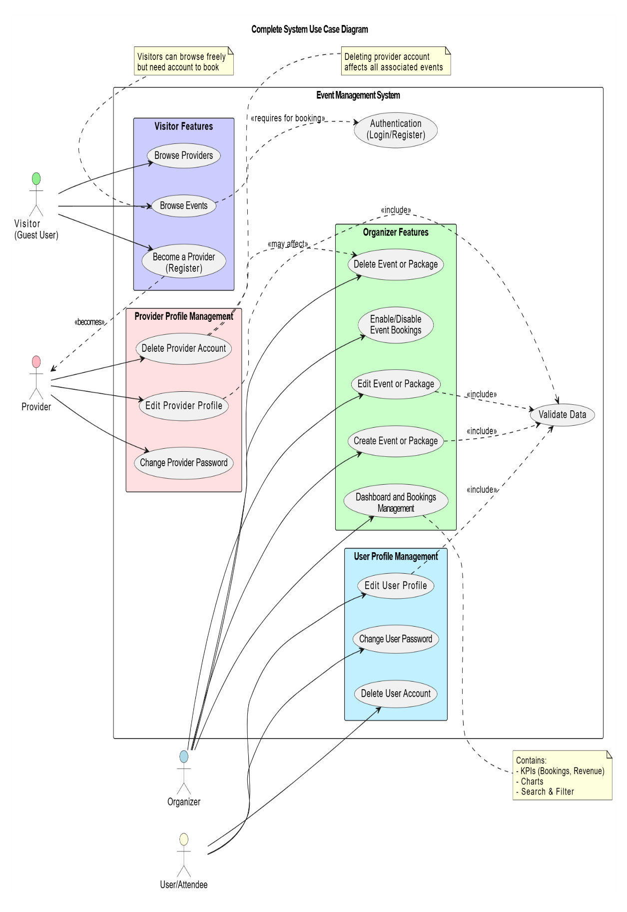

**2.Detailed Analysis**

**1.Introduction**

This chapter aims to transform the functional requirements identified during the preliminary analysis phase into precise engineering designs. Utilizing UML modeling to illustrate system interactions, this section will establish the technical framework to be adopted by the development team in subsequent stages

**2.purposes**

we will:

* Formalize system behavior through state diagrams capturing entity lifecycles
* Map operational workflows via activity diagrams
* Define interaction patterns using sequence diagrams
* Establish validation protocols for data integrity
* Model the static structure of the system using class diagrams, defining key entities (classes), their attributes, operations, and the relationships between them. This will provide a blueprint for the system's architecture and data organization.

**3.System Requirements:**

Functional and nonfunctional Requirements Table

|  |  |  |  |  |
| --- | --- | --- | --- | --- |
| **Req ID** | **Requirement Title** | **Priority** | **Description** | **Category** |
| **FR-01** | User Registration | High | System shall allow users to register with email, password, full name, phone number, and select role (User) | Authentication |
| **FR-02** | provider Registration | High | System shall allow providers to register with email, password, full name, phone number, select role (provider) ,city,service type,and description | Authentication |
| **FR-03** | Registration Validation | High | System shall validate email format, phone number (+13 digits), password strength (min 8 chars, 1 uppercase, 1 number) | Authentication |
| **FR-04** | User Login | High | System shall allow users/providers/admin to log in with email and password | Authentication |
| **FR-05** | User Logout | Medium | System shall allow users/providers/admin to log out and terminate session | Authentication |
| **FR-06** | Forgot Password | High | System shall provide password reset functionality via email reset link | Authentication |
| **FR-07** | View Profile | Medium | System shall allow users to view their profile information | Profile Management |
| **FR-08** | Edit Profile | Medium | System shall allow users to edit name, email, phone number, and profile picture | Profile Management |
| **FR-09** | Change Password | Medium | System shall allow users to change password | Profile Management |
| **FR-10** | Delete Account | Low | System shall allow users to delete their accounts | Profile Management |
| **FR-11** | Account Deletion Confirmation | Low | System shall require password confirmation before account deletion | Profile Management |
| **FR-12** | Display Events | High | System shall display all available events on main browsing page | Event Browsing |
| **FR-13** | Filter Events | High | System shall allow filtering events by date range, location, price range, and event type | Event Browsing |
| **FR-14** | Event Cards Display | High | System shall display event cards showing title, description, image, date, time, location, availability, total bookings | Event Browsing |
| **FR-15** | Search Events | High | System shall provide search functionality by event title or keywords | Event Browsing |
| **FR-16** | Capacity Status Display | Medium | System shall show event capacity status (available seats) | Event Browsing |
| **FR-17** | Event Details Display | High | System shall display full event details including description, images, capacity, and ticket price | Event Details |
| **FR-18** | Booking Availability | High | System shall display booking availability status | Event Details |
| **FR-19** | Supplier Information | Medium | System shall display associated supplier information if tagged | Event Details |
| **FR-20** | Prevent Overbooking | High | System shall prevent booking if capacity is exceeded | Booking |
| **FR-21** | Login Required for Booking | High | System shall require user login before completing booking | Booking |
| **FR-22** | Generate Booking Reference | High | System shall generate unique booking reference number upon confirmation | Booking |
| **FR-23** | Update Capacity | High | System shall reduce available capacity immediately upon booking | Booking |
| **FR-24** | Booking Confirmation Email | High | System shall send booking confirmation email with reference number | Booking |
| **FR-25** | Display Host Packages | Medium | System shall display host packages with base setup details | Host Packages |
| **FR-26** | Book Host Package | Medium | System shall allow users to book host package for specific date or location | Host Packages |
| **FR-27** | Host Booking Reference | Medium | System shall generate unique reference number for host bookings | Host Packages |
| **FR-28** | Display Upcoming Bookings | High | System shall display user's upcoming bookings | Booking History |
| **FR-29** | Display Past Bookings | Medium | System shall display user's past bookings (completed) | Booking History |
| **FR-30** | Cancel Booking | High | System shall allow users to cancel confirmed bookings | Booking History |
| **FR-31** | Restore Capacity on Cancel | High | System shall restore event capacity when booking is canceled | Booking History |
| **FR-32** | Create Public Event | High | System shall allow organizers to create new public events | Event Management |
| **FR-33** | Event Required Fields | High | System shall require mandatory fields: title, description, location, date (future), time, capacity, ticket price | Event Management |
| **FR-34** | Edit Event | High | System shall allow organizers to edit events | Event Management |
| **FR-35** | Delete Event | Medium | System shall allow organizers to delete events | Event Management |
| **FR-36** | Enable/Disable Bookings | Medium | System shall allow organizers to enable or disable booking functionality (Open/Close status) | Event Management |
| **FR-37** | Create Host Package | Medium | System shall allow organizers to create new host packages | Host Package Management |
| **FR-38** | Package Required Fields | Medium | System shall require mandatory fields: title, description, base setup details, location options, package price | Host Package Management |
| **FR-39** | Customizable Package Elements | Low | System shall allow organizers to specify customizable elements in host packages | Host Package Management |
| **FR-40** | Edit Host Package | Medium | System shall allow organizers to edit host packages | Host Package Management |
| **FR-41** | Delete Host Package | Medium | System shall allow organizers to delete host packages | Host Package Management |
| **FR-42** | Enable/Disable Package Bookings | Medium | System shall allow organizers to enable or disable booking functionality for host packages | Host Package Management |
| **FR-43** | Filter Events by Status | Medium | System shall allow filtering events by status: All, Active, Canceled, Completed | Event Dashboard |
| **FR-44** | Search Events | Medium | System shall allow searching for events | Event Dashboard |
| **FR-45** | Event Dashboard Display | High | System shall display organizer's event dashboard with Type, City, Date, Status, Bookings, Stats, Revenue, Actions | Event Dashboard |
| **FR-46** | Per-Event Statistics | High | System shall display per-event statistics: total bookings, remaining seats, total revenue | Analytics |
| **FR-47** | General Statistics | High | System shall display general statistics: total events created, active events, total overall revenue | Analytics |
| **FR-48** | Supplier Registration | Medium | System shall allow suppliers to register with business name, service type, city, description, contact information | Supplier Management |
| **FR-49** | Search Suppliers | Medium | System shall allow searching suppliers by service type or city | Supplier Management |
| **FR-50** | Service Categories | Medium | System shall support service categories: Catering, Photography, Venues, Entertainment, Decoration, Audio/Visual, Transportation | Supplier Management |
| **FR-51** | Generate Reference Number | High | System shall generate unique alphanumeric reference number (8-12 characters) | Booking System |
| **FR-52** | Prevent Overbooking | High | System shall prevent overbooking | Booking System |
| **FR-53** | Registration Notification | High | System shall send email notification upon registration (success/failure) | Notifications |
| **FR-54** | Password Reset Notification | High | System shall send email with password reset link and confirmation | Notifications |
| **FR-55** | Booking Notification | High | System shall send email notification for booking actions (confirmation/cancellation) | Notifications |
| **FR-56** | Event Update Notification | High | System shall notify attendees when event is canceled, date changed, or location changed | Notifications |
| **FR-57** | Event Reminder | Medium | System shall send reminder email 24 hours before event | Notifications |
| **FR-58** | Organizer Alerts | High | System shall notify organizer for new bookings and capacity status (80%, 100%) | Notifications |
| **FR-59** | Visitor Browse Events | High | System shall allow visitors to browse all available events without registration | Visitor Management |
| **FR-60** | Visitor Search & Filter | High | System shall allow visitors to use search and filter functionality for events | Visitor Management |
| **FR-61** | Visitor View Event Details | High | System shall display full event details to visitors | Visitor Management |
| **FR-62** | Prevent Visitor Booking | High | System shall prevent visitors from making bookings without login | Visitor Management |
| **FR-63** | Redirect to Login | High | System shall redirect visitors to registration/login page when attempting to book | Visitor Management |
| **FR-64** | Visitor Browse Suppliers | Medium | System shall allow visitors to browse supplier directory | Visitor Management |

**1. Authentication Functional Requirements:**

|  |  |  |  |  |
| --- | --- | --- | --- | --- |
| **Requirements ID** | **Description** | **Module** | **Priority** | **Detailed Specification** |
| **REQ-FR-UM-01** | New user account creation | User Management | High | • Collects user name and email • Validates email format • Enforces strong password policy (8+ chars, upper/lower case, numbers) |
| **RQ-FR-UM-02** | User login | User Management | High | •Verifies email and password • Authenticates credentials against stored data |

Table 14:UM functional requirements

**3.1Requirements Modeling**

3.3.1.1 use case diagram for visitor

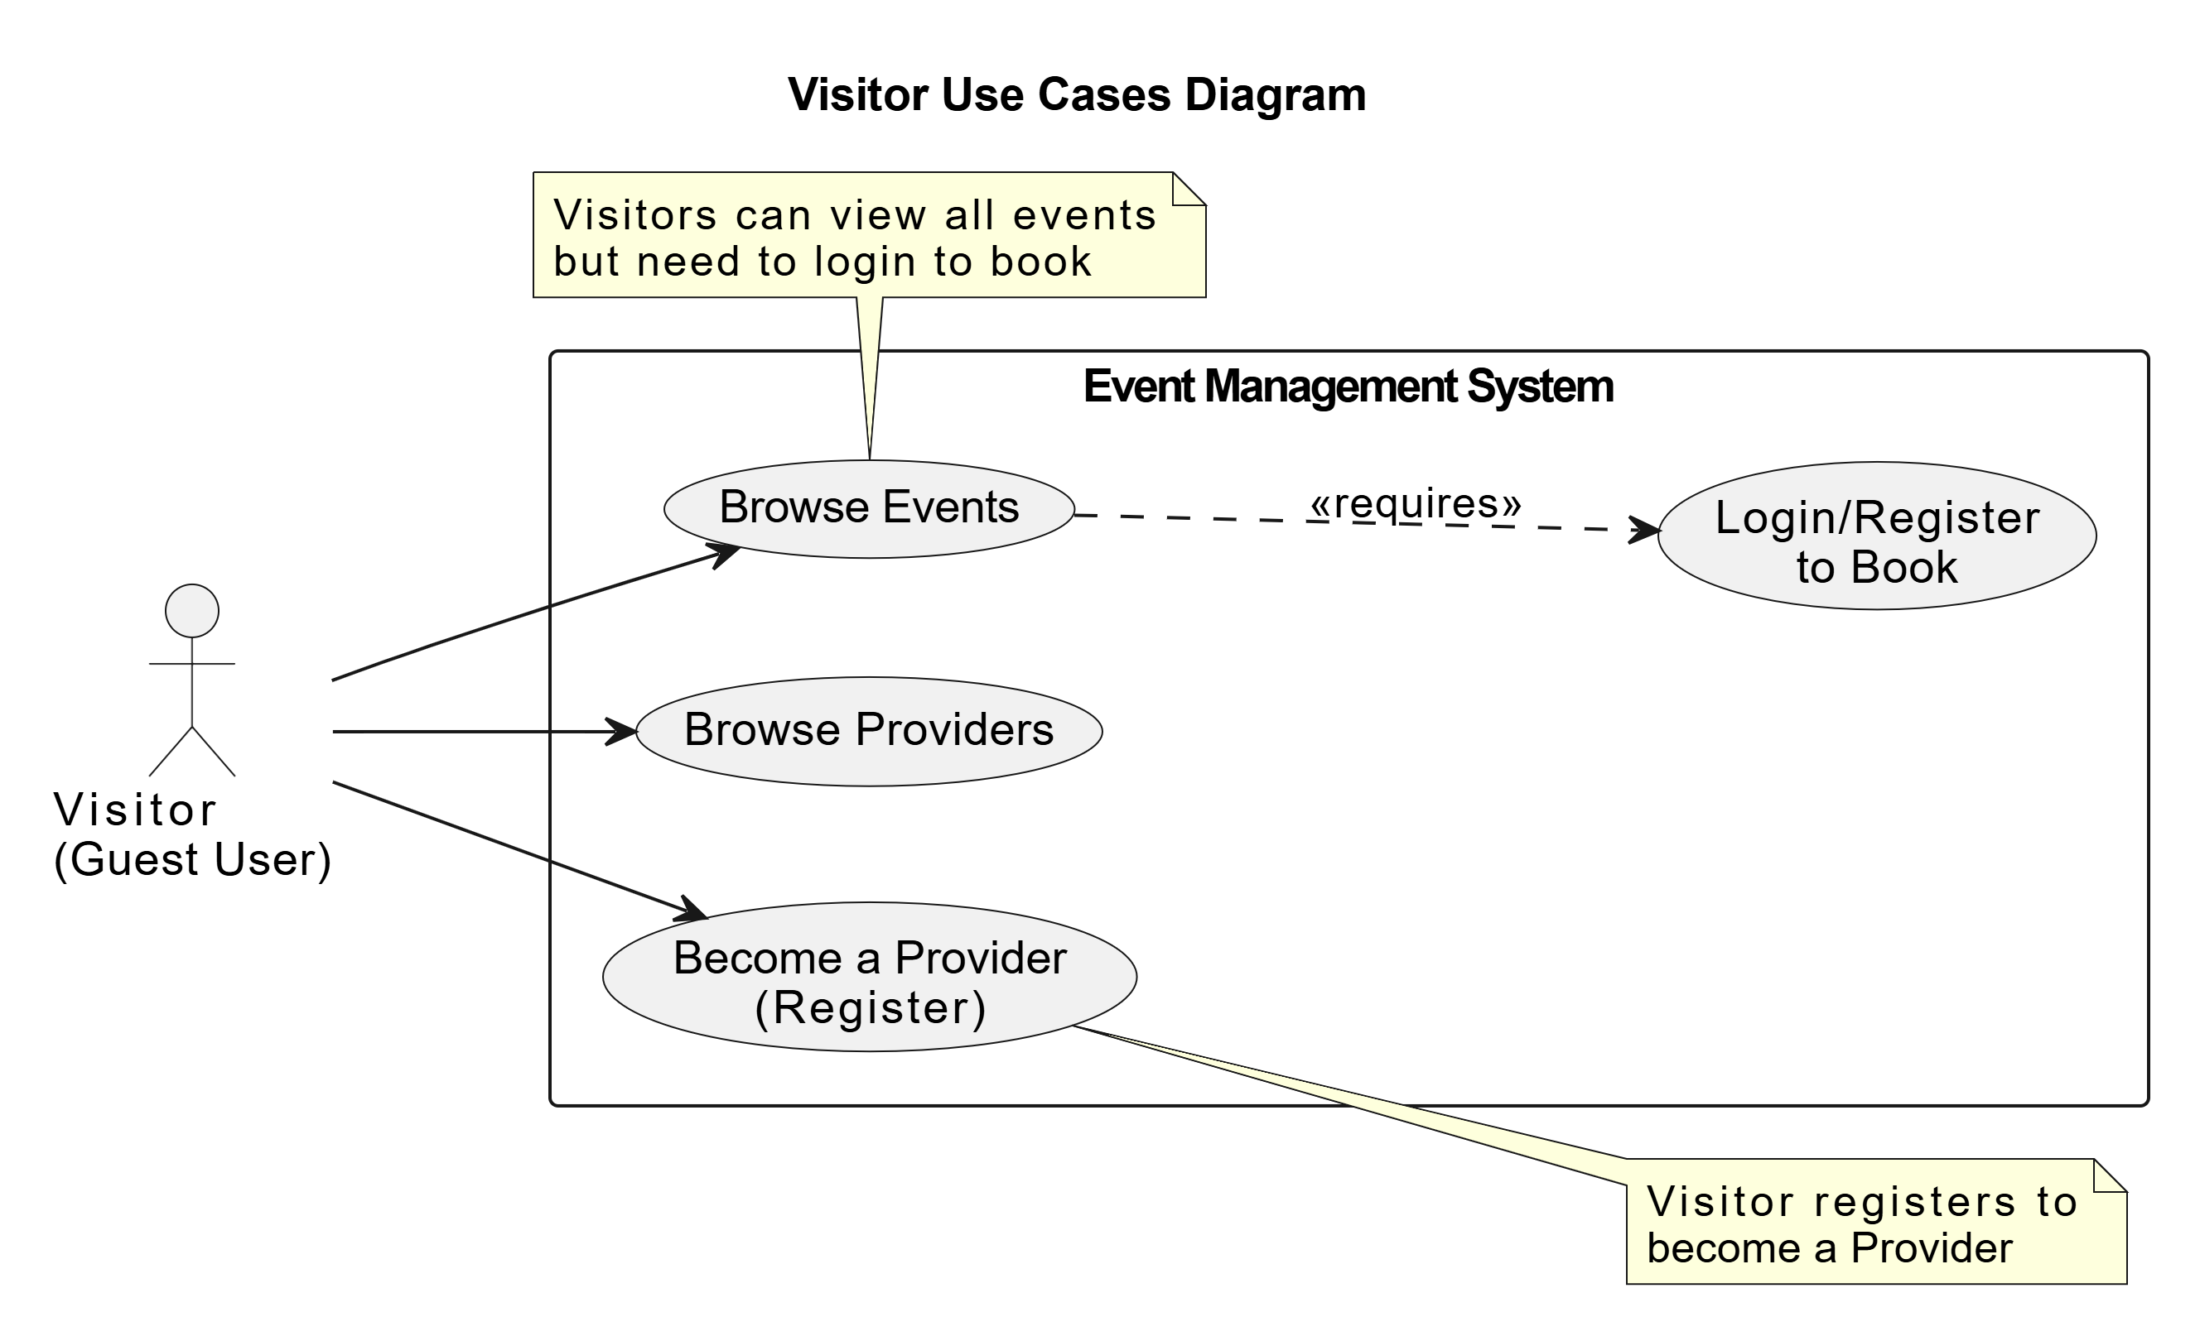

**3.3.1.3 Activity Diagram for visitor**

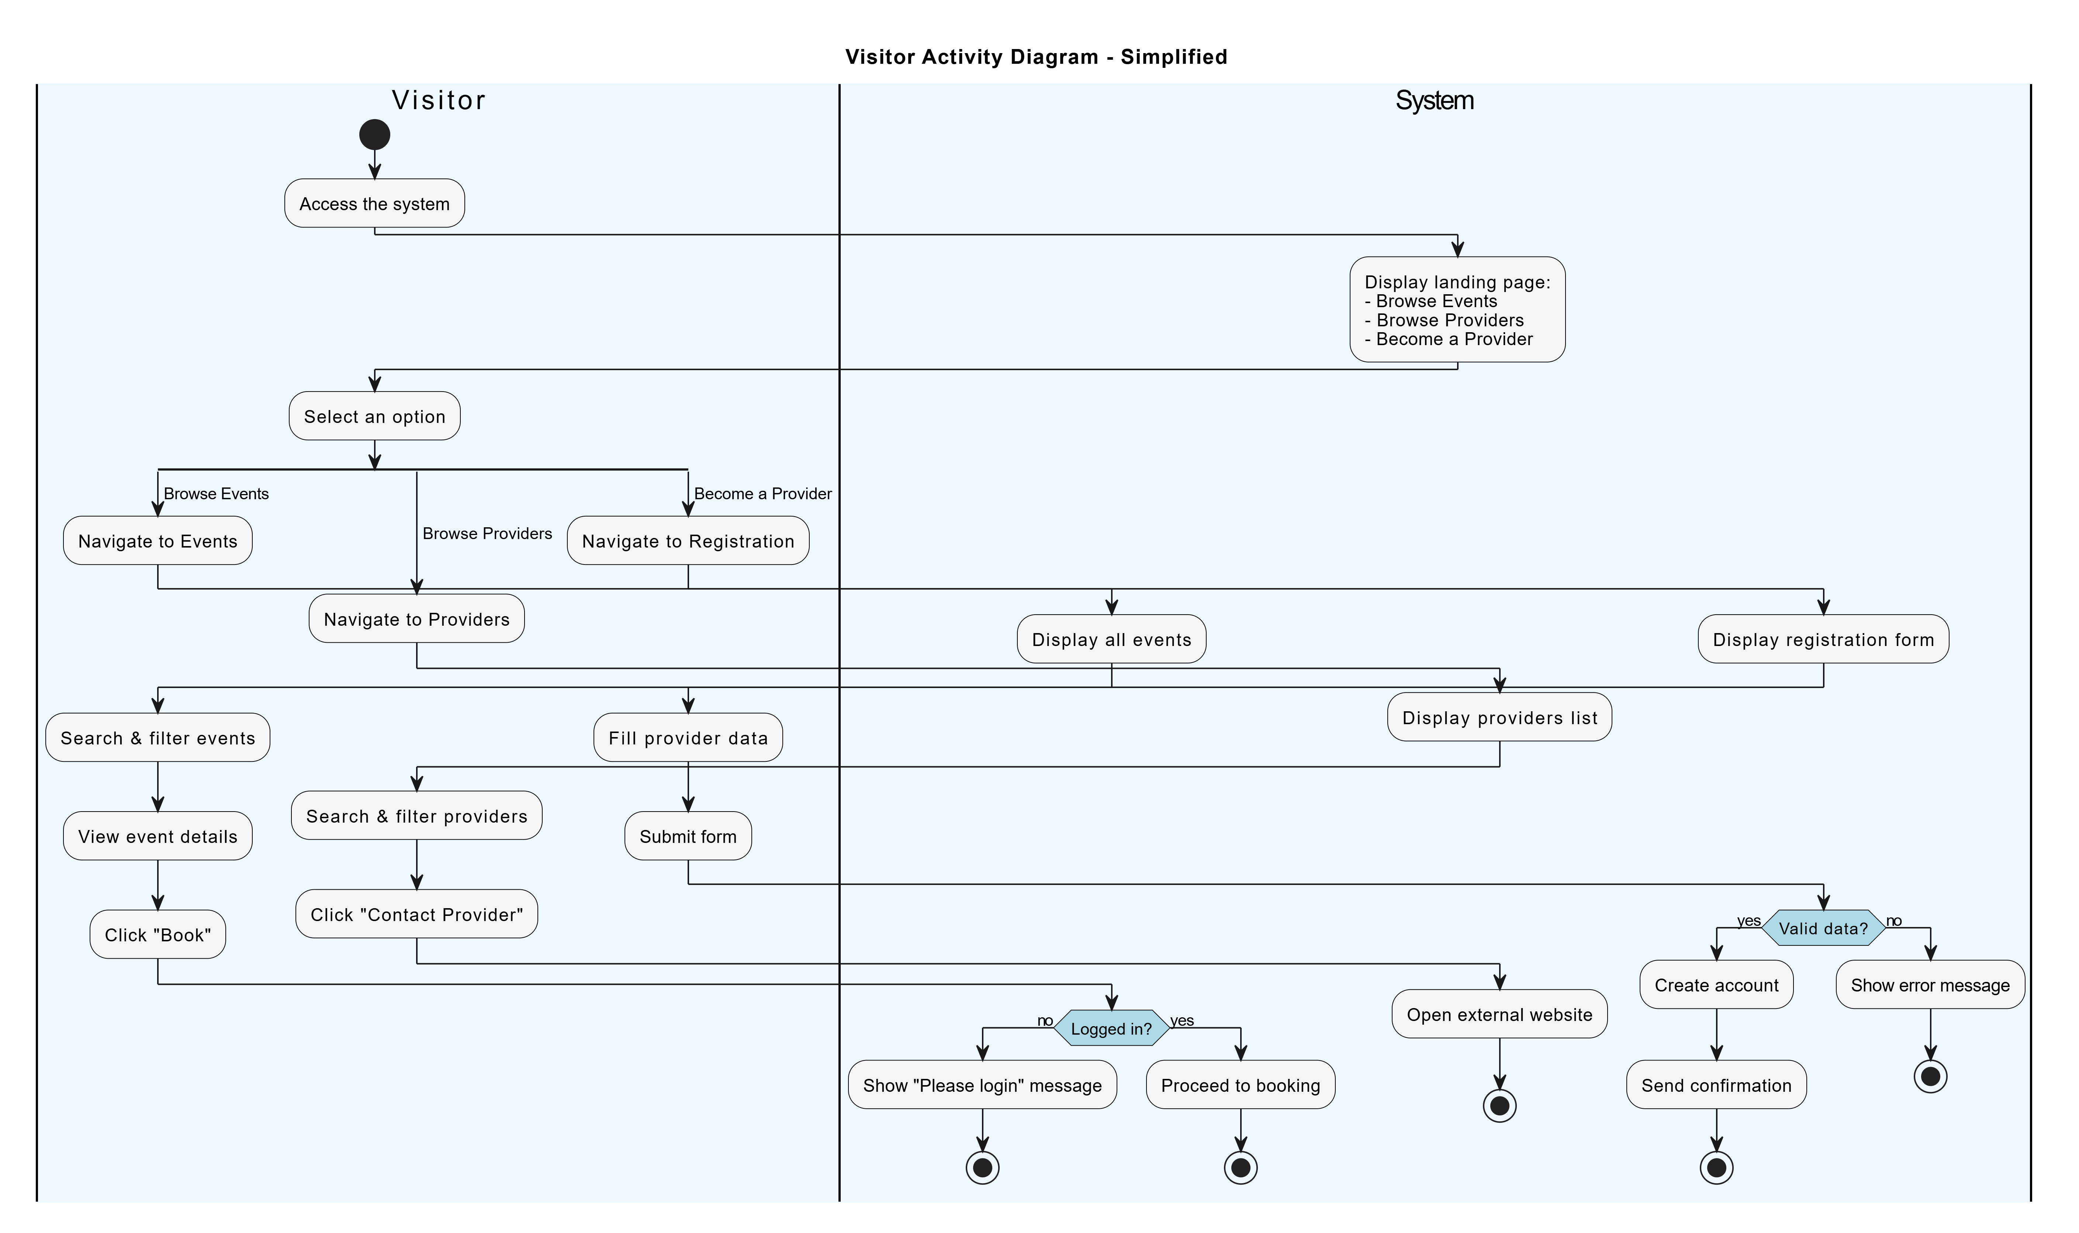

**Case 1: Browse Events as Visitor**

|  |  |
| --- | --- |
| **Use case name:** | Browse and View Events Without Registration |
| **Participating Actors:** | Visitor (Guest User) |
| **The flow of events:** | 1. Visitor accesses the system 2. System displays landing page with three options:    * Browse Events    * Browse Providers    * Become a Provider 3. Visitor selects "Browse Events" 4. System displays all available events without requiring login 5. Visitor uses search & filter functionality (date, location, price, type) 6. System displays filtered results 7. Visitor clicks on "View Event Details" 8. System displays full event details (description, images, capacity, price, supplier info) 9. Visitor clicks on "Book Event" 10. System checks if user is logged in 11. System displays message: "You don't have an account ID. Please login or register to book" 12. System redirects to login/register page |
| **Alternative flows:** | A1. Visitor doesn't attempt to book:   * Visitor continues browsing events * No login required   A2. Visitor is already logged in:   * System proceeds to booking flow * No login prompt displayed   A3. No events match filter:   * System displays "No events found" message |
| **Entry condition** | 1. System is operational 2. Visitor has internet access |
| **Exit conditions** | **Success:**   * Visitor can browse all events freely * Full event details displayed * Search and filter work correctly * Login prompt shown when attempting to book   **Failure:**   * No events available * System unable to load event data |

**Use Case 2: Browse Providers as Visitor**

|  |  |
| --- | --- |
| **Use case name:** | Browse Supplier Directory Without Registration |
| **Participating Actors:** | Visitor (Guest User) |
| **The flow of events:** | 1. Visitor accesses the system 2. System displays landing page with three options 3. Visitor selects "Browse Providers" 4. System displays supplier directory without requiring login 5. Visitor browses and filters supplier listings 6. Visitor clicks on "Contact Provider" 7. System navigates to provider's external website |
| **Alternative flows:** | A1. No providers match filter:   * System displays "No providers found" message   A2. External website unavailable:   * System shows error message |
| **Entry condition** | 1.System is operational  2.Providers are registered in system |
| **Exit conditions** | **Success:**   * Visitor can browse all providers freely * Filter functionality works * External website opens successfully   **Failure:**   * No providers available * External link broken |

**Use Case 3: Become a Provider (Register as Provider)**

|  |  |
| --- | --- |
| **Use case name:** | Provider Registration by Visitor |
| **Participating Actors:** | Visitor (Guest User becoming Provider) |
| **The flow of events:** | 1. Visitor accesses the system 2. System displays landing page with three options 3. Visitor selects "Become a Provider" 4. System displays Provider Registration Form 5. Visitor fills registration data:    * Business Name    * Contact Information (email, phone)    * Services Offered    * Business Description    * Other required details 6. Visitor clicks "Submit" 7. System validates registration data 8. If valid:    * System creates provider account    * System sends confirmation email    * System displays success message |
| **Alternative flows:** | A1. Invalid or missing data:   * System displays validation error message * Visitor must correct errors * Visitor remains on registration form   A2. Email already registered:   * System displays "Email already exists" error * Visitor must use different email   A3. Visitor cancels registration:   * Visitor clicks "Cancel" * System returns to landing page * No account created |
| **Entry condition** | 1.System is operational  2.Visitor wants to become a provider |
| **Exit conditions** | **Success:**   * Provider account created successfully * Confirmation email sent * Visitor can now login as provider   **Failure:**   * Validation errors displayed * Missing required fields * Email already exists * No account created |

3.3.1.2**Use Case specification**

|  |  |
| --- | --- |
| **Use case name:** | User Registration System |
| **Participating Actors:** | User/attendee |
| **The flow of events:** | 1-User accesses registration page  2-System displays registration form  3-User enters registration data:   * Full Name * Email * Password * Confirm Password * Phone Number (starts with +, 13 digits) * Role (User/Provider)   4-User clicks "Register"  5-System validates:  a) All fields filled → Continue  b) Missing fields → Show error "Please fill all required fields"  6-System validates email format  a) Valid format → Continue  b) Invalid → Show error "Invalid email format"  7-System validates phone number  a) Valid (+13 digits) → Continue  b) Invalid → Show error "Phone must start with + and contain 13 digits"  8-System validates password strength  a) Valid (8+ chars, 1 uppercase, 1 number) → Continue  b) Invalid → Show error "Password must meet requirements"  9-System checks password confirmation match  a) Passwords match → Continue  b) Don't match → Show error "Passwords do not match"  10-System checks email availability in database  a) Available → Continue  b) Already exists → Show error "Email already exists"  11-System creates user account  12-System sends welcome email |
| **Alternative flows:** | A1: Invalid email format during registration  A2: Weak password entered  A3: Phone number format incorrect  A4: Passwords don't match  A5: Email already registered  A6: Welcome email fails to send (user still created) |
| **Entry condition** | 1-User opens the application/system  2-System displays the registration screen  3-User is not logged in |
| **Exit conditions** | **Success:**  User account created, logged in, redirected to home page  **Failure:**  Error messages displayed, user remains on registration page |

Table 15:use case specification 1

Use case for user registration:

**3.3.1.3 Activity Diagram for User Registration System**

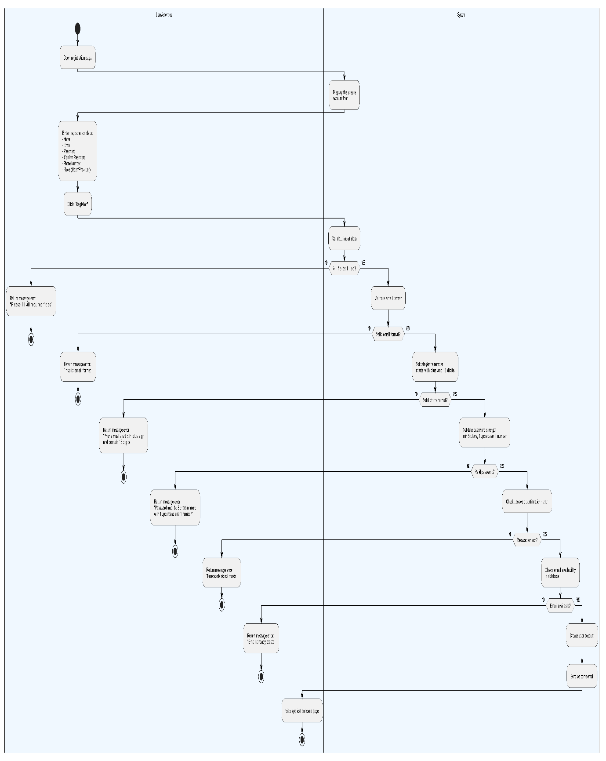

|  |  |
| --- | --- |
| **Use case name:** | Login and Forgot Password |
| **Participating Actors:** | User/Attendee |
| **The flow of events:** | 1. **Main Flow (Login):** 2. User accesses the login page 3. System displays login page 4. User enters email and password 5. User clicks "Login" button 6. System validates credentials 7. System authenticates user and creates session 8. User accesses dashboard 9. **Alternative Flow (Forgot Password):** 10. User is on login page 11. User clicks "Forget password" link 12. System displays email input form 13. User enters email address 14. User clicks "Send Reset Instructions" button 15. System displays message: "Check your email" 16. User clicks "Back to login" 17. System returns to login page |
| **Alternative flows:** | A1. Invalid credentials (Login):   * System displays error message * User remains on login page   A2. Empty fields (Login):   * System prompts user to fill required fields   A3. Empty email field (Forgot Password):   * **System prompts user to enter email address**   **A4. User cancels password reset:**   * **User clicks "Back to login"** * **System returns to login page** |
| **Entry condition** | 1- System is operational  2- User is on login page |
| **Exit conditions** | **Success (Login):**   * User authenticated successfully * Session created * User redirected to dashboard   **Success (Forgot Password):**   * Confirmation message displayed * User returned to login page   **Failure:**   * Error/validation message displayed * User remains on current page |

Table 17:use case specification 2



**3.3.2.2Use Case specification**

|  |  |
| --- | --- |
| **Use case name:** | Event Discovery and Booking |
| **Participating Actors:** | End User |
| **The flow of events:** | **Main Flow:**   1. User accesses the system 2. User clicks on "Browse Events" 3. System displays Discover Events page containing:    * Search & filter controls (search field, city, type, date, price)    * Event listings (event name, type, date, location, spots, price, capacity status) 4. User clicks on "search & Select status filter" 5. System displays the related results 6. User clicks on "View Package/Event" 7. System displays details of the selected event:    * Description, images, capacity, availability    * Ticket price, supplier information (if tagged) 8. User clicks on "Book package/event" 9. System checks if capacity is available 10. System checks if user is logged in 11. System confirms booking 12. System generates unique booking reference number 13. System reduces available capacity immediately 14. System sends booking confirmation email with reference number 15. User chooses to view bookings or browse more events   **Alternative Flow A (View My Bookings):**   1. User clicks on "View my bookings" 2. System displays user bookings with details (upcoming & past bookings) 3. User selects a booking 4. User decides to cancel or return 5. If cancel:    * System cancels booking    * System restores event capacity    * System sends cancellation confirmation message   **Alternative Flow B (Browse More Events):**   1. System returns to browse more events page |
| **Alternative flows:** | A1. Event capacity exceeded:   * System shows error message: "Event capacity exceeded" * User cannot proceed with booking   A2. User not logged in:   * System shows error message: "Please login first" * User redirected to login page   A3. Empty search/filter:   * System displays all available events   A4. No events match filter criteria:   * System displays "No events found" message   A5. Booking cancellation:   * User cancels booking from "My Bookings" * System restores event capacity * System sends cancellation confirmation |
| **Entry condition** | 1- System is operational  2-Events are available in the system  3- User has access to the system |
| **Exit conditions** | **Success:**   * Event booking confirmed successfully * Unique reference number generated * Confirmation email sent * Event capacity updated * User can view booking in "My Bookings"   **Success (Cancel Booking):**   * Booking canceled successfully * Event capacity restored * Cancellation confirmation sent   **Failure:**   * Error message displayed (capacity exceeded / not logged in) * User remains on current page * No changes to event capacity or booking status |

Table 19 :use case specification 3

**3.3.2.3Activity Diagram for Electrical Devices Management**



Figure 10:activity diagram for electrical devices management

|  |  |
| --- | --- |
| **Use case name:** | Organizer Dashboard and Bookings Management |
| **Participating Actors:** | Organizer |
| **The flow of events:** | 1. Organizer logs into the system 2. System displays the organizer's dashboard containing:    * Key Performance Indicators (KPIs):      + Total Bookings count      + Total Revenue amount    * Charts: Bookings & Revenue    * Recent Bookings Table 3. Organizer navigates to Bookings Section 4. System displays Bookings Management page containing:    * Key Indicator: Total Revenue    * Search and Filter Controls    * Bookings Table (Bookings List) 5. Organizer clicks on "search & Select status filter" 6. System displays the related results |
| **Alternative flows:** | A1. No bookings available:   * System displays "No bookings found" message   A2. Empty search/filter:   * System displays all bookings |
| **Entry condition** | 1. Organizer is authenticated 2. System is operational |
| **Exit conditions** | **Success:**   * Dashboard data displayed successfully * Bookings list filtered and displayed * Statistics and charts visible   **Failure:**   * Error loading dashboard data * No results match filter criteria |

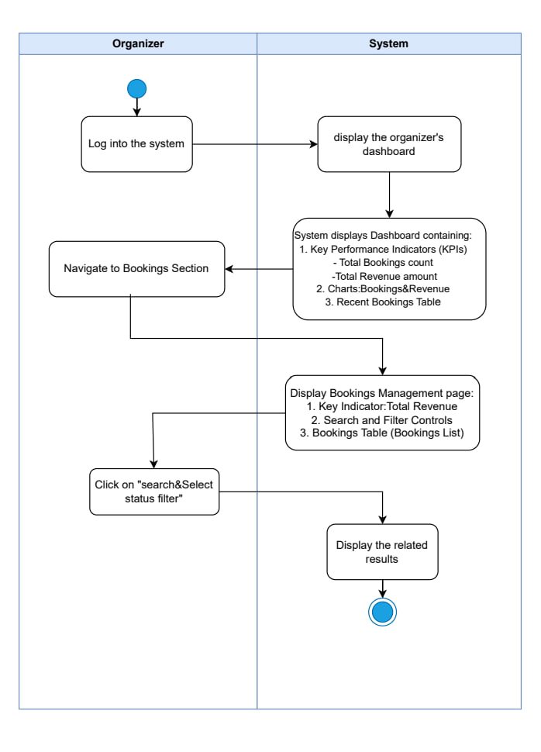

|  |  |
| --- | --- |
| **Use case name:** | Enable or Disable Event Bookings |
| **Participating Actors:** | Organizer |
| **The flow of events:** | 1. Organizer logs into the system 2. System displays the organizer's dashboard 3. Organizer navigates to Events Section 4. System displays all existing events 5. Organizer clicks on "Disable Bookings" button 6. System shows the booking status changing to "closed" 7. System sends a success notification 8. Event booking status updated |
| **Alternative flows:** | A1. Enable Bookings:   * Organizer clicks "Enable Bookings" * System changes status to "open" * Success notification sent   A2. No events available:   * System displays "No events found" message |
| **Entry condition** | 1. Organizer is authenticated 2. Event exists in the system 3. System is operational |
| **Exit conditions** | **Success:**   * Booking status changed successfully (Open/Closed) * Success notification displayed * Event updated in database   **Failure:**   * Error updating booking status * System displays error message |

**Disable/Enable Bookings**

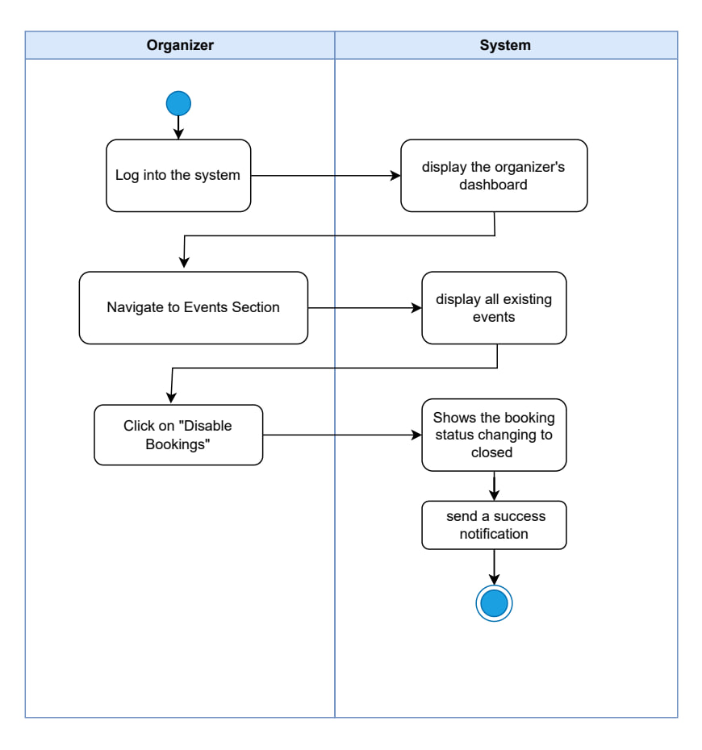

|  |  |
| --- | --- |
| **Use case name:** | Edit Existing Event or Package |
| **Participating Actors:** | Organizer |
| **The flow of events:** | **The flow of events:**  1.Organizer logs into the system  2.System displays the organizer's dashboard  3.Organizer navigates to Events Section  4.System displays all existing events  5.Organizer clicks on "Edit Event"  6.System displays the Edit Event Form with current data  7.Organizer enters edit event data:   * 1. Title   2. Type (public/hosting package)   3. Location   4. Date & Time   5. Price   6. Capacity   7. Status   8. Booking settings   8.Organizer makes a decision to update or cancel   1. If update:    1. Organizer clicks "Update Event"    2. System validates inputs    3. System sends a success notification    4. The updated event is reflected in the events table |
| **Alternative flows:** | A1. Cancel edit:   * Organizer clicks "cancel" * System returns to events list * No changes saved   A2. Invalid data:   * System displays validation error * Organizer remains on edit form   A3. Missing required fields:   * System prompts to fill required fields |
| **Entry condition** | 1.Organizer is authenticated  2.Event exists in the system  3.System is operational |
| **Exit conditions** | **Success:**   * Event updated successfully * Success notification displayed * Changes reflected in events table   **Failure:**   * Validation errors displayed * Organizer remains on edit form * No changes saved to database * System displays error message |

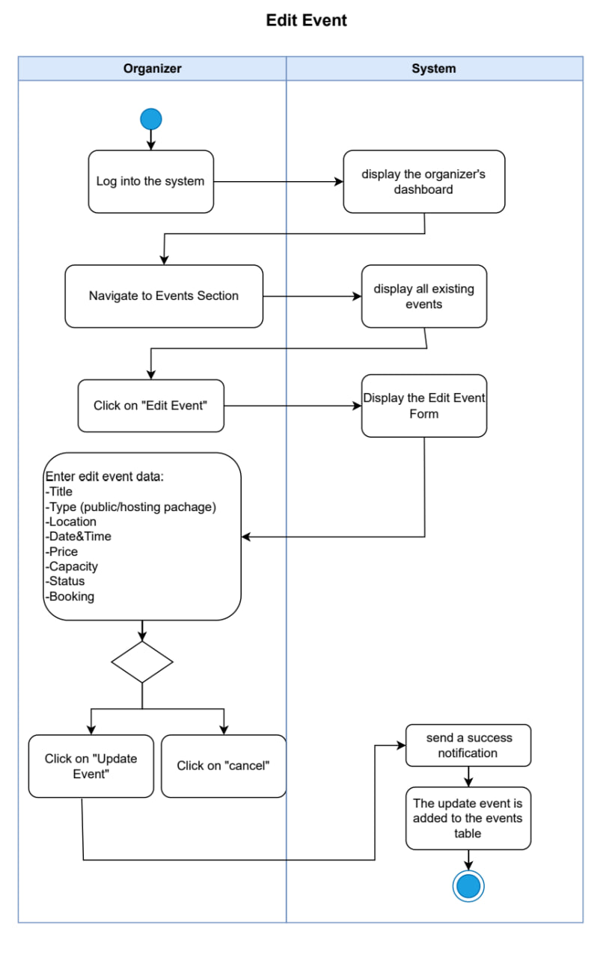

|  |  |
| --- | --- |
| **Use case name:** | Delete Event or Package |
| **Participating Actors:** | Organizer |
| **The flow of events:** | 1. Organizer logs into the system 2. System displays the organizer's dashboard 3. Organizer navigates to Events Section 4. System displays all existing events 5. Organizer clicks on "Delete Event" 6. System displays the confirm message: "Are you sure you want to delete this event?" 7. Organizer makes a decision:    * Click "cancel" to abort    * Click "Yes" to confirm deletion 8. If confirmed:    * System sends a success notification    * The event is removed from the events table |
| **Alternative flows:** | A1. Cancel deletion:   * Organizer clicks "cancel" * System returns to events list * Event remains unchanged   A2. Event has active bookings:   * System displays warning message * Organizer can still proceed with deletion (optional business rule) |
| **Entry condition** | 1. Organizer is authenticated 2. Event exists in the system 3. System is operational |
| **Exit conditions** | **Success:**   * Event deleted successfully * Success notification displayed * Event removed from database and events table   **Failure:**   * Deletion canceled by organizer * Event remains in system |

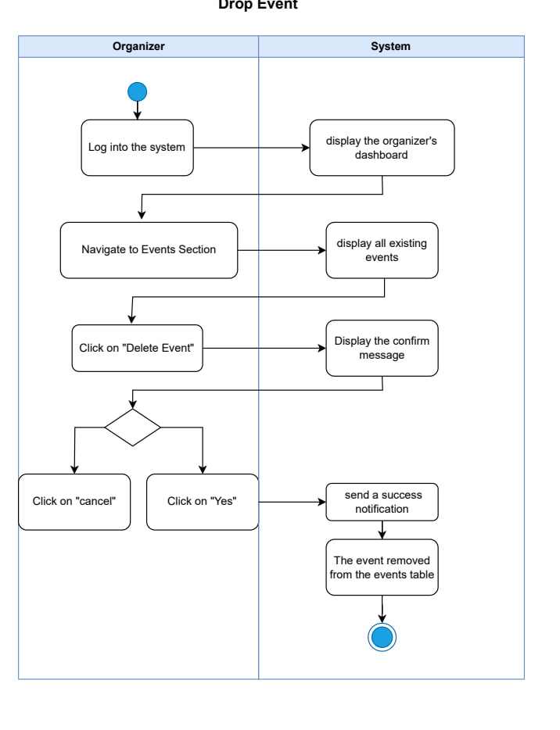

**Use Case 5: Create Event/Package**

**Use case name:**  
Create New Public Event or Host Package

**Participating Actors:**  
Organizer

**The flow of events:**

1. Organizer logs into the system
2. System displays the organizer's dashboard
3. Organizer navigates to Events Section
4. System displays all existing events
5. Organizer clicks on "Create New Event"
6. System displays Create Event Form
7. Organizer selects Event Type (Public Event or Host Package)
8. If Public Event:
   * Organizer enters: Title, Description, Location, Date (future), Time, Capacity, Ticket Price
   * Optional: Image, Supplier information
9. If Host Package:
   * Organizer enters: Title, Description, Base setup details, Location options, Package Price, Customizable elements
   * Optional: Image, Supplier information
10. Organizer clicks "Create Event" or "Cancel"
11. If submitted:
    * System validates all required fields are filled
    * System checks if date is in the future
    * System saves event to database
    * System sends success notification
    * System displays event in events list

**Alternative flows:**  
A1. Missing required fields:

* System displays error: "Please fill all required fields"
* Organizer remains on create form

A2. Past date entered:

* System displays error: "Date must be in the future"
* Organizer must correct the date

A3. Cancel creation:

* Organizer clicks "Cancel"
* System returns to events list
* No event created

**Entry condition:**

1. Organizer is authenticated
2. System is operational

**Exit conditions:**  
**Success:**

* Event/Package created successfully
* Success notification displayed
* New event visible in events list
* Event available for users to browse and book

**Failure:**

* Validation errors displayed
* Required fields missing
* Invalid date (past date)
* Organizer remains on create form
* No event created in database

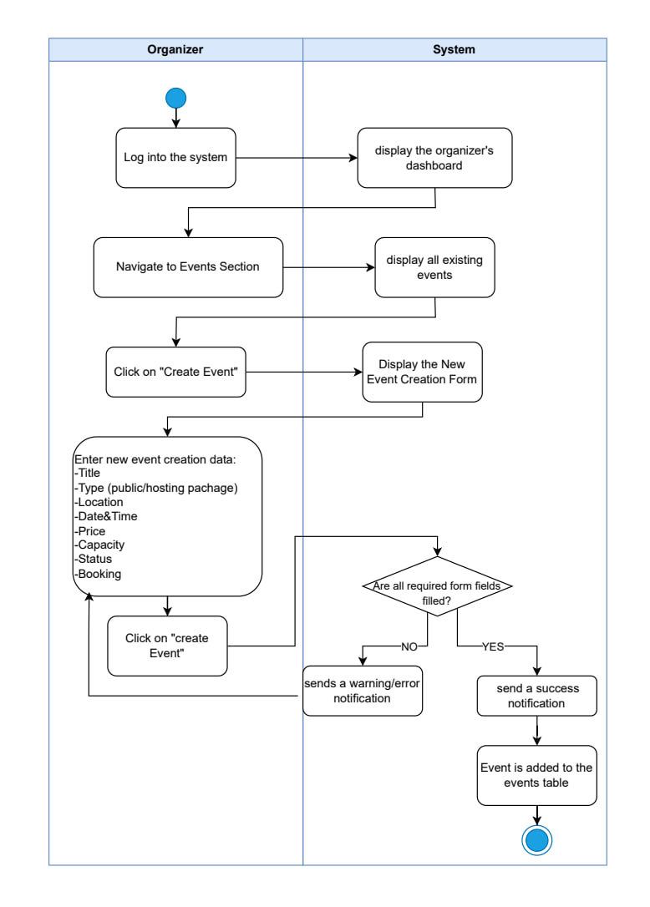



**Use Case 1: Browse Events as Visitor**

|  |  |
| --- | --- |
| **Use case name:** | Browse and View Events Without Registration |
| **Participating Actors:** | Visitor (Guest User) |
| **The flow of events:** | 1. Visitor accesses the system 2. System displays landing page with three options:    * Browse Events    * Browse Providers    * Become a Provider 3. Visitor selects "Browse Events" 4. System displays all available events without requiring login 5. Visitor uses search & filter functionality (date, location, price, type) 6. System displays filtered results 7. Visitor clicks on "View Event Details" 8. System displays full event details (description, images, capacity, price, supplier info) 9. Visitor clicks on "Book Event" 10. System checks if user is logged in 11. System displays message: "You don't have an account ID. Please login or register to book" 12. System redirects to login/register page |
| **Alternative flows:** | A1. Visitor doesn't attempt to book:   * Visitor continues browsing events * No login required   A2. Visitor is already logged in:   * System proceeds to booking flow * No login prompt displayed   A3. No events match filter:   * System displays "No events found" message |
| **Entry condition** | 1. System is operational 2. Visitor has internet access |
| **Exit conditions** | **Success:**   * Visitor can browse all events freely * Full event details displayed * Search and filter work correctly * Login prompt shown when attempting to book   **Failure:**   * No events available * System unable to load event data |

**Use Case 2: Browse Providers as Visitor**

|  |  |
| --- | --- |
| **Use case name:** | Browse Supplier Directory Without Registration |
| **Participating Actors:** | Visitor (Guest User) |
| **The flow of events:** | 1. Visitor accesses the system 2. System displays landing page with three options 3. Visitor selects "Browse Providers" 4. System displays supplier directory without requiring login 5. Visitor browses and filters supplier listings 6. Visitor clicks on "Contact Provider" 7. System navigates to provider's external website |
| **Alternative flows:** | A1. No providers match filter:   * System displays "No providers found" message   A2. External website unavailable:   * System shows error message |
| **Entry condition** | 1.System is operational  2.Providers are registered in system |
| **Exit conditions** | **Success:**   * Visitor can browse all providers freely * Filter functionality works * External website opens successfully   **Failure:**   * No providers available * External link broken |

**Use Case 3: Become a Provider (Register as Provider)**

|  |  |
| --- | --- |
| **Use case name:** | Provider Registration by Visitor |
| **Participating Actors:** | Visitor (Guest User becoming Provider) |
| **The flow of events:** | 1. Visitor accesses the system 2. System displays landing page with three options 3. Visitor selects "Become a Provider" 4. System displays Provider Registration Form 5. Visitor fills registration data:    * Business Name    * Contact Information (email, phone)    * Services Offered    * Business Description    * Other required details 6. Visitor clicks "Submit" 7. System validates registration data 8. If valid:    * System creates provider account    * System sends confirmation email    * System displays success message |
| **Alternative flows:** | A1. Invalid or missing data:   * System displays validation error message * Visitor must correct errors * Visitor remains on registration form   A2. Email already registered:   * System displays "Email already exists" error * Visitor must use different email   A3. Visitor cancels registration:   * Visitor clicks "Cancel" * System returns to landing page * No account created |
| **Entry condition** | 1.System is operational  2.Visitor wants to become a provider |
| **Exit conditions** | **Success:**   * Provider account created successfully * Confirmation email sent * Visitor can now login as provider   **Failure:**   * Validation errors displayed * Missing required fields * Email already exists * No account created |

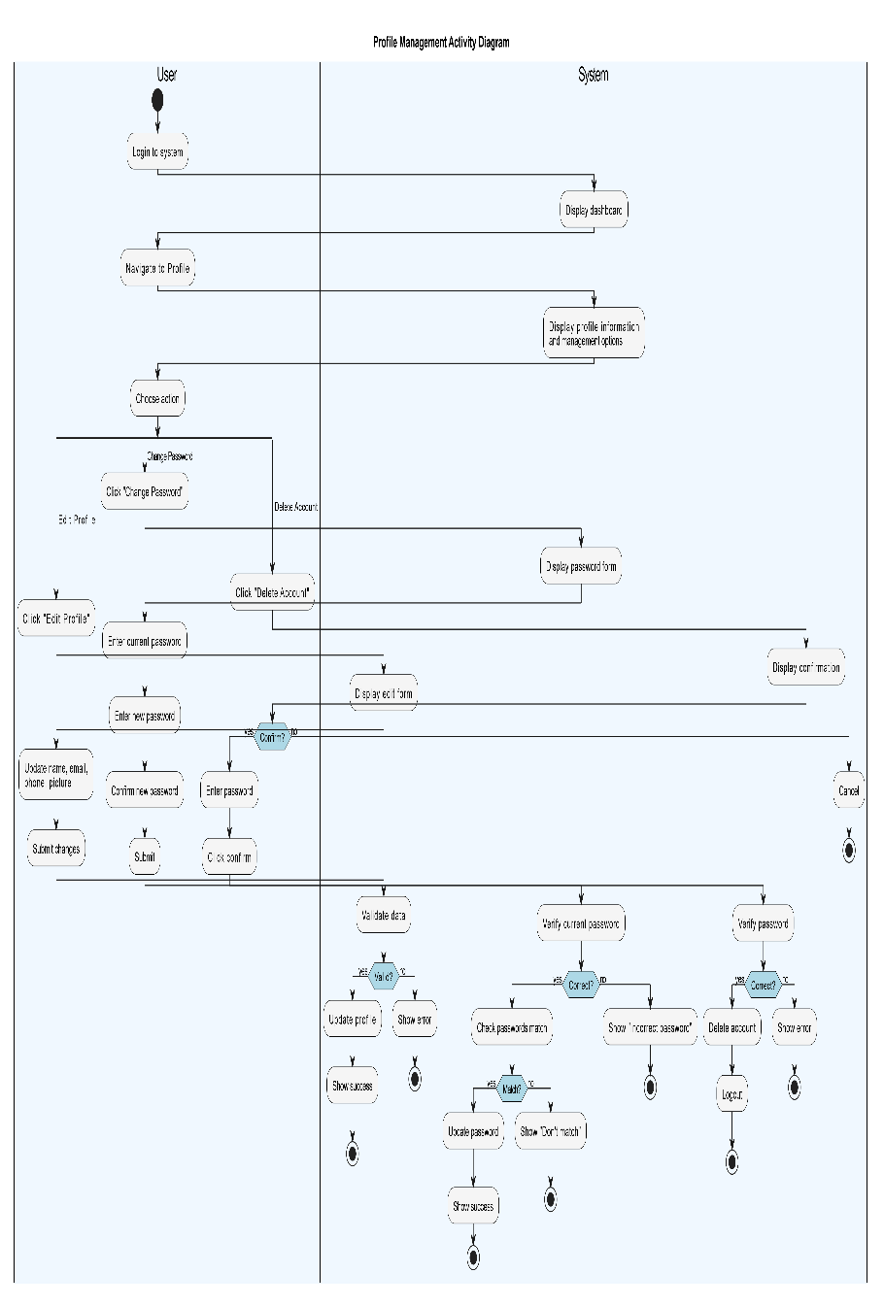

**Use Case Specification: Profile Management**

**Use Case 1: Edit Profile**

|  |  |
| --- | --- |
| **Use case name:** | Edit User Profile Information |
| **Participating Actors:** | User/Attendee |
| **The flow of events:** | 1. User logs into the system 2. System displays dashboard 3. User navigates to Profile 4. System displays profile information and management options 5. User clicks "Edit Profile" 6. System displays edit form with current information 7. User updates information:    * Name    * Email    * Phone number    * Profile picture 8. User submits changes 9. System validates data 10. System updates profile information 11. System displays success message |
| **Alternative flows:** | A1. Invalid data entered:   * System displays validation error * User must correct errors * User remains on edit form   A2. Email already exists:   * System displays "Email already in use" error * User must use different email   A3. User cancels edit:   * System returns to profile page * No changes saved |
| **Entry condition** | 1. User is authenticated and logged in 2. System is operational |
| **Exit conditions** | **Success:**   * Profile information updated successfully * Success message displayed * Updated information visible in profile   **Failure:**   * Validation errors displayed * Invalid data entered * No changes saved to database |

**Use Case 2: Change Password**

|  |  |
| --- | --- |
| **Use case name:** | Edit User Profile Information |
| **Participating Actors:** | User/Attendee |
| **The flow of events:** | 1. User logs into the system 2. System displays dashboard 3. User navigates to Profile 4. System displays profile information and management options 5. User clicks "Change Password" 6. System displays password change form 7. User enters current password 8. User enters new password 9. User confirms new password 10. User clicks "Submit" 11. System verifies current password is correct 12. System checks if new passwords match 13. System updates password in database 14. System displays success message |
| **Alternative flows:** | A1. Current password incorrect:   * System displays error: "Incorrect current password" * User must enter correct current password * User remains on password form   A2. New passwords don't match:   * System displays error: "Passwords don't match" * User must re-enter matching passwords * User remains on password form   A3. New password doesn't meet requirements:   * System displays validation error * User must enter valid password   A4. User cancels:   * System returns to profile page * Password remains unchanged |
| **Entry condition** | 1. User is authenticated and logged in 2. System is operational |
| **Exit conditions** | **Success:**   * Password updated successfully * Success message displayed * User can login with new password   **Failure:**   * Current password incorrect * New passwords don't match * Validation errors displayed * Password remains unchanged |

|  |  |
| --- | --- |
| **Use case name:** | Delete User Account |
| **Participating Actors:** | User/Attendee |
| **The flow of events:** | 1. User logs into the system 2. System displays dashboard 3. User navigates to Profile 4. System displays profile information and management options 5. User clicks "Delete Account" 6. System displays confirmation dialog with warning message 7. User confirms deletion 8. System prompts user to enter password for confirmation 9. User enters password 10. User clicks "Confirm Delete" 11. System verifies password is correct 12. System deletes user account 13. System deletes all associated user data 14. System logs out user 15. System displays success message or redirects to homepage |
| **Alternative flows:** | A1. User cancels deletion:   * User clicks "Cancel" on confirmation dialog * System returns to profile page * No account deletion occurs   A2. Incorrect password entered:   * System displays error: "Incorrect password" * User must enter correct password * Account not deleted   A3. User has active bookings:   * System displays warning about active bookings * User can still proceed or cancel (business rule dependent) |
| **Entry condition** | 1. User is authenticated and logged in  2. System is operational   1. User has valid account |
| **Exit conditions** | **Success:**   * User account deleted successfully * All user data removed from database * User logged out automatically * Success message displayed   **Failure:**   * Incorrect password entered * User cancels deletion * Account remains active * User remains logged in |

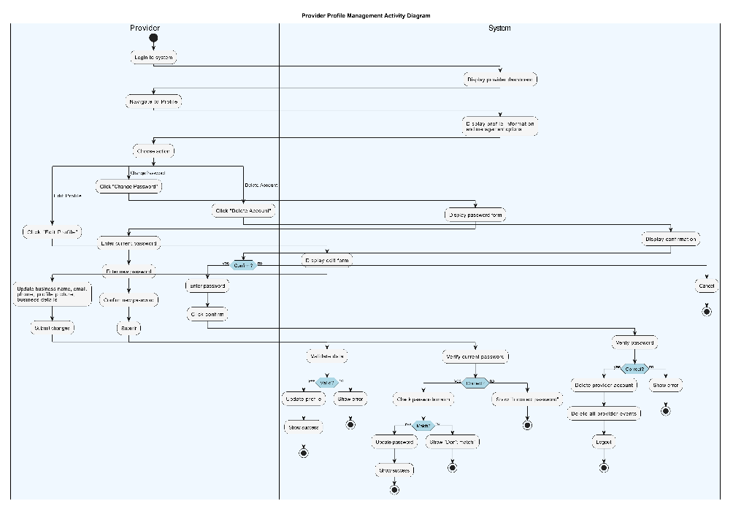

**Chapter 5: System Design**

**1.System Initial Design**

In order to design the backend architecture of a robust and scalable web application like the Alternative Energy Management System, developed using Java Spring Boot, Firebase, and ReactJS, a properly designed architectural pattern needs to be applied. The applied architecture for the backend is the Layered (N-Tier) Architecture with Modularized Microservice Principles.

**1.Selected Architecture: Layered Architecture with Modularized Services**

**Definition:** The Layered Architecture, or N-Tier Architecture, structures the backend into tiers where each tier is intended to address a given concern. Shared tiers are:

1. **Presentation Layer (Controller)** – Takes care of processing HTTP requests and forwarding them to service layer actions.
2. **Service Layer (Business Logic)** – Stores intrinsic logic, verifications, and rules that rule the application.
3. **Data Access Layer (Repository)** – Manages database interaction (Firebase in our case here).
4. **Model Layer (Entities/DTOs)** – Made up of data structures that are passed between layers.

Modularization in spirit of microservice architecture is performed in this pattern to maintain the core domains such as SolarPanelService, DeviceService, UserService, etc., decoupled, even when there is a monolithic Spring Boot application.

**Why This Architecture?**

1. **Separation of Concerns**

* Clean decoupling between web processing (controllers), business logic (services), and database operations (repositories) results in better maintainability and testability.
* Each module (e.g., user, devices, solar panel) can evolve independently with minimal side effects.

1. **Scalability**

* Even though the system begins as a monolith, services are designed to be modular and can then scale out into individual microservices if needed (e.g., running SolarPanelService independently).
* Firebase enables easy real-time data updates and scalability for some data types (alerts, user preferences, etc.).

1. **Spring Boot Compatibility**

* Spring Boot inherently supports layer-based architecture and dependency injection and is therefore an ideal choice.
* Developers like Spring Security, Bean Validation, and integration with Firebase using Spring Cloud GCP libraries are supported easily.

1. **Security and Validation**

* Input validation (email, voltage, power) can be imposed both at DTO (Data Transfer Object) and service layers by using annotations (@Valid, @NotNull, @Min, etc.).
* Authentication and role-based access are managed using Spring Security and Firebase Authentication.

1. **Maintainability and Extensibility**

* Services such as EnergyAnalysisService, NotificationService, and RecommendationEngineService encapsulate logic and are future extension-friendly without impacting other parts of the application.
* Future extension with AI engines or third-party APIs (e.g., solar forecast using weather) is easy.

1. **Firebase Integration**

* Firebase Firestore (NoSQL) integrates nicely with Spring Boot using Firebase Admin SDK.
* Services can have custom DAOs or Firebase utility classes to encapsulate Firebase's query and update data logic.
* Firebase's capabilities of real-time can be utilized to refresh dashboards in real time.

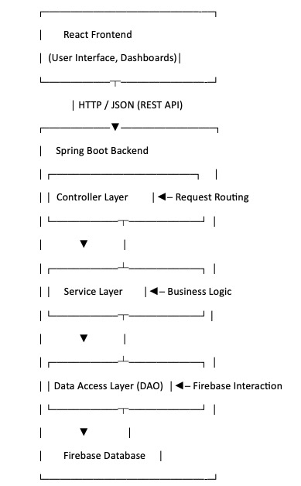**2.System Architecture:**

Figure 15:system architecture

**3.Class diagram:**

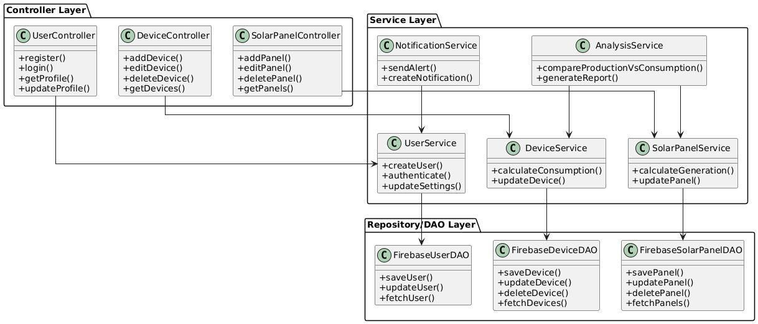

Figure 16:class diagram in high level

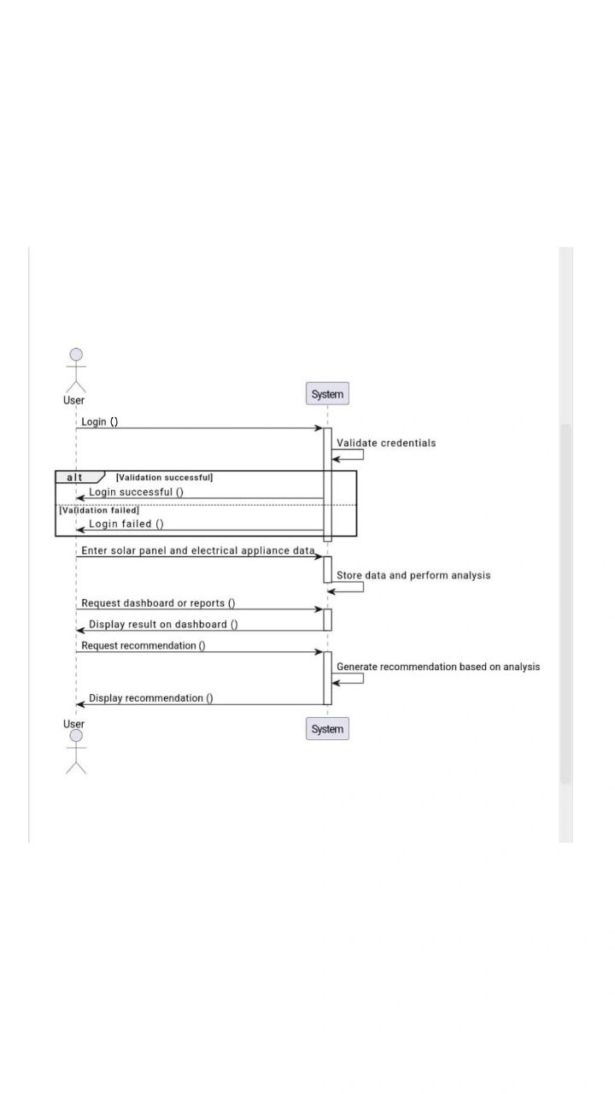**4.Sequence diagram**

Figure 17:sequence diagram in high level

**2.Detailed Design**

**1.Introduction:**

This section presents the detailed design of the system by providing an in-depth representation of its internal components. It focuses on outlining the software structure and database architecture using diagrams that describe the relationships and interactions among different elements of the system.

**2.Purpose :**

The purpose of the Detailed Design section is to translate the system’s functional requirements into clear, technical structures that guide the development process. This section defines how each part of the system will be implemented and how different components interact with each other. The included diagrams help organize the codebase. This level of design is essential for building a robust, scalable, and maintainable application.

**3.functonal Requirements:**

**1. User Management Functional Requirements:**

|  |  |  |  |  |
| --- | --- | --- | --- | --- |
| **Requirements ID** | **Description** | **Module** | **Priority** | **Detailed Specification** |
| **REQ-FR-UM-01** | New user account creation | User Management | High | • Collects user name and email • Validates email format • Enforces strong password policy (8+ chars, upper/lower case, numbers) |
| **RQ-FR-UM-02** | User login | User Management | High | •Verifies email and password • Authenticates credentials against stored data |

**3.3.1.4 Sequence Diagram for signup &login**

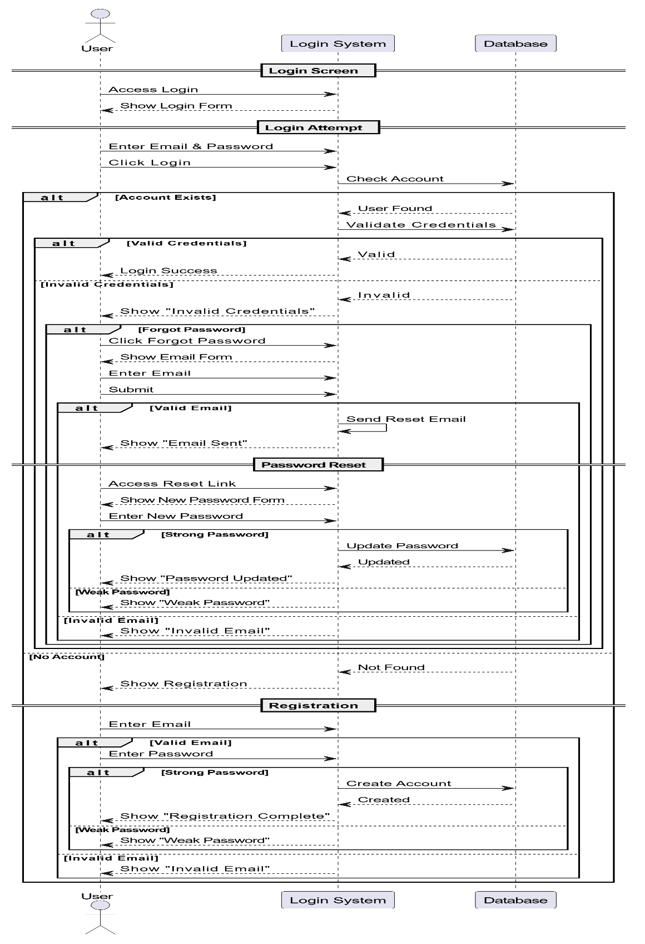

Figure 18:sequence diagram for signup&login

**2.Solar Panel Management - Functional Requirements**

**Solar Panel CRUD Operations**

|  |  |  |  |  |
| --- | --- | --- | --- | --- |
| **Requirements ID** | **Description** | **Module** | **Priority** | **Detailed Specification** |
| REQ-FR-SPM-03 | Add new solar panel | Solar Panel Management | High | **Input Fields:** • Panel type (dropdown) • Technical specs (voltage, current, efficiency, quantity, tilt/direction) • Location (dropdown) |
| REQ-FR-SPM-04 | Modify solar panel data | Solar Panel Management | High |  |
| REQ-FR-SPM-05 | Delete solar panel | Solar Panel Management | High | **Confirmation:** • System shall show a confirmation dialog before deletion |

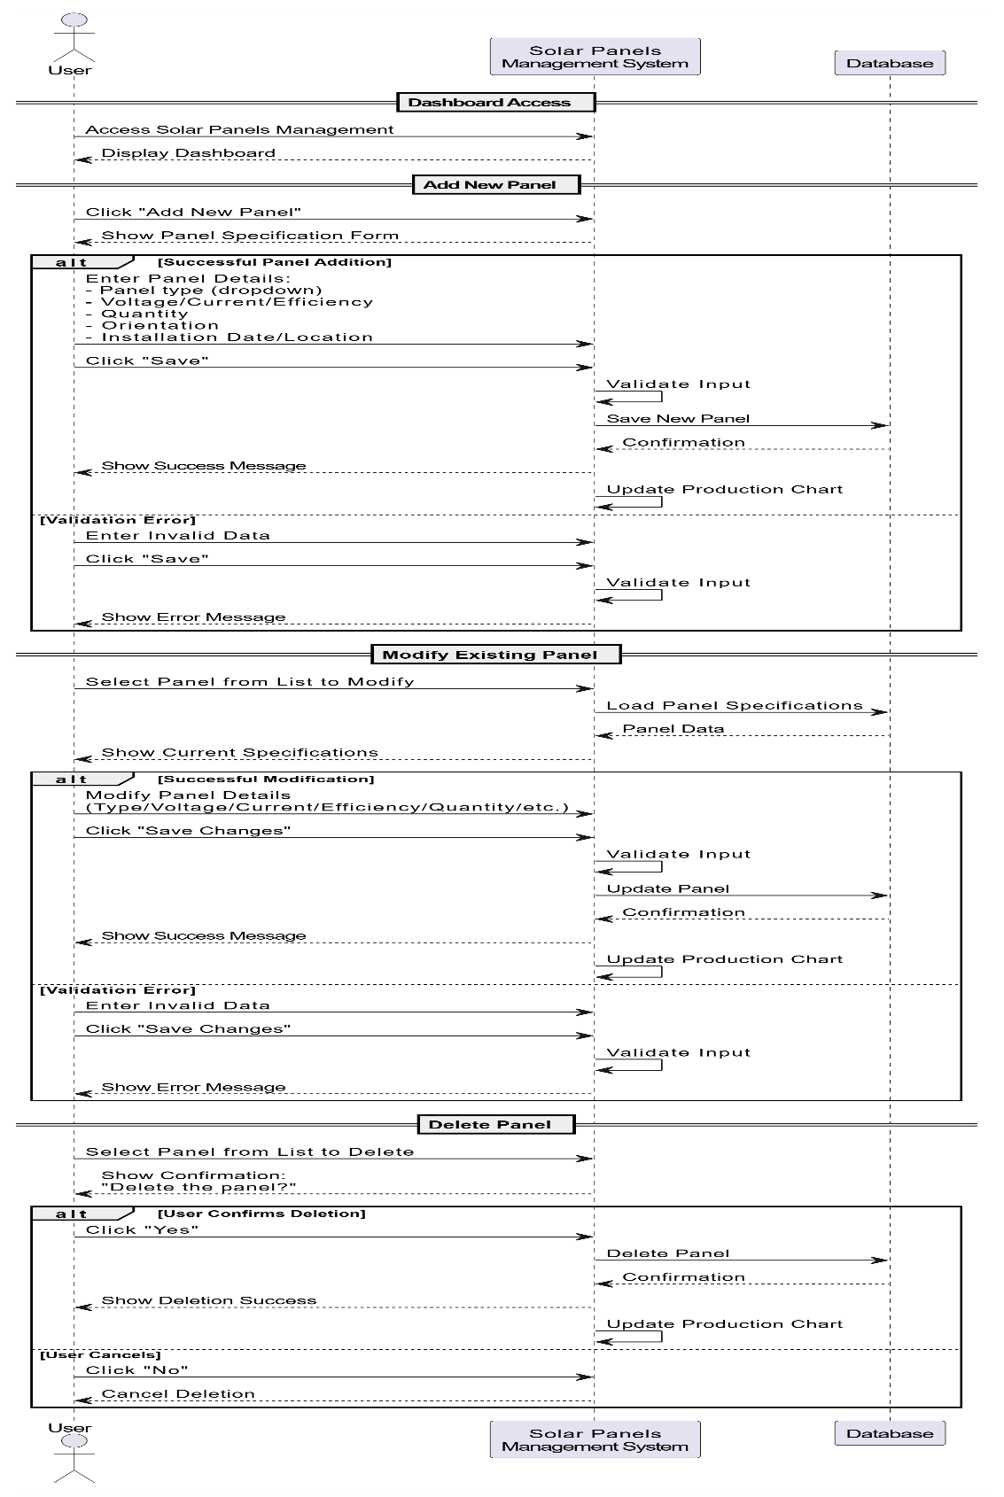**3.3.2.4 Sequence Diagram**:

Figure 19:sequence diagram for solar energy management

**3.Electrical Device Management - Functional Requirements**

**Solar Panel CRUD Operations**

|  |  |  |  |  |
| --- | --- | --- | --- | --- |
| **Requirements ID** | **Description** | **Module** | **Priority** | **Detailed Specification** |
| **REQ-FR-EDM-06** | Add new electrical device | Electrical Device Management | High | **Input Fields:** • Category (dropdown) • Technical specs (Brand& Model, power, usage hours) • priority (dropdown) |
| **REQ-FR-EDM-07** | Modify electrical device | Electrical Device Management | High |  |
| **REQ-FR-EDM-08** | Delete electrical device | Electrical Device Management | High | **Confirmation:** • System shall show a confirmation dialog before deletion |

**3.3.2.4Sequence diagram for Electrical Devices Management**

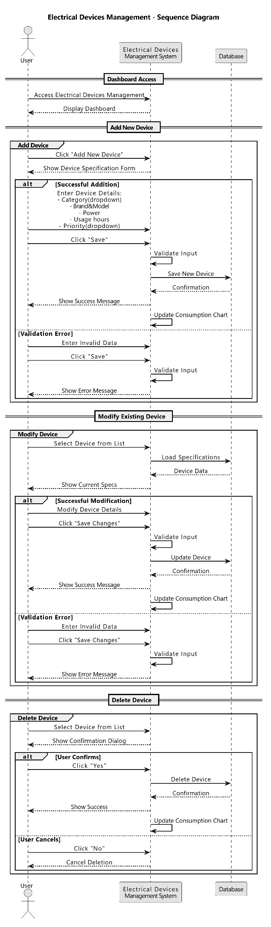

Figure 20:sequence diagram for electrical devices management

**.Solar Energy Management - Functional Requirement**

|  |  |  |  |  |
| --- | --- | --- | --- | --- |
| **Requirements ID** | **Description** | **Module** | **Priority** | **Detailed Specification** |
| REQ-FR-SED-01 | Display energy production vs consumption chart | Solar Energy Dashboard | High | System shall display a comparative chart of energy production and consumption when the user accesses the dashboard. |
| REQ-FR-SED-02 | Select time filter for energy chart | Solar Energy Dashboard | Medium | User can click to filter the chart by: daily, weekly, or monthly. System updates the chart accordingly. |
| REQ-FR-SED-03 | Display top energy consuming devices | Analysis | High | When user selects "analysis devices", system shall display the devices with the highest consumption. |
| REQ-FR-SED-04 | Generate energy saving recommendations | Recommendation & Insight | Medium | System shall generate personalized energy saving tips when the user selects the recommendation & insight option. |
| REQ-FR-SED-05 | View consumption reports | Reports | High | User selects daily/weekly/monthly report, and system displays report accordingly. |
| REQ-FR-SED-06 | Allow user to continue operations | System Navigation | Low | After completing any action, user can continue to perform other operations in the system. |

**4.3.2.4Sequence diagram for Solar Energy Management**

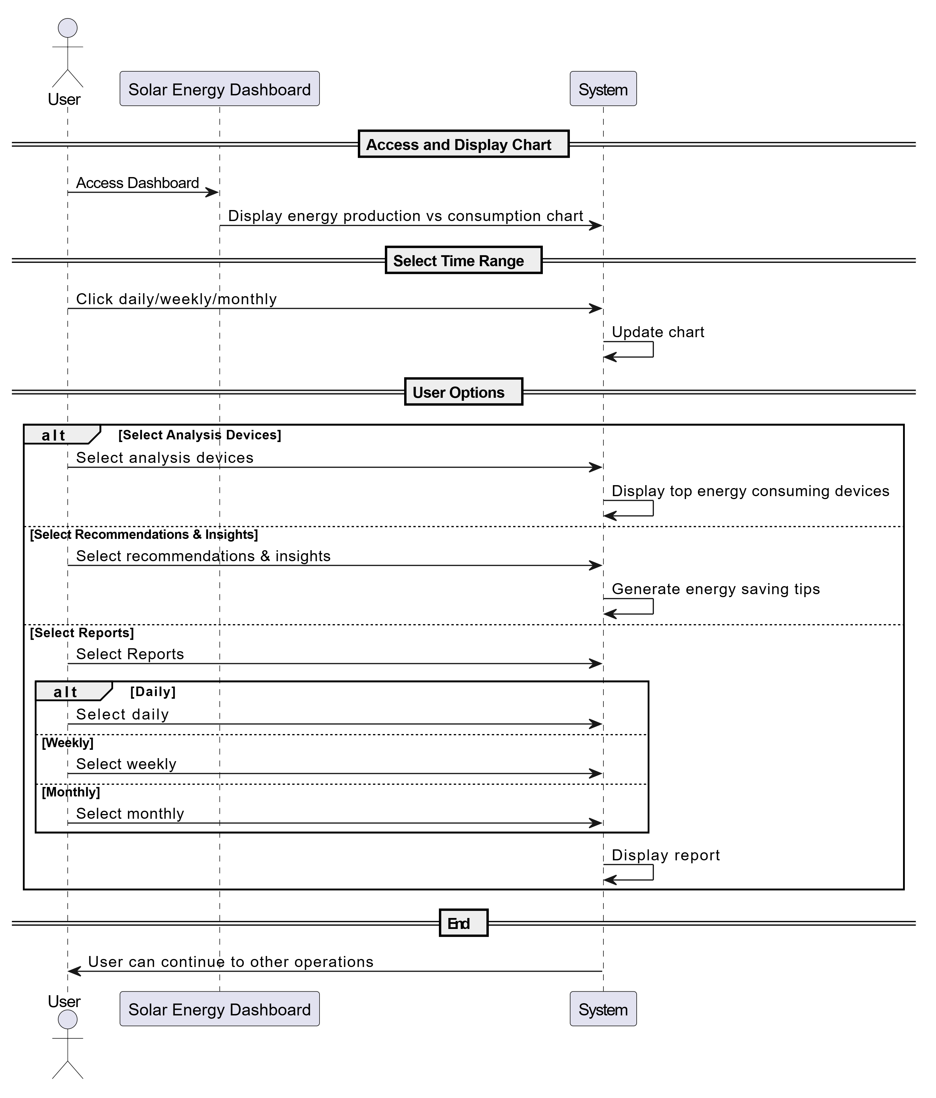

Figure 21:sequence diagram for solar energy dashboard

**5. User Profile Management- Functional Requirement**

|  |  |  |  |  |
| --- | --- | --- | --- | --- |
| **Requirements ID** | **Description** | **Module** | **Priority** | **Detailed Specification** |
| **REQ-FR-UPM-01** | View user profile dashboard | User Profile Management | High | Upon accessing the profile, the system shall display a dashboard with three main sections:  -Personal Information  - Security Settings  - Notification Preferences |
| **REQ-FR-UPM-02** | Update personal information | User Profile Management | High | **Fields to display:**  -Full name  - Email  - Location(dropdown) |
| **REQ-FR-UPM-03** | Update password | User Profile Management | High | **Fields:**  - Current password  - New password  - Confirm new password |
| **REQ-FR-UPM-04** | Manage notification preferences | User Profile Management | Medium | **Options:**  **-**Low production warnings  -Overconsumption alerts  -Weekly energy reports  -Monthly energy reports |

**5.3.2.4Sequence diagram for User Profile Management**

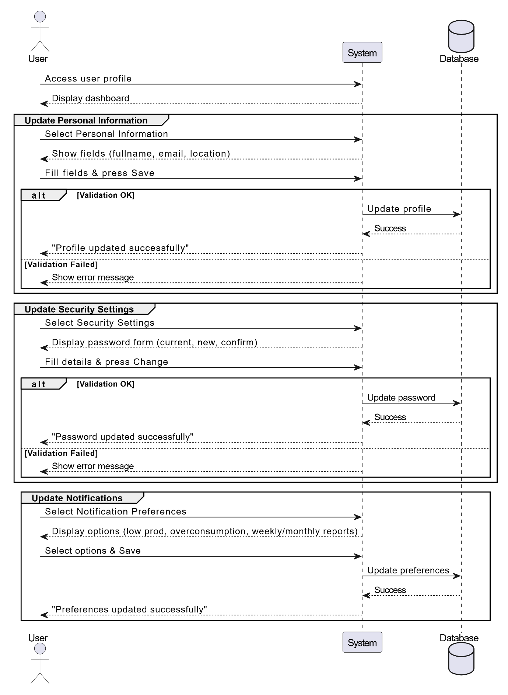

Figure 22:sequence diagram for user profile management

**4.System Class Diagram**

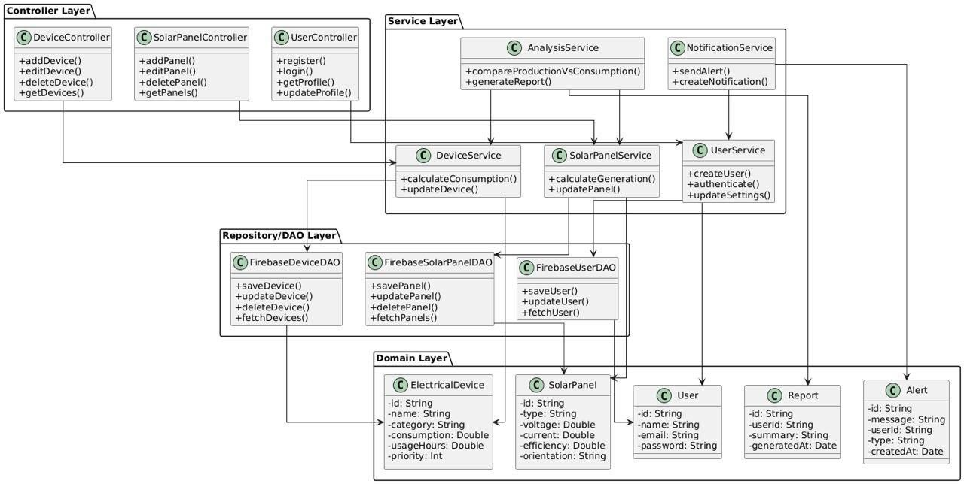

Figure 23 : class diagram

1. **ERD - Entity-Relationship Diagram**

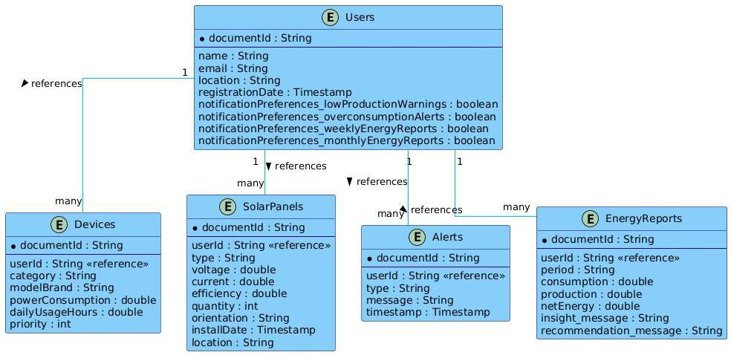

Figure 24:ERD diagram

**3.Requirement Trackability Matrix (RTM) (V.3)**

|  |  |  |  |  |  |  |  |  |
| --- | --- | --- | --- | --- | --- | --- | --- | --- |
| **Requirement ID** | **Title** | **Use Case** | **System Design** | **Analysis** | **Detailed Design** | **Coding** | **Test Cases** | **Change log** |
| REQ-FR-01 | The system should allow creating a new user account | UC-01 |  |  |  |  |  |  |
| REQ-FR-02 | The system should allow secure user login | UC-01 |  |  |  |  |  |  |
| REQ-FR-03 | User can add new solar panels | UC-02 |  |  |  |  |  |  |
| REQ-FR-04 | User can modify solar panel data | UC-02 |  |  |  |  |  |  |
| REQ-FR-05 | User can delete solar panels | UC-02 |  |  |  |  |  |  |
| REQ-FR-06 | User can add electrical devices | UC-03 |  |  |  |  |  |  |
| REQ-FR-07 | User can modify electrical devices | UC-03 |  |  |  |  |  |  |
| REQ-FR-08 | User can delete electrical devices | UC-03 |  |  |  |  |  |  |
| REQ-FR-09 | Validate numerical inputs | UC-02, UC-03 |  |  |  |  |  |  |
| REQ-FR-10 | Calculate solar energy production | UC-04 |  |  |  |  |  |  |
| REQ-FR-11 | Calculate total energy consumption | UC-04 |  |  |  |  |  |  |
| REQ-FR-12 | Display production vs consumption | UC-04 |  |  |  |  |  |  |
| REQ-FR-13 | Display main dashboard | UC-04 |  |  |  |  |  |  |
| REQ-FR-14 | Generate detailed reports | UC-04 |  |  |  |  |  |  |
| REQ-FR-15 | Send automatic alerts | – |  |  |  |  |  | This requirement has been deleted. |

|  |  |  |  |  |  |  |  |  |
| --- | --- | --- | --- | --- | --- | --- | --- | --- |
| REQ-FR-16 | Provide energy saving recommendations | UC-04 |  |  |  |  |  |  |
| REQ-FR-17 | View user profile page | UC-05 |  |  |  |  |  |  |
| REQ-FR-18 | Update personal information | UC-05 |  |  |  |  |  |  |
| REQ-FR-19 | Change password | UC-05 |  |  |  |  |  |  |
| REQ-FR-20 | Manage notification preferences | UC-05 |  |  |  |  |  | This requirement has been added |
| REQ-21 | The system shall correctly display either an error message or a success notification. |  |  |  |  |  |  | This requirement has been added. |
| REQ-NFR-01 | The system should respond quickly to user requests |  |  |  |  |  |  |  |
| REQ-NFR-02 | Sensitive information must be encrypted |  |  |  |  |  |  |  |
| REQ-NFR-03 | Secure authentication must be enforced for users |  |  |  |  |  |  |  |
| REQ-NFR-04 | The system must support a growing number of users/events |  |  |  |  |  |  |  |
| REQ-NFR-05 | The system must support multiple languages |  |  |  |  |  |  | This requirement has been deleted. |
| REQ-NFR-06 | The website must be available 24/7 with minimal downtime |  |  |  |  |  |  |  |

Table 29:RTM V.3

**7.Summary**

In this chapter, we focused on designing the system in a clear and organized way. We chose a layered architecture where each layer handles specific tasks like handling requests, business logic, and database interaction. This separation makes the system easier to maintain and extend.

We divided the system into smaller modules such as solar panel management, electrical devices, and energy analysis, each working independently but connected within the system.

We used modern technologies like Java Spring Boot with Firebase and React to build a secure, responsive, and scalable system.

We created diagrams showing how different components interact, which helps developers understand and build the system efficiently.

Finally, we clearly defined the requirements for each part and linked them to design, implementation, and testing processes to ensure the system’s quality and completeness.

**Chapter6: Implementation**

**1.Introduction**

This section provides a visual overview of the system's core interfaces through a series of detailed screenshots. These screenshots help illustrate the overall design of key interactive elements and explain how different user groups, including regular users, event organizers, and service providers, interact with the system. This contributes to enhanced usability and a seamless, efficient user experience.

**2.Purpose:**

This section aims to visually review the core interfaces of the Events and Activities Planning Platform System, explaining the principles upon which their design is based. By presenting screenshots with brief descriptions of each interface, the expected user experience is clarified, the most important interactive elements are highlighted, and how these interfaces support interaction between users, organizers, and service providers with the system's various functions are explained. This also allows stakeholders to understand the system's visual design and provide constructive feedback for its improvement.

**3.User Interfaces**

**1.Sign in**

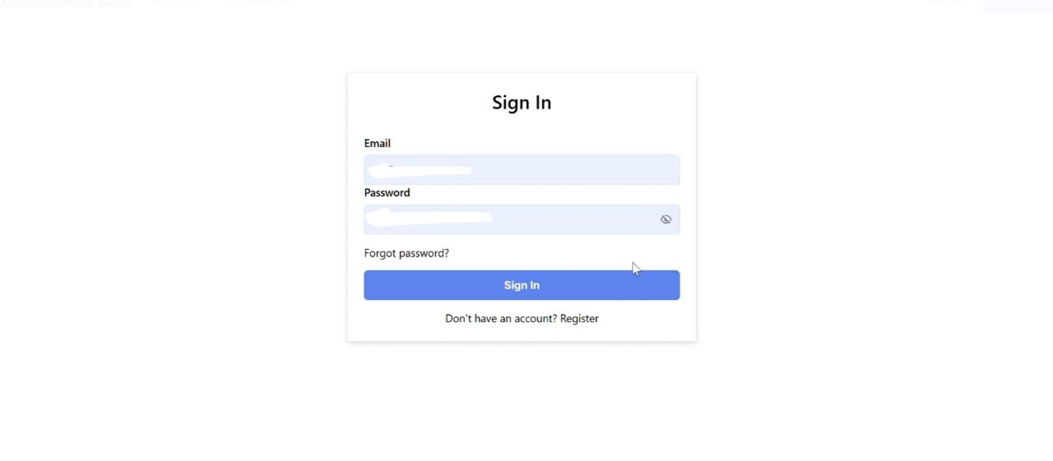

Figure 25:Sign in interface<<1>>

**2.** **New Register** **For User**

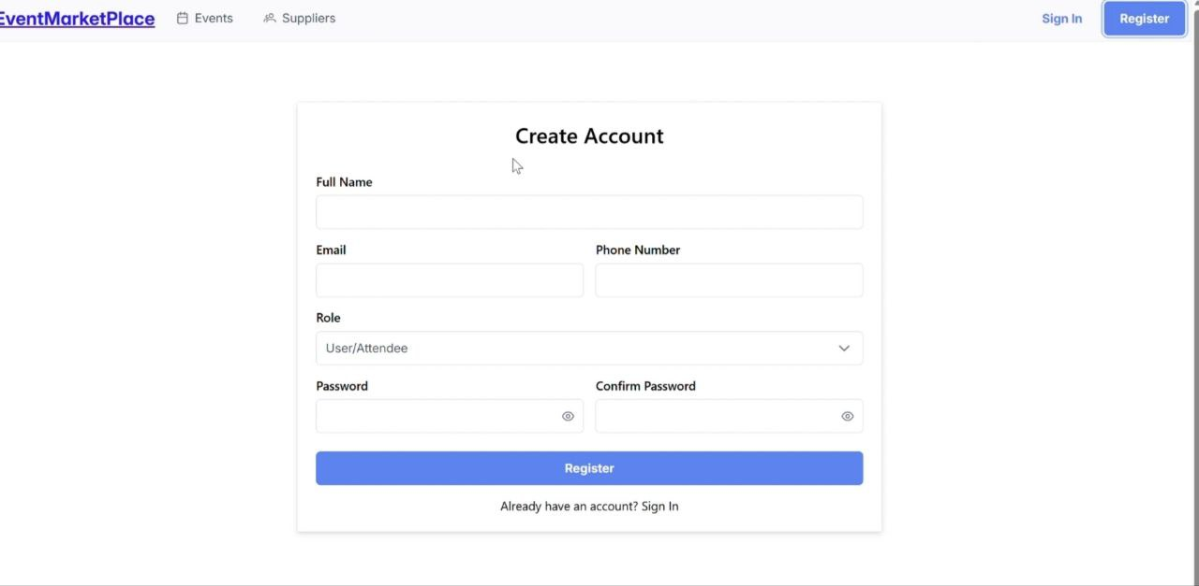

Figure 26:New Register For User <<2>>

**3.** **New Register** **For Supplier**

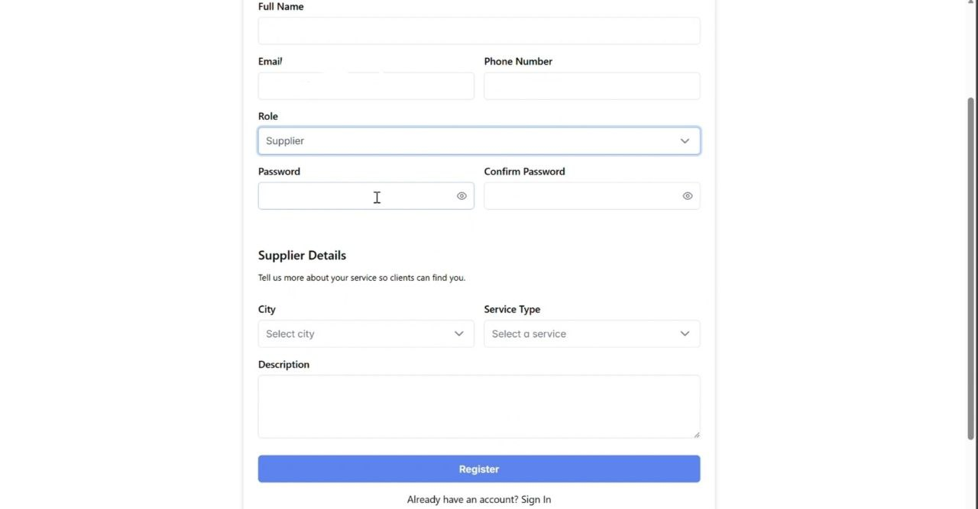

Figure 27 :New Register For Supplier<<3>>

**4. Dashboard For Organizer**

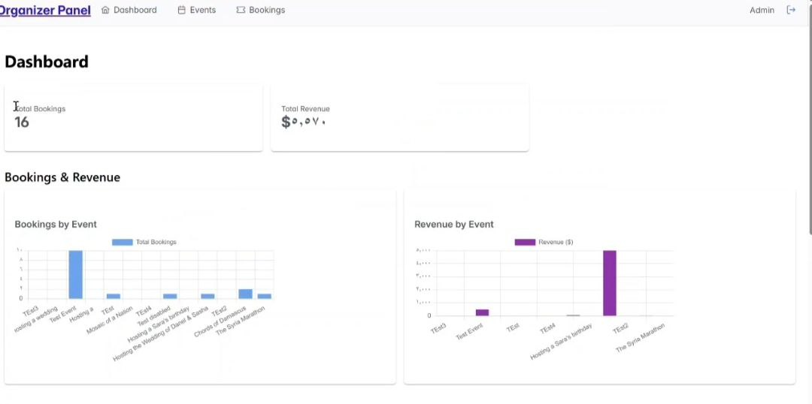

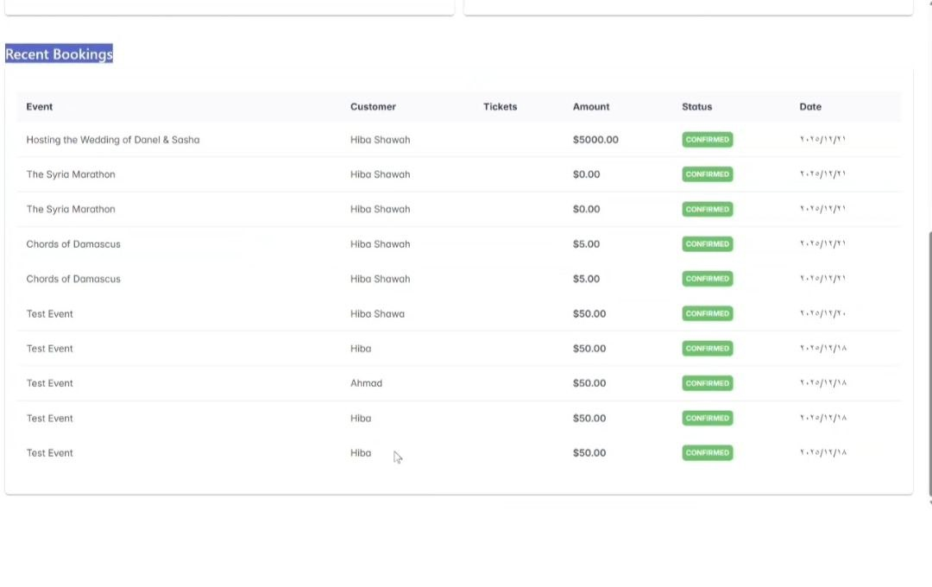

Figure 28:Dashboard For Organizer <<4>>

**5. Dashboard For Supplier**

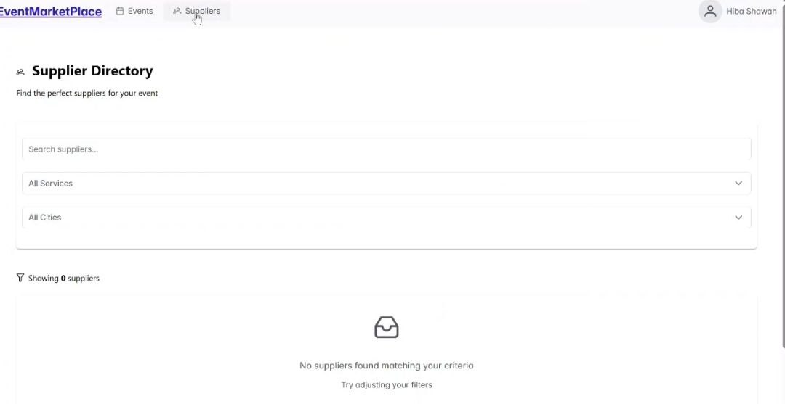

Figure 29:Dashboard For Supplier<5>>

**6.Create New Event**

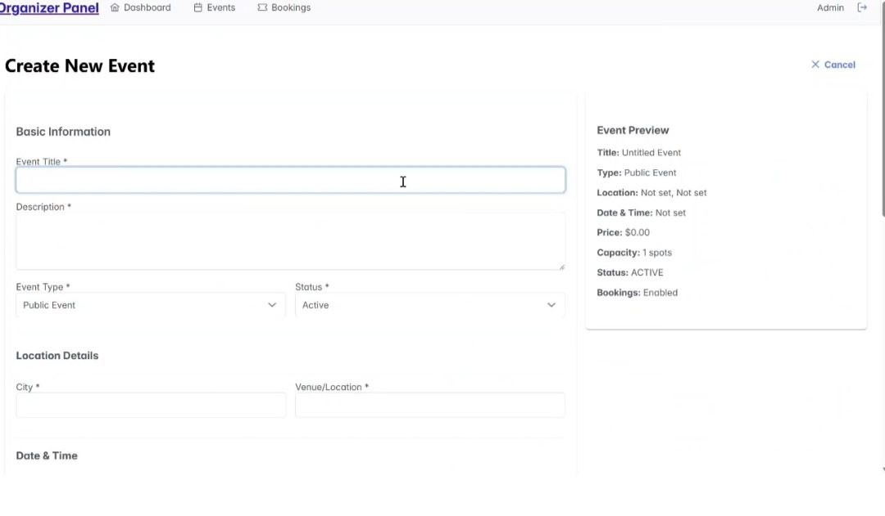

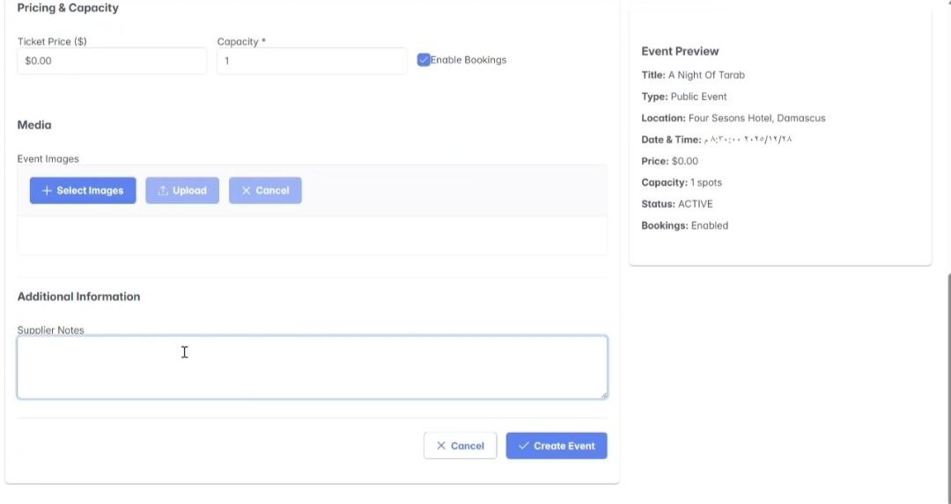

Figure 30 :Create New Event <<6>>

**7.Edit Events**

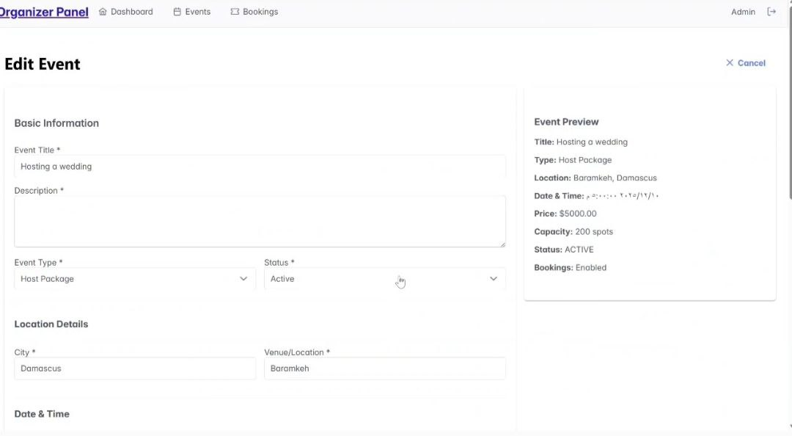

Figure 31:Edit Events <<7>>

**8.Manage Events**

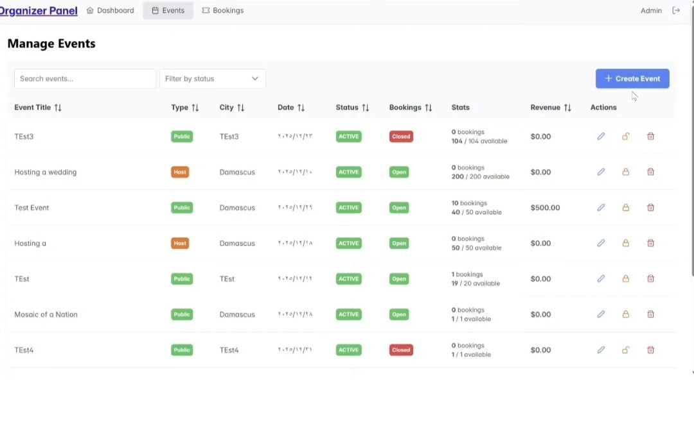

Figure 32 : Manage Events<<8>>

**9.Booking Management**

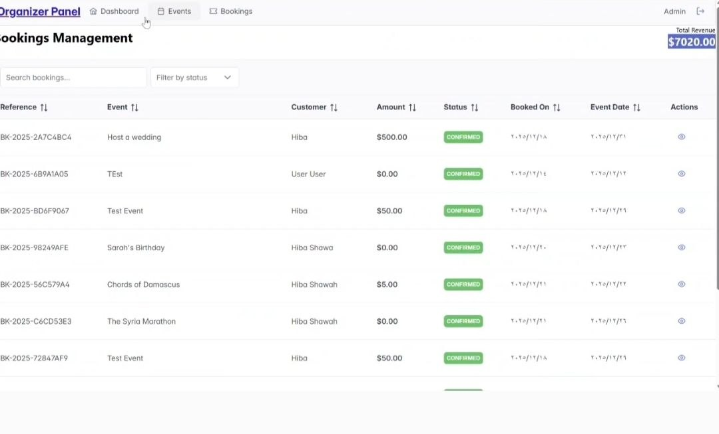

Figure 33:Booking Management <<9>>

**10.My Bookings**

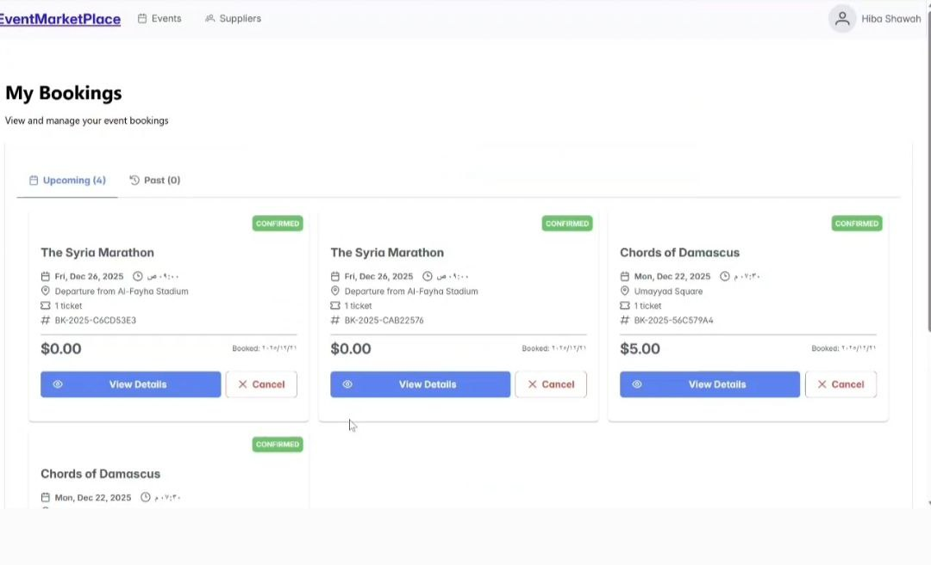

Figure 34: My Bookings <<10>>

**11.User Profile**

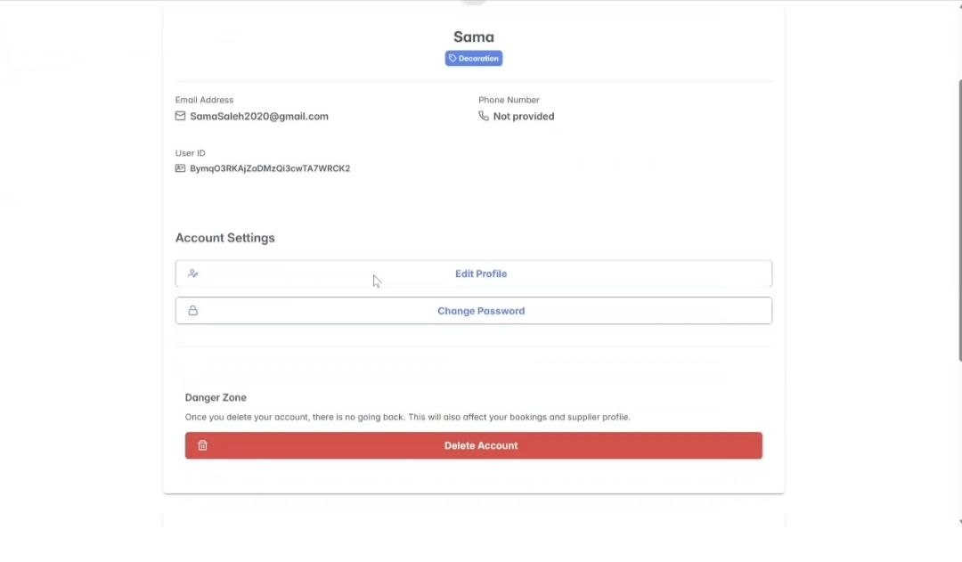

Figure 35:User Profile<<11>>

**4. REST API Documentation –** **Events and Activities Planning Platform System System**

**4.1.Introduction**

**4.1. Introduction**

This document provides a comprehensive reference for the RESTful APIs of the Events and Activities Planning Platform. This platform is designed to support efficient event management and organization by enabling event organizers to create public invitations, organize public and private events, and manage associated bookings. Service providers, on the other hand, are limited to creating a profile to showcase their information and services within the platform, without managing events or other content. These APIs allow third-party applications, such as web or mobile apps, to interact with the system to perform a range of essential tasks, including registering users, organizers, and providers; creating and managing invitations and events of various types; and processing bookings. The platform also provides visual graphs illustrating booking and revenue metrics for each event, supporting an understanding of event performance without relying on detailed analytical reports.

**4.2.Purpose**

The purpose of this documentation is to explain how to use each API endpoint in the system, including their paths, HTTP methods, required parameters, and the structure of both requests and responses. This aims to make integration easier and to ensure that the system is used properly and efficiently by developers and technical teams.

**4.3.API Structure Overview**

The APIs in this system are systematically categorized into four main sections. Each section is responsible for a specific component of Events and Activities Planning Platform System. This modular organization makes it easier for developers to navigate and utilize the APIs based on their intended functionality:

|  |  |
| --- | --- |
| **Section** | **Primary Function** |
| **SupplierController** | Manages supplier profiles linked to existing users, including operations to register a new supplier, retrieve supplier information by user ID, update supplier details, and delete supplier profiles. |
| **EventController** | Manages event operations, including creation, retrieval, updating, deletion, and booking management, providing full event lifecycle control. |
| **BookingController** | Handles event bookings by allowing users to create, view, and cancel bookings, while managing booking and payment information. |
| **DashboardController** | Aggregates event and booking data to provide dashboard statistics, including bookings, capacity, revenue, and recent booking activity. |
| **AuthenticationController** | Manages user authentication and profile operations, including user registration, identity verification via Firebase, profile updates with optional profile picture upload, and permanent account deletion. |

Table 30:API Structure

**1. SupplierController API Documentation:**

**1.1. Register New Supplier**

- **Endpoint:** /api/Supplier

- **Method:** POST

- **Description**: Registers a new supplier profile. The supplier information is linked to an existing user account.

- **Parameters:** None

- **Request Body**:{

"userId": "string",

"description": "string",

"serviceType": "enum",

"city": " string ",}

In addition: The name, email, and phoneNumber fields are automatically populated from the associated user profile.

**-Response:**

200 OK with the created Supplier object.

400 Bad Request with error message.

**1.2. Get Supplier by User ID**

**- Endpoint:** /api/suppliers/user/{userId}

**- Method:** GET

**- Description:** Retrieves a supplier profile associated with a specific user ID.

**- Parameters:**

userId (path, string, required): The ID of the user linked to the supplier profile.

**- Request Body:** None

**- Response:**

200 OK with the Supplier object.

404 Not Found if no supplier exists for the user.

400 Bad Request with error message.

**1.3. Get All Suppliers**

**- Endpoint:** /api/suppliers

**- Method:** GET

- **Description:** Retrieves a list of all registered suppliers.

**- Parameters:** None

**- Request Body:** None

**- Response:**

200 OK with a list of Supplier objects.

400 Bad Request with error message.

**1.4. Update Suppliers**

**- Endpoint:** /api/suppliers/{id}

**- Method:** PUT

**- Description:** Updates an existing supplier profile. Preserves the original createdAt timestamp.

**- Parameters:**

id (path, string, required): The ID of the supplier to update.

**- Request Body:**

"userId": "string",

"name": "string",

"email": "string",

"phonenumber": "string",

"description": "string",

"serviceType": "enum",

"city": " string ",

"createdAt": " Instant ",

"updateAt": "Instant",}

**- Response:**

200 OK with the updated Supplier object.

400 Bad Request if the update fails.

500 Internal Server Error.

**1.5. Delete Supplier**

**- Endpoint:** /api/suppliers/{id}

**- Method:** DELETE

**- Description:** Deletes a supplier profile by ID.

**- Parameters:**

id (path, string, required): The ID of the supplier to delete.

- **Request Body:** None

- **Response:**

200 OK with confirmation message "Supplier deleted".

400 Bad Request with error message.

**2. EventController API Documentation:**

**2.1. Create Event**

**- Endpoint:** /api/events

**- Method:** POST

**- Description:** Creates a new event in the system.

**- Parameters:** None

**- Request Body:** Event object containing the event details (title, description, type, location, date/time, capacity, ticket price, etc.)

**- Response:**

200 OK with the created Event object

400 Bad Request with error message if creation fails

**2.2. Get Event by ID**

**- Endpoint:** /api/events/{id}

**-** **Method:** GET

**- Description:** Retrieves the details of a specific event by its ID.

**- Parameters:**

id (path, string, required): The ID of the event

**- Request Body:** None

**- Response:**

200 OK with the Event object

404 Not Found if event does not exist

400 Bad Request if there is an error

**2.3. Get All Events**

**- Endpoint:** /api/events

**- Method:** GET

**- Description:** Retrieves a list of all events.

**- Parameters:** None

**- Request Body**: None

**- Response:**

200 OK with a list of Event objects

400 Bad Request if there is an error

**2.4. Update Event**

**- Endpoint:** /api/events/{id}

**- Method:** PUT

**- Description:** Updates the details of an existing event.

**- Parameters:**

id (path, string, required): The ID of the event to update

**- Request Body:** Event object containing updated event details

**- Response:**

200 OK with the updated Event object

400 Bad Request with error message if update fails

**2.5. Toggle Event Booking**

**- Endpoint:** /api/events/{id}/toggle-booking

**- Method:** PUT

**- Description:** Toggles the booking availability of an event (enabled/disabled).

**- Parameters:**

id (path, string, required): The ID of the event

**- Request Body:** None

**- Response:**

200 OK with the updated Event object showing new booking status

400 Bad Request with error message if toggle fails

**2.6. Delete Event**

**- Endpoint:** /api/events/{id}

**- Method:** DELETE

**- Description:** Deletes an event by its ID.

**- Parameters:**

id (path, string, required): The ID of the event to delete

**- Request Body:** None

**- Response:**

200 OK with confirmation message "Event deleted"

400 Bad Request with error message if deletion fails

**3. BookingController API Documentation**

**3.1. Create Booking**

- **Endpoint:** /api/bookings

- **Method:** POST

- **Description:** Creates a new booking for a specific event.

- **Parameters:** None

- **Request Body:**

{

"eventId": "string",

"numberOfSeats": "integer",

"paymentMethod": "string"

}

- **Response:**

201 Created with the created Booking object and associated Payment object, or 400 Bad Request / 500 Internal Server Error.

**3.2. Get Booking by ID**

- **Endpoint:** /api/bookings/{id}

- **Method:** GET

- **Description:** Retrieves a booking by its ID.

- **Parameters:**

id (path, string, required): The ID of the booking.

- **Request Body:** None

- **Response:**

200 OK with the Booking object, or 404 Not Found, or 500 Internal Server Error.

**3.3. Get All Bookings**

- **Endpoint:** /api/bookings

- **Method:** GET

- **Description:** Retrieves all bookings in the system.

- **Parameters:** None

- **Request Body:** None

- **Response:**

200 OK with a list of Booking objects, or 500 Internal Server Error.

**3.4. Get Bookings by User ID**

- **Endpoint:** /api/bookings/user/{userId}

- **Method:** GET

- **Description:** Retrieves all bookings for a specific user.

- **Parameters:**

userId (path, string, required): The ID of the user.

- **Request Body:** None

- **Response:**

200 OK with a list of Booking objects, or 500 Internal Server Error.

**3.5. Get Upcoming Bookings for User**

- **Endpoint:** /api/bookings/user/{userId}/upcoming

- **Method:** GET

- **Description:** Retrieves upcoming bookings for a specific user (events not yet occurred and not canceled).

- **Parameters:**

userId (path, string, required): The ID of the user.

- **Request Body:** None

- **Response:**

200 OK with a list of upcoming Booking objects, or 500 Internal Server Error.

**3.6. Get Past Bookings for User**

- **Endpoint:** /api/bookings/user/{userId}/past

- **Method:** GET

- **Description:** Retrieves past bookings for a specific user (events already occurred and not canceled).

- **Parameters:**

userId (path, string, required): The ID of the user.

- **Request Body:** None

- **Response:**

200 OK with a list of past Booking objects, or 500 Internal Server Error.

**3.7. Cancel Booking**

- **Endpoint:** /api/bookings/{id}/cancel

- **Method:** PUT

- **Description:** Cancels a booking by ID, only allowed by the booking owner. Payment status is set to refunded.

- **Parameters:**

id (path, string, required): The ID of the booking.

- **Request Body:** None

- **Response:**

200 OK with the updated Booking object, or 403 Forbidden if user not allowed, or 404 Not Found, or 500 Internal Server Error.

**4. AuthController API Documentation**

**4.1 Register New User**

- **Endpoint:** /api/auth/register

- **Method:** POST

- **Description:** Registers a new user account using Firebase Authentication and stores the user profile data in Firestore. Upon successful registration, a welcome email is sent to the user.

- **Parameters:** None

- **Request Body:**{

"name": "string",

"email": "string",

"password": "string",

"phoneNumber": "string (optional)", }

- **Response:**

200 OK with the created User object

400 Bad Request if registration fails

**4.2 Verify User Token (Login Verification)**

- **Endpoint:** /api/auth/verify

- **Method:** POST

- **Description:** Verifies a Firebase authentication token and retrieves the corresponding user profile from the database.

- **Parameters:**

Authorization (header, string, required): Bearer Firebase ID Token

- **Request Body:** None

- **Response:**

200 OK with a LoginResponse object containing the Firebase token and User data

401 Unauthorized if the token is invalid

**4.3 Update User Profile**

- **Endpoint:** /api/auth/user/{uid}

- **Method:** PUT

- **Description:** Updates user profile information, including optional profile picture upload. If a new email is provided, it is also updated in Firebase Authentication.

- **Parameters:**

uid (path, string, required): The unique ID of the user

- **Request Body (Multipart):**

user (User object, required)

file (MultipartFile, optional): Profile picture

- **Response:**

200 OK with the updated User object

400 Bad Request if update fails

**4.4 Delete User Profile Picture**

- **Endpoint:** /api/auth/user/{uid}/profile-picture

- **Method:** DELETE

- **Description:** Deletes the user’s profile picture from Firebase Storage and updates the user profile accordingly.

- **Parameters:**

uid (path, string, required): The unique ID of the user

- **Request Body:** None

- **Response:**

200 OK with the updated User object

400 Bad Request if no profile picture exists or deletion fails

**4.5 Delete User Account**

- **Endpoint:** /api/auth/user/{uid}

- **Method:** DELETE

- **Description:** Permanently deletes a user account from Firebase Authentication and removes the corresponding user record from Firestore.

- **Parameters:**

uid (path, string, required): The unique ID of the user

- **Request Body:** None

- **Response:**

200 OK with confirmation message.

400 Bad Request if deletion fails.

**5. DashboardController API Documentation**

**5.1. Get** **Organization Dashboard Statistics**

- **Endpoint:** /api/dashboard/organization

- **Method:** GET

- **Description:** Retrieves aggregated dashboard statistics for the organization. This endpoint provides an overview of all events, including booking statistics, capacity information, revenue details, and a list of the most recent bookings.

- **Parameters:** None

- **Request Body:** None

- **Response:**

200 OK Returns a DashboardStats object containing:

A list of event-level statistics (EventStatsDTO) including total bookings, total capacity, available seats, and total revenue per event.

The overall number of bookings across all events.

The overall revenue generated from all events.

A list of the most recent bookings, sorted by booking date in descending order (limited to the latest 10 bookings).

500 Internal Server Error: If an unexpected server-side error occurs during data retrieval or processing.

**4.4.Detailed Table of REST API Endpoints**

This table presents all the REST API endpoints used in the System, organized into four main categories based on the system’s core functionalities: SupplierController,EventController, BookingController, DashboardController, AuthController. Each entry includes the HTTP method, full endpoint path, and a brief description to facilitate understanding of how each API function operates and connects to system tasks.

|  |  |  |  |
| --- | --- | --- | --- |
| Controller | Endpoint | Method | Description |
| Supplier | /api/Supplier | POST | Registers a new supplier profile. The supplier information is linked to an existing user account. |
|  | /api/suppliers/user/{userId} | GET | Retrieves a supplier profile associated with a specific user ID. |
|  | /api/suppliers | GET | Retrieves a list of all registered suppliers. |
|  | /api/suppliers/{id} | PUT | Updates an existing supplier profile. Preserves the original createdAt timestamp. |
|  | /api/suppliers/{id} | DELETE | Deletes a supplier profile by ID. |
| EventController | /api/events | POST | Creates a new event in the system. |
|  | /api/events/{id} | GET | Retrieves the details of a specific event by its ID. |
|  | /api/events | GET | Retrieves a list of all events. |
|  | /api/events/{id} | PUT | Updates the details of an existing event. |
|  | /api/events/{id}/toggle-booking | PUT | Toggles the booking availability of an event (enabled/disabled). |
|  | /api/events/{id} | DELETE | Deletes an event by its ID. |
| BookingController | /api/bookings | POST | Creates a new booking for a specific event. |
|  | /api/bookings/{id} | GET | Retrieves a booking by its ID. |
|  | /api/bookings | GET | Retrieves all bookings in the system. |
|  | /api/bookings/user/{userId} | GET | Retrieves all bookings for a specific user. |
|  | /api/bookings/user/{userId}/upcoming | GET | Retrieves upcoming bookings for a specific user (events not yet occurred and not canceled). |
|  | /api/bookings/user/{userId}/past | GET | Retrieves past bookings for a specific user (events already occurred and not canceled). |
|  | /api/bookings/{id}/cancel | PUT | Cancels a booking by ID, only allowed by the booking owner. Payment status is set to refunded. |
| AuthController | /api/auth/register | POST | Registers a new user account using Firebase Authentication and stores the user profile data in Firestore. Upon successful registration, a welcome email is sent to the user. |
|  | /api/auth/verify | POST | Verifies a Firebase authentication token and retrieves the corresponding user profile from the database. |
|  | /api/auth/user/{uid} | PUT | Updates user profile information, including optional profile picture upload. If a new email is provided, it is also updated in Firebase Authentication. |
|  | /api/auth/user/{uid}/profile-picture | DELETE | Deletes the user’s profile picture from Firebase Storage and updates the user profile accordingly. |
|  | /api/auth/user/{uid} | DELETE | Permanently deletes a user account from Firebase Authentication and removes the corresponding user record from Firestore. |
| DashboardController | /api/dashboard/organization | GET | Retrieves aggregated dashboard statistics for the organization. This endpoint provides an overview of all events, including booking statistics, capacity information, revenue details, and a list of the most recent bookings |

Table 31:API

**5.Execution Test case**

|  |  |  |  |  |  |
| --- | --- | --- | --- | --- | --- |
| **TCID** | **Requirement ID** | **Test Case Title** | **Precondition** | **Test Steps** | **Expected Result** |
| TC-01 | REQ-01 | Create a New User Account | User is on the registration page | 1. Enter valid registration data (username, email, password,location)2. Click "Register" button | Account is created successfully and confirmation shown |
| TC-02 | REQ-02 | User Login with Valid Credentials | User has a registered account | 1. Navigate to login page2. Enter valid username and password3. Click "Login" | User is logged in and redirected to profile dashboard |
| TC-03 | REQ-03 | Reset Forgotten Password | User is on the login page | 1. Click "Forgot Password?" 2. Enter registered email3. Submit reset request | Password reset email is sent and user can reset password |
| TC-04 | REQ-04 | Enforce Secure Authentication | User tries to login | 1. Enter username and password2. Attempt login with invalid password3. Attempt login with valid password | System rejects invalid login and allows valid login only |
| TC-05 | REQ-05 | Update User Password | User is logged in | 1. Navigate to user profile  2. Enter current password  3. Enter new password and confirm4. Save changes | Password is updated and confirmation message shown |
| TC-06 | REQ-06 | Update Personal Information | User is logged in | 1. Go to user profile  2. Modify personal information fields  3. Save changes | Personal information is updated successfully |
| TC-07 | REQ-07 | View Profile Dashboard | User is logged in | 1. Login  2. Navigate to dashboard page | User’s profile dashboard with all relevant info is displayed |
| TC-08 | REQ-08 | Manage Notification Preferences | User is logged in | 1. Go to notification settings  2. Modify preferences  3. Save changes | Notification preferences updated successfully |

|  |  |  |  |  |  |
| --- | --- | --- | --- | --- | --- |
| TC-09 | REQ-09 | Add a New Solar Panel | User is logged in | 1. Go to solar panels page  2. Click "Add New Panel"  3. Enter valid panel data4. Save | New solar panel is added successfully and appears in list |
| TC-10 | REQ-10 | Modify Existing Solar Panel Data | User has at least one panel | 1. Select a solar panel  2. Edit panel details  3. Save changes | Solar panel data updated and changes reflected immediately |
| TC-11 | REQ-11 | Delete a Solar Panel | User has at least one panel | 1. Select a solar panel2. Click "Delete"3. Confirm deletion | Solar panel is deleted and removed from the list |
| TC-12 | REQ-12 | Automatic Update of Solar Energy Chart | User modifies solar panels | 1. Add, modify, or delete a solar panel2. View energy production chart | Solar energy production chart updates automatically |
| TC-13 | REQ-13 | Add a New Electrical Device | User is logged in | 1. Go to device management2. Click "Add Device"3. Enter device info4. Save | Device is added and shown in the device list |
| TC-14 | REQ-14 | Edit Electrical Device Data | User has devices added | 1. Select device2. Edit device info3. Save | Device data updates successfully |
| TC-15 | REQ-15 | Delete Electrical Device | User has devices added | 1. Select device2. Click "Delete"3. Confirm deletion | Device is deleted and removed from the list |
| TC-16 | REQ-16 | Auto-update Electricity Consumption Chart | User modifies devices | 1. Add, edit, or delete device2. Check consumption chart | Chart updates automatically to reflect changes |

|  |  |  |  |  |  |
| --- | --- | --- | --- | --- | --- |
| TC-17 | REQ-17 | Validate Numerical Inputs | User enters numerical data | 1. Input valid number within range2. Input invalid number out of range3. Input text instead of number | Valid inputs accepted; invalid inputs rejected with error message |
| TC-18 | REQ-18 | View Energy Stats on Dashboard | User is logged in and has both solar panels and devices added | 1.Log in to the system  2.Open the dashboard | System automatically calculates and displays:  -Solar energy production  -Total energy consumption  -A visual comparison between production and consumption |
| TC-19 | REQ-19 | Display Energy Production vs Consumption Chart | User is logged in and has both solar panels and devices added | 1.Log in to the system  2.Open the dashboard | Chart correctly displays production vs consumption |
| TC-20 | REQ-20 | Select Time Filter for Energy Chart | Data available | 1. Choose time filter (daily, weekly, monthly)2. View updated chart | Chart updates according to selected time filter |
| TC-21 | REQ-21 | Generate Daily/Weekly/Monthly Reports | Data available | 1. Select report type (daily, weekly, monthly)2. Generate report | Detailed report for selected period is generated |
| TC-22 | REQ-22 | View Reports | Consumption data present | 1. Navigate to dashboard  2. Select report | report is displayed correctly |
| TC-23 | REQ-23 | Provide Energy Saving Recommendations | Data available | 1. Open dashboard 2.select recommendations section  3. Review tips | Energy saving recommendations are displayed clearly |

|  |  |  |  |  |  |
| --- | --- | --- | --- | --- | --- |
| TC-24 | REQ-24 | Process Requests Quickly | System running normally | 1. Perform multiple requests simultaneously | System responds promptly without delays |
| TC-25 | REQ-25 | Encrypt Sensitive Information | Sensitive data saved | 1. Save password or sensitive info2. Check storage method | Data is securely encrypted |
| TC-26 | REQ-26 | Handle Growing Users and Events | System under load | 1. Simulate high user load2. Monitor system stability | System maintains performance under load |
| TC-27 | REQ-27 | Ensure 24/7 Availability with Minimal Downtime | System operational | 1. Monitor uptime over 24 hours | System remains available with minimal downtime |
| TC-28 | REQ-28 | Allow Continuous Operations without Interruptions | User actively using system | 1. Perform continuous operations2. Monitor for interruptions | No interruptions or data loss during operations |
| TC-29 | REQ-29 | Display Main Dashboard | User logged in | 1. Log in2. Open main dashboard | Main dashboard with key user info is displayed |
| TC-30 | REQ-30 | Display Top Energy Consuming Devices | Devices with consumption data | 1. Open dashboard 2.Nevigate to devices analysis  3.View top consuming devices | Devices are correctly listed in descending order of consumption |

Table 32:execution test cases

**6. Requirement Trackability Matrix (RTM) (V.4)**

|  |  |  |  |  |  |  |  |  |
| --- | --- | --- | --- | --- | --- | --- | --- | --- |
| **Requirement Id** | **Title** | **Use Case** | **System**  **Design** | **Analysis** | **Detailed Design** | **Coding** | | **Test Cases** |
| **Frontend** | **Backend** |
| REQ-01 | The system should allow the creation of an account for a new user. | [UC-01](https://github.com/Hiba2003-cmd/Alternative-Energy-Management-System/blob/main/design/UC-01.png) | [Interface <1>](https://github.com/Hiba2003-cmd/Alternative-Energy-Management-System/blob/main/design/interface(1).png) | [seq.1](https://github.com/Hiba2003-cmd/Alternative-Energy-Management-System/blob/main/design/seq.1.png) | [class diagram](https://github.com/Hiba2003-cmd/Alternative-Energy-Management-System/blob/main/design/Class%20diagram.png) | [Authentication.jsx](https://github.com/Hiba2003-cmd/Alternative-Energy-Management-System/blob/main/alternative-energy-management-system/frontend/src/pages/Authentication.jsx) | [UserController.java#L24](https://github.com/Hiba2003-cmd/Alternative-Energy-Management-System/blob/af9d187d52e86f862dd47aa472e69d70abbe9888/alternative-energy-management-system/backend/src/main/java/com/backend/alternativeenergymanagementsystem/controller/UserController.java#L24) | [manual test cases](https://view.officeapps.live.com/op/view.aspx?src=https%3A%2F%2Fraw.githubusercontent.com%2FHiba2003-cmd%2FAlternative-Energy-Management-System%2Frefs%2Fheads%2Fmain%2Ftest%2Fmanual%2520test%2520cases.docx&wdOrigin=BROWSELINK) |
| REQ-02 | The system should allow the user to log in. | [UC-01](https://github.com/Hiba2003-cmd/Alternative-Energy-Management-System/blob/main/design/UC-01.png) | [Interface<2>](https://github.com/Hiba2003-cmd/Alternative-Energy-Management-System/blob/main/design/interface(2).png) | [seq.1](https://github.com/Hiba2003-cmd/Alternative-Energy-Management-System/blob/main/design/seq.1.png) | [class diagram](https://github.com/Hiba2003-cmd/Alternative-Energy-Management-System/blob/main/design/Class%20diagram.png) | [Authentication.jsx](https://github.com/Hiba2003-cmd/Alternative-Energy-Management-System/blob/main/alternative-energy-management-system/frontend/src/pages/Authentication.jsx) | [firebaseService.js#L2](https://github.com/Hiba2003-cmd/Alternative-Energy-Management-System/blob/af9d187d52e86f862dd47aa472e69d70abbe9888/alternative-energy-management-system/frontend/src/services/firebaseService.js#L2) | [manual test cases](https://view.officeapps.live.com/op/view.aspx?src=https%3A%2F%2Fraw.githubusercontent.com%2FHiba2003-cmd%2FAlternative-Energy-Management-System%2Frefs%2Fheads%2Fmain%2Ftest%2Fmanual%2520test%2520cases.docx&wdOrigin=BROWSELINK) |
| REQ-03 | The system should allow the user to reset their password in case they forget it. | [UC-01](https://github.com/Hiba2003-cmd/Alternative-Energy-Management-System/blob/main/design/UC-01.png) | [Interface<3>](https://github.com/Hiba2003-cmd/Alternative-Energy-Management-System/blob/main/design/interface(3).png) | [seq.1](https://github.com/Hiba2003-cmd/Alternative-Energy-Management-System/blob/main/design/seq.1.png) | [class diagram](https://github.com/Hiba2003-cmd/Alternative-Energy-Management-System/blob/main/design/Class%20diagram.png) | [Authentication.jsx](https://github.com/Hiba2003-cmd/Alternative-Energy-Management-System/blob/main/alternative-energy-management-system/frontend/src/pages/Authentication.jsx) | [authService.js#L47](https://github.com/Hiba2003-cmd/Alternative-Energy-Management-System/blob/af9d187d52e86f862dd47aa472e69d70abbe9888/alternative-energy-management-system/frontend/src/services/authService.js#L47) | [manual test cases](https://view.officeapps.live.com/op/view.aspx?src=https%3A%2F%2Fraw.githubusercontent.com%2FHiba2003-cmd%2FAlternative-Energy-Management-System%2Frefs%2Fheads%2Fmain%2Ftest%2Fmanual%2520test%2520cases.docx&wdOrigin=BROWSELINK) |
| REQ-04 | The system should enforce secure authentication and require users to log in with passwords. | [UC-01](https://github.com/Hiba2003-cmd/Alternative-Energy-Management-System/blob/main/design/UC-01.png) | [Interface<2>](https://github.com/Hiba2003-cmd/Alternative-Energy-Management-System/blob/main/design/interface(2).png) | [seq.1](https://github.com/Hiba2003-cmd/Alternative-Energy-Management-System/blob/main/design/seq.1.png) | [class diagram](https://github.com/Hiba2003-cmd/Alternative-Energy-Management-System/blob/main/design/Class%20diagram.png) | [Authentication.jsx](https://github.com/Hiba2003-cmd/Alternative-Energy-Management-System/blob/main/alternative-energy-management-system/frontend/src/pages/Authentication.jsx) | [UserService.java#L30](https://github.com/Hiba2003-cmd/Alternative-Energy-Management-System/blob/af9d187d52e86f862dd47aa472e69d70abbe9888/alternative-energy-management-system/backend/src/main/java/com/backend/alternativeenergymanagementsystem/service/UserService.java#L30) | [manual test cases](https://view.officeapps.live.com/op/view.aspx?src=https%3A%2F%2Fraw.githubusercontent.com%2FHiba2003-cmd%2FAlternative-Energy-Management-System%2Frefs%2Fheads%2Fmain%2Ftest%2Fmanual%2520test%2520cases.docx&wdOrigin=BROWSELINK) |
| REQ-05 | The system should allow the user to update their password. | [UC-05](https://github.com/Hiba2003-cmd/Alternative-Energy-Management-System/blob/main/design/UC-05.png) | [Interface<16>](https://github.com/Hiba2003-cmd/Alternative-Energy-Management-System/blob/main/design/interface(16).png) | [seq.5](https://github.com/Hiba2003-cmd/Alternative-Energy-Management-System/blob/main/design/seq.5.png) | [class diagram](https://github.com/Hiba2003-cmd/Alternative-Energy-Management-System/blob/main/design/Class%20diagram.png) | [UserProfile.jsx](https://github.com/Hiba2003-cmd/Alternative-Energy-Management-System/blob/main/alternative-energy-management-system/frontend/src/pages/UserProfile.jsx) | [userService.js#L59](https://github.com/Hiba2003-cmd/Alternative-Energy-Management-System/blob/af9d187d52e86f862dd47aa472e69d70abbe9888/alternative-energy-management-system/frontend/src/services/userService.js#L59) | [manual test cases](https://view.officeapps.live.com/op/view.aspx?src=https%3A%2F%2Fraw.githubusercontent.com%2FHiba2003-cmd%2FAlternative-Energy-Management-System%2Frefs%2Fheads%2Fmain%2Ftest%2Fmanual%2520test%2520cases.docx&wdOrigin=BROWSELINK) |
| REQ-06 | The system should allow the user to update personal information. | [UC-05](https://github.com/Hiba2003-cmd/Alternative-Energy-Management-System/blob/main/design/UC-05.png) | [Interface<16>](https://github.com/Hiba2003-cmd/Alternative-Energy-Management-System/blob/main/design/interface(16).png) | [seq.5](https://github.com/Hiba2003-cmd/Alternative-Energy-Management-System/blob/main/design/seq.5.png) | [class diagram](https://github.com/Hiba2003-cmd/Alternative-Energy-Management-System/blob/main/design/Class%20diagram.png) | [UserProfile.jsx](https://github.com/Hiba2003-cmd/Alternative-Energy-Management-System/blob/main/alternative-energy-management-system/frontend/src/pages/UserProfile.jsx) | [UserController.java#L73](https://github.com/Hiba2003-cmd/Alternative-Energy-Management-System/blob/af9d187d52e86f862dd47aa472e69d70abbe9888/alternative-energy-management-system/backend/src/main/java/com/backend/alternativeenergymanagementsystem/controller/UserController.java#L73) | [manual test cases](https://view.officeapps.live.com/op/view.aspx?src=https%3A%2F%2Fraw.githubusercontent.com%2FHiba2003-cmd%2FAlternative-Energy-Management-System%2Frefs%2Fheads%2Fmain%2Ftest%2Fmanual%2520test%2520cases.docx&wdOrigin=BROWSELINK) |

|  |  |  |  |  |  |  |  |  |
| --- | --- | --- | --- | --- | --- | --- | --- | --- |
| REQ-07 | The system should allow the user to view their profile dashboard. | [UC-05](https://github.com/Hiba2003-cmd/Alternative-Energy-Management-System/blob/main/design/UC-05.png) | [Interface<16>](https://github.com/Hiba2003-cmd/Alternative-Energy-Management-System/blob/main/design/interface(16).png) | [seq.5](https://github.com/Hiba2003-cmd/Alternative-Energy-Management-System/blob/main/design/seq.5.png) | [class diagram](https://github.com/Hiba2003-cmd/Alternative-Energy-Management-System/blob/main/design/Class%20diagram.png) | [UserProfile.jsx](https://github.com/Hiba2003-cmd/Alternative-Energy-Management-System/blob/main/alternative-energy-management-system/frontend/src/pages/UserProfile.jsx) | [UserController.java#L51](https://github.com/Hiba2003-cmd/Alternative-Energy-Management-System/blob/af9d187d52e86f862dd47aa472e69d70abbe9888/alternative-energy-management-system/backend/src/main/java/com/backend/alternativeenergymanagementsystem/controller/UserController.java#L51) | [manual test cases](https://view.officeapps.live.com/op/view.aspx?src=https%3A%2F%2Fraw.githubusercontent.com%2FHiba2003-cmd%2FAlternative-Energy-Management-System%2Frefs%2Fheads%2Fmain%2Ftest%2Fmanual%2520test%2520cases.docx&wdOrigin=BROWSELINK) |
| REQ-08 | The system should allow the user to manage notification preferences. | [UC-05](https://github.com/Hiba2003-cmd/Alternative-Energy-Management-System/blob/main/design/UC-05.png) | [Interface<16>](https://github.com/Hiba2003-cmd/Alternative-Energy-Management-System/blob/main/design/interface(16).png) | [seq.5](https://github.com/Hiba2003-cmd/Alternative-Energy-Management-System/blob/main/design/seq.5.png) | [class diagram](https://github.com/Hiba2003-cmd/Alternative-Energy-Management-System/blob/main/design/Class%20diagram.png) | [UserProfile.jsx](https://github.com/Hiba2003-cmd/Alternative-Energy-Management-System/blob/main/alternative-energy-management-system/frontend/src/pages/UserProfile.jsx) | [User.java#L25](https://github.com/Hiba2003-cmd/Alternative-Energy-Management-System/blob/af9d187d52e86f862dd47aa472e69d70abbe9888/alternative-energy-management-system/backend/src/main/java/com/backend/alternativeenergymanagementsystem/model/User.java#L25) | [manual test cases](https://view.officeapps.live.com/op/view.aspx?src=https%3A%2F%2Fraw.githubusercontent.com%2FHiba2003-cmd%2FAlternative-Energy-Management-System%2Frefs%2Fheads%2Fmain%2Ftest%2Fmanual%2520test%2520cases.docx&wdOrigin=BROWSELINK) |
| REQ-09 | The system should display the main dashboard for the user. | [UC-04](https://github.com/Hiba2003-cmd/Alternative-Energy-Management-System/blob/main/design/UC-04.png) | [Interface<4>](https://github.com/Hiba2003-cmd/Alternative-Energy-Management-System/blob/main/design/interface(4).png) | [seq.4](https://github.com/Hiba2003-cmd/Alternative-Energy-Management-System/blob/main/design/seq.4.png) | [class diagram](https://github.com/Hiba2003-cmd/Alternative-Energy-Management-System/blob/main/design/Class%20diagram.png) | [Dashboard.jsx](https://github.com/Hiba2003-cmd/Alternative-Energy-Management-System/blob/af9d187d52e86f862dd47aa472e69d70abbe9888/alternative-energy-management-system/frontend/src/pages/Dashboard.jsx) | [EnergyAnalysisController.java](https://github.com/Hiba2003-cmd/Alternative-Energy-Management-System/blob/af9d187d52e86f862dd47aa472e69d70abbe9888/alternative-energy-management-system/backend/src/main/java/com/backend/alternativeenergymanagementsystem/controller/EnergyAnalysisController.java) | [manual test cases](https://view.officeapps.live.com/op/view.aspx?src=https%3A%2F%2Fraw.githubusercontent.com%2FHiba2003-cmd%2FAlternative-Energy-Management-System%2Frefs%2Fheads%2Fmain%2Ftest%2Fmanual%2520test%2520cases.docx&wdOrigin=BROWSELINK) |
| REQ-10 | The system should display the top energy consuming devices. | [UC-04](https://github.com/Hiba2003-cmd/Alternative-Energy-Management-System/blob/main/design/UC-04.png) | [Interface<5>](https://github.com/Hiba2003-cmd/Alternative-Energy-Management-System/blob/main/design/interface(5).png) |  | [class diagram](https://github.com/Hiba2003-cmd/Alternative-Energy-Management-System/blob/main/design/Class%20diagram.png) | [TopConsumingDevicesTable.jsx](https://github.com/Hiba2003-cmd/Alternative-Energy-Management-System/blob/af9d187d52e86f862dd47aa472e69d70abbe9888/alternative-energy-management-system/frontend/src/components/TopConsumingDevicesTable.jsx) |  | [manual test cases](https://view.officeapps.live.com/op/view.aspx?src=https%3A%2F%2Fraw.githubusercontent.com%2FHiba2003-cmd%2FAlternative-Energy-Management-System%2Frefs%2Fheads%2Fmain%2Ftest%2Fmanual%2520test%2520cases.docx&wdOrigin=BROWSELINK) |
| REQ-11 | The system should allow the user to add new solar panels. | [UC-02](https://github.com/Hiba2003-cmd/Alternative-Energy-Management-System/blob/main/design/UC-02.png) | [Interface<9>](https://github.com/Hiba2003-cmd/Alternative-Energy-Management-System/blob/main/design/interface(9).png) | [seq.2](https://github.com/Hiba2003-cmd/Alternative-Energy-Management-System/blob/main/design/seq.2.png) | [class diagram](https://github.com/Hiba2003-cmd/Alternative-Energy-Management-System/blob/main/design/Class%20diagram.png) | SolarPanelManagement.jsx | [SolarPanelController.java#L22](https://github.com/Hiba2003-cmd/Alternative-Energy-Management-System/blob/af9d187d52e86f862dd47aa472e69d70abbe9888/alternative-energy-management-system/backend/src/main/java/com/backend/alternativeenergymanagementsystem/controller/SolarPanelController.java#L22) | [manual test cases](https://view.officeapps.live.com/op/view.aspx?src=https%3A%2F%2Fraw.githubusercontent.com%2FHiba2003-cmd%2FAlternative-Energy-Management-System%2Frefs%2Fheads%2Fmain%2Ftest%2Fmanual%2520test%2520cases.docx&wdOrigin=BROWSELINK) |
| REQ-12 | The system should allow the user to modify solar panel data. | [UC-02](https://github.com/Hiba2003-cmd/Alternative-Energy-Management-System/blob/main/design/UC-02.png) | [Interface<10>](https://github.com/Hiba2003-cmd/Alternative-Energy-Management-System/blob/main/design/interface(10).png) | [seq.2](https://github.com/Hiba2003-cmd/Alternative-Energy-Management-System/blob/main/design/seq.2.png) | [class diagram](https://github.com/Hiba2003-cmd/Alternative-Energy-Management-System/blob/main/design/Class%20diagram.png) | SolarPanelManagement.jsx | [SolarPanelController.java#L66](https://github.com/Hiba2003-cmd/Alternative-Energy-Management-System/blob/af9d187d52e86f862dd47aa472e69d70abbe9888/alternative-energy-management-system/backend/src/main/java/com/backend/alternativeenergymanagementsystem/controller/SolarPanelController.java#L66) | [manual test cases](https://view.officeapps.live.com/op/view.aspx?src=https%3A%2F%2Fraw.githubusercontent.com%2FHiba2003-cmd%2FAlternative-Energy-Management-System%2Frefs%2Fheads%2Fmain%2Ftest%2Fmanual%2520test%2520cases.docx&wdOrigin=BROWSELINK) |
| REQ-13 | The system should allow the user to delete a solar panel. | [UC-02](https://github.com/Hiba2003-cmd/Alternative-Energy-Management-System/blob/main/design/UC-02.png) | [Interface<11>](https://github.com/Hiba2003-cmd/Alternative-Energy-Management-System/blob/main/design/interface(11).png) | [seq.2](https://github.com/Hiba2003-cmd/Alternative-Energy-Management-System/blob/main/design/seq.2.png) | [class diagram](https://github.com/Hiba2003-cmd/Alternative-Energy-Management-System/blob/main/design/Class%20diagram.png) | SolarPanelManagement.jsx | [SolarPanelController.java#L83](https://github.com/Hiba2003-cmd/Alternative-Energy-Management-System/blob/af9d187d52e86f862dd47aa472e69d70abbe9888/alternative-energy-management-system/backend/src/main/java/com/backend/alternativeenergymanagementsystem/controller/SolarPanelController.java#L83) | [manual test cases](https://view.officeapps.live.com/op/view.aspx?src=https%3A%2F%2Fraw.githubusercontent.com%2FHiba2003-cmd%2FAlternative-Energy-Management-System%2Frefs%2Fheads%2Fmain%2Ftest%2Fmanual%2520test%2520cases.docx&wdOrigin=BROWSELINK) |

|  |  |  |  |  |  |  |  |  |
| --- | --- | --- | --- | --- | --- | --- | --- | --- |
| REQ-14 | The system should automatically update the solar energy production chart after any changes | [UC-02](https://github.com/Hiba2003-cmd/Alternative-Energy-Management-System/blob/main/design/UC-02.png) | [interface<8>](https://github.com/Hiba2003-cmd/Alternative-Energy-Management-System/blob/main/design/interface(8).png) | [seq.2](https://github.com/Hiba2003-cmd/Alternative-Energy-Management-System/blob/main/design/seq.2.png) | [class diagram](https://github.com/Hiba2003-cmd/Alternative-Energy-Management-System/blob/main/design/Class%20diagram.png) | [SolarProductionCharts.jsx](https://github.com/Hiba2003-cmd/Alternative-Energy-Management-System/blob/af9d187d52e86f862dd47aa472e69d70abbe9888/alternative-energy-management-system/frontend/src/components/SolarProductionCharts.jsx) |  | [manual test cases](https://view.officeapps.live.com/op/view.aspx?src=https%3A%2F%2Fraw.githubusercontent.com%2FHiba2003-cmd%2FAlternative-Energy-Management-System%2Frefs%2Fheads%2Fmain%2Ftest%2Fmanual%2520test%2520cases.docx&wdOrigin=BROWSELINK) |
| REQ-15 | The system should allow the user to add new electrical devices. | [UC-03](https://github.com/Hiba2003-cmd/Alternative-Energy-Management-System/blob/main/design/UC-03.png) | [Interface<13>](https://github.com/Hiba2003-cmd/Alternative-Energy-Management-System/blob/main/design/interface(13).png) | [seq.3](https://github.com/Hiba2003-cmd/Alternative-Energy-Management-System/blob/main/design/seq.3.png) | [class diagram](https://github.com/Hiba2003-cmd/Alternative-Energy-Management-System/blob/main/design/Class%20diagram.png) | [ElectricalDeviceManagement.jsx](https://github.com/Hiba2003-cmd/Alternative-Energy-Management-System/blob/af9d187d52e86f862dd47aa472e69d70abbe9888/alternative-energy-management-system/frontend/src/pages/ElectricalDeviceManagement.jsx) | [DeviceService.java#L23](https://github.com/Hiba2003-cmd/Alternative-Energy-Management-System/blob/af9d187d52e86f862dd47aa472e69d70abbe9888/alternative-energy-management-system/backend/src/main/java/com/backend/alternativeenergymanagementsystem/service/DeviceService.java#L22) | [manual test cases](https://view.officeapps.live.com/op/view.aspx?src=https%3A%2F%2Fraw.githubusercontent.com%2FHiba2003-cmd%2FAlternative-Energy-Management-System%2Frefs%2Fheads%2Fmain%2Ftest%2Fmanual%2520test%2520cases.docx&wdOrigin=BROWSELINK) |
| REQ-16 | The system should allow the user to modify device data. | [UC-03](https://github.com/Hiba2003-cmd/Alternative-Energy-Management-System/blob/main/design/UC-03.png) | [Interface<14>](https://github.com/Hiba2003-cmd/Alternative-Energy-Management-System/blob/main/design/interface(14).png) | [seq.3](https://github.com/Hiba2003-cmd/Alternative-Energy-Management-System/blob/main/design/seq.3.png) | [class diagram](https://github.com/Hiba2003-cmd/Alternative-Energy-Management-System/blob/main/design/Class%20diagram.png) | [ElectricalDeviceManagement.jsx](https://github.com/Hiba2003-cmd/Alternative-Energy-Management-System/blob/af9d187d52e86f862dd47aa472e69d70abbe9888/alternative-energy-management-system/frontend/src/pages/ElectricalDeviceManagement.jsx) | [DeviceService.java#L56](https://github.com/Hiba2003-cmd/Alternative-Energy-Management-System/blob/af9d187d52e86f862dd47aa472e69d70abbe9888/alternative-energy-management-system/backend/src/main/java/com/backend/alternativeenergymanagementsystem/service/DeviceService.java#L56) | [manual test cases](https://view.officeapps.live.com/op/view.aspx?src=https%3A%2F%2Fraw.githubusercontent.com%2FHiba2003-cmd%2FAlternative-Energy-Management-System%2Frefs%2Fheads%2Fmain%2Ftest%2Fmanual%2520test%2520cases.docx&wdOrigin=BROWSELINK) |
| REQ-17 | The system should allow the user to delete an electrical device. | [UC-03](https://github.com/Hiba2003-cmd/Alternative-Energy-Management-System/blob/main/design/UC-03.png) | [Interface<15>](https://github.com/Hiba2003-cmd/Alternative-Energy-Management-System/blob/main/design/interface(15).png) | [seq.3](https://github.com/Hiba2003-cmd/Alternative-Energy-Management-System/blob/main/design/seq.3.png) | [class diagram](https://github.com/Hiba2003-cmd/Alternative-Energy-Management-System/blob/main/design/Class%20diagram.png) | [ElectricalDeviceManagement.jsx](https://github.com/Hiba2003-cmd/Alternative-Energy-Management-System/blob/af9d187d52e86f862dd47aa472e69d70abbe9888/alternative-energy-management-system/frontend/src/pages/ElectricalDeviceManagement.jsx) | [DeviceService.java#L66](https://github.com/Hiba2003-cmd/Alternative-Energy-Management-System/blob/af9d187d52e86f862dd47aa472e69d70abbe9888/alternative-energy-management-system/backend/src/main/java/com/backend/alternativeenergymanagementsystem/service/DeviceService.java#L66) | [manual test cases](https://view.officeapps.live.com/op/view.aspx?src=https%3A%2F%2Fraw.githubusercontent.com%2FHiba2003-cmd%2FAlternative-Energy-Management-System%2Frefs%2Fheads%2Fmain%2Ftest%2Fmanual%2520test%2520cases.docx&wdOrigin=BROWSELINK) |
| REQ-18 | The system should automatically update the electricity consumption chart after any changes. | [UC-03](https://github.com/Hiba2003-cmd/Alternative-Energy-Management-System/blob/main/design/UC-03.png) | [Interface<12>](https://github.com/Hiba2003-cmd/Alternative-Energy-Management-System/blob/main/design/interface(12).png) | [seq.3](https://github.com/Hiba2003-cmd/Alternative-Energy-Management-System/blob/main/design/seq.3.png) | [class diagram](https://github.com/Hiba2003-cmd/Alternative-Energy-Management-System/blob/main/design/Class%20diagram.png) | [ConsumptionCharts.jsx](https://github.com/Hiba2003-cmd/Alternative-Energy-Management-System/blob/af9d187d52e86f862dd47aa472e69d70abbe9888/alternative-energy-management-system/frontend/src/components/ConsumptionCharts.jsx) |  | [manual test cases](https://view.officeapps.live.com/op/view.aspx?src=https%3A%2F%2Fraw.githubusercontent.com%2FHiba2003-cmd%2FAlternative-Energy-Management-System%2Frefs%2Fheads%2Fmain%2Ftest%2Fmanual%2520test%2520cases.docx&wdOrigin=BROWSELINK) |
| REQ-19 | The system should calculate the user’s solar energy production. | [UC-02](https://github.com/Hiba2003-cmd/Alternative-Energy-Management-System/blob/main/design/UC-02.png) | [Interface<4>](https://github.com/Hiba2003-cmd/Alternative-Energy-Management-System/blob/main/design/interface(4).png) | [seq.2](https://github.com/Hiba2003-cmd/Alternative-Energy-Management-System/blob/main/design/seq.2.png) | [class diagram](https://github.com/Hiba2003-cmd/Alternative-Energy-Management-System/blob/main/design/Class%20diagram.png) | [SolarPanelManagement.jsx](https://github.com/Hiba2003-cmd/Alternative-Energy-Management-System/blob/af9d187d52e86f862dd47aa472e69d70abbe9888/alternative-energy-management-system/frontend/src/pages/SolarPanelManagement.jsx) | [SolarPanelService.java#L75](https://github.com/Hiba2003-cmd/Alternative-Energy-Management-System/blob/af9d187d52e86f862dd47aa472e69d70abbe9888/alternative-energy-management-system/backend/src/main/java/com/backend/alternativeenergymanagementsystem/service/SolarPanelService.java#L75) | [manual test cases](https://view.officeapps.live.com/op/view.aspx?src=https%3A%2F%2Fraw.githubusercontent.com%2FHiba2003-cmd%2FAlternative-Energy-Management-System%2Frefs%2Fheads%2Fmain%2Ftest%2Fmanual%2520test%2520cases.docx&wdOrigin=BROWSELINK) |

|  |  |  |  |  |  |  |  |  |
| --- | --- | --- | --- | --- | --- | --- | --- | --- |
| REQ-20 | The system should calculate total energy consumption. | [UC-03](https://github.com/Hiba2003-cmd/Alternative-Energy-Management-System/blob/main/design/UC-03.png) |  | [seq.3](https://github.com/Hiba2003-cmd/Alternative-Energy-Management-System/blob/main/design/seq.3.png) | [class diagram](https://github.com/Hiba2003-cmd/Alternative-Energy-Management-System/blob/main/design/Class%20diagram.png) | [ElectricalDeviceManagement.jsx](https://github.com/Hiba2003-cmd/Alternative-Energy-Management-System/blob/af9d187d52e86f862dd47aa472e69d70abbe9888/alternative-energy-management-system/frontend/src/pages/ElectricalDeviceManagement.jsx) | [DeviceService.java#L80](https://github.com/Hiba2003-cmd/Alternative-Energy-Management-System/blob/af9d187d52e86f862dd47aa472e69d70abbe9888/alternative-energy-management-system/backend/src/main/java/com/backend/alternativeenergymanagementsystem/service/DeviceService.java#L80) | [manual test cases](https://view.officeapps.live.com/op/view.aspx?src=https%3A%2F%2Fraw.githubusercontent.com%2FHiba2003-cmd%2FAlternative-Energy-Management-System%2Frefs%2Fheads%2Fmain%2Ftest%2Fmanual%2520test%2520cases.docx&wdOrigin=BROWSELINK) |
| REQ-21 | The system should compare production/consumption and display it to the user. | [UC-04](https://github.com/Hiba2003-cmd/Alternative-Energy-Management-System/blob/main/design/UC-04.png) | [Interface<4>](https://github.com/Hiba2003-cmd/Alternative-Energy-Management-System/blob/main/design/interface(4).png) | [seq.4](https://github.com/Hiba2003-cmd/Alternative-Energy-Management-System/blob/main/design/seq.4.png) | [class diagram](https://github.com/Hiba2003-cmd/Alternative-Energy-Management-System/blob/main/design/Class%20diagram.png) | [Dashboard.jsx](https://github.com/Hiba2003-cmd/Alternative-Energy-Management-System/blob/af9d187d52e86f862dd47aa472e69d70abbe9888/alternative-energy-management-system/frontend/src/pages/Dashboard.jsx) | [Dashboard.jsx#L68](https://github.com/Hiba2003-cmd/Alternative-Energy-Management-System/blob/af9d187d52e86f862dd47aa472e69d70abbe9888/alternative-energy-management-system/frontend/src/pages/Dashboard.jsx#L68) | [manual test cases](https://view.officeapps.live.com/op/view.aspx?src=https%3A%2F%2Fraw.githubusercontent.com%2FHiba2003-cmd%2FAlternative-Energy-Management-System%2Frefs%2Fheads%2Fmain%2Ftest%2Fmanual%2520test%2520cases.docx&wdOrigin=BROWSELINK) |
| REQ-22 | The system should display an energy production vs consumption chart. | [UC-04](https://github.com/Hiba2003-cmd/Alternative-Energy-Management-System/blob/main/design/UC-04.png) | [Interface<4>](https://github.com/Hiba2003-cmd/Alternative-Energy-Management-System/blob/main/design/interface(4).png) | [seq.4](https://github.com/Hiba2003-cmd/Alternative-Energy-Management-System/blob/main/design/seq.4.png) | [class diagram](https://github.com/Hiba2003-cmd/Alternative-Energy-Management-System/blob/main/design/Class%20diagram.png) | [EnergyProductionConsumptionChart.jsx](https://github.com/Hiba2003-cmd/Alternative-Energy-Management-System/blob/af9d187d52e86f862dd47aa472e69d70abbe9888/alternative-energy-management-system/frontend/src/components/EnergyProductionConsumptionChart.jsx) | [EnergyAnalysisController.java](https://github.com/Hiba2003-cmd/Alternative-Energy-Management-System/blob/af9d187d52e86f862dd47aa472e69d70abbe9888/alternative-energy-management-system/backend/src/main/java/com/backend/alternativeenergymanagementsystem/controller/EnergyAnalysisController.java) | [manual test cases](https://view.officeapps.live.com/op/view.aspx?src=https%3A%2F%2Fraw.githubusercontent.com%2FHiba2003-cmd%2FAlternative-Energy-Management-System%2Frefs%2Fheads%2Fmain%2Ftest%2Fmanual%2520test%2520cases.docx&wdOrigin=BROWSELINK) |
| REQ-23 | The system should allow the user to select a time filter for the energy chart (daily, weekly, monthly | [UC-04](https://github.com/Hiba2003-cmd/Alternative-Energy-Management-System/blob/main/design/UC-04.png) | [Interface<4>](https://github.com/Hiba2003-cmd/Alternative-Energy-Management-System/blob/main/design/interface(4).png) | [seq.4](https://github.com/Hiba2003-cmd/Alternative-Energy-Management-System/blob/main/design/seq.4.png) | [class diagram](https://github.com/Hiba2003-cmd/Alternative-Energy-Management-System/blob/main/design/Class%20diagram.png) | [Dashboard.jsx](https://github.com/Hiba2003-cmd/Alternative-Energy-Management-System/blob/af9d187d52e86f862dd47aa472e69d70abbe9888/alternative-energy-management-system/frontend/src/pages/Dashboard.jsx) | [EnergyAnalysisController.java](https://github.com/Hiba2003-cmd/Alternative-Energy-Management-System/blob/af9d187d52e86f862dd47aa472e69d70abbe9888/alternative-energy-management-system/backend/src/main/java/com/backend/alternativeenergymanagementsystem/controller/EnergyAnalysisController.java) | [manual test cases](https://view.officeapps.live.com/op/view.aspx?src=https%3A%2F%2Fraw.githubusercontent.com%2FHiba2003-cmd%2FAlternative-Energy-Management-System%2Frefs%2Fheads%2Fmain%2Ftest%2Fmanual%2520test%2520cases.docx&wdOrigin=BROWSELINK) |
| REQ-24 | The system should generate detailed daily/weekly/monthly reports. | [UC-04](https://github.com/Hiba2003-cmd/Alternative-Energy-Management-System/blob/main/design/UC-04.png) | [interface 6](https://github.com/Hiba2003-cmd/Alternative-Energy-Management-System/blob/main/design/interface(6).png) | [seq.4](https://github.com/Hiba2003-cmd/Alternative-Energy-Management-System/blob/main/design/seq.4.png) | [class diagram](https://github.com/Hiba2003-cmd/Alternative-Energy-Management-System/blob/main/design/Class%20diagram.png) | [Dashboard.jsx](https://github.com/Hiba2003-cmd/Alternative-Energy-Management-System/blob/af9d187d52e86f862dd47aa472e69d70abbe9888/alternative-energy-management-system/frontend/src/pages/Dashboard.jsx) | [EnergyAnalysisController.java](https://github.com/Hiba2003-cmd/Alternative-Energy-Management-System/blob/af9d187d52e86f862dd47aa472e69d70abbe9888/alternative-energy-management-system/backend/src/main/java/com/backend/alternativeenergymanagementsystem/controller/EnergyAnalysisController.java) | [manual test cases](https://view.officeapps.live.com/op/view.aspx?src=https%3A%2F%2Fraw.githubusercontent.com%2FHiba2003-cmd%2FAlternative-Energy-Management-System%2Frefs%2Fheads%2Fmain%2Ftest%2Fmanual%2520test%2520cases.docx&wdOrigin=BROWSELINK) |
| REQ-25 | The system should allow the user to view consumption reports. | [UC-04](https://github.com/Hiba2003-cmd/Alternative-Energy-Management-System/blob/main/design/UC-04.png) | [interface 6](https://github.com/Hiba2003-cmd/Alternative-Energy-Management-System/blob/main/design/interface(6).png) | [seq.5](https://github.com/Hiba2003-cmd/Alternative-Energy-Management-System/blob/main/design/seq.5.png) | [class diagram](https://github.com/Hiba2003-cmd/Alternative-Energy-Management-System/blob/main/design/Class%20diagram.png) | [Dashboard.jsx](https://github.com/Hiba2003-cmd/Alternative-Energy-Management-System/blob/af9d187d52e86f862dd47aa472e69d70abbe9888/alternative-energy-management-system/frontend/src/pages/Dashboard.jsx) | [EnergyAnalysisController.java](https://github.com/Hiba2003-cmd/Alternative-Energy-Management-System/blob/af9d187d52e86f862dd47aa472e69d70abbe9888/alternative-energy-management-system/backend/src/main/java/com/backend/alternativeenergymanagementsystem/controller/EnergyAnalysisController.java) | [manual test cases](https://view.officeapps.live.com/op/view.aspx?src=https%3A%2F%2Fraw.githubusercontent.com%2FHiba2003-cmd%2FAlternative-Energy-Management-System%2Frefs%2Fheads%2Fmain%2Ftest%2Fmanual%2520test%2520cases.docx&wdOrigin=BROWSELINK) |

|  |  |  |  |  |  |  |  |  |
| --- | --- | --- | --- | --- | --- | --- | --- | --- |
| REQ-26 | The system should provide the user with recommendations and tips for saving energy. | [UC-04](https://github.com/Hiba2003-cmd/Alternative-Energy-Management-System/blob/main/design/UC-04.png) | [interface <7>](https://github.com/Hiba2003-cmd/Alternative-Energy-Management-System/blob/main/design/interface(7).png) | [seq.4](https://github.com/Hiba2003-cmd/Alternative-Energy-Management-System/blob/main/design/seq.4.png) | [class diagram](https://github.com/Hiba2003-cmd/Alternative-Energy-Management-System/blob/main/design/Class%20diagram.png) | [Dashboard.jsx](https://github.com/Hiba2003-cmd/Alternative-Energy-Management-System/blob/af9d187d52e86f862dd47aa472e69d70abbe9888/alternative-energy-management-system/frontend/src/pages/Dashboard.jsx) | [EnergyAnalysisController.java](https://github.com/Hiba2003-cmd/Alternative-Energy-Management-System/blob/af9d187d52e86f862dd47aa472e69d70abbe9888/alternative-energy-management-system/backend/src/main/java/com/backend/alternativeenergymanagementsystem/controller/EnergyAnalysisController.java) | [manual test cases](https://view.officeapps.live.com/op/view.aspx?src=https%3A%2F%2Fraw.githubusercontent.com%2FHiba2003-cmd%2FAlternative-Energy-Management-System%2Frefs%2Fheads%2Fmain%2Ftest%2Fmanual%2520test%2520cases.docx&wdOrigin=BROWSELINK) |
| REQ-27 | The system should be capable of processing requests quickly. |  |  |  |  |  |  | [manual test cases](https://view.officeapps.live.com/op/view.aspx?src=https%3A%2F%2Fraw.githubusercontent.com%2FHiba2003-cmd%2FAlternative-Energy-Management-System%2Frefs%2Fheads%2Fmain%2Ftest%2Fmanual%2520test%2520cases.docx&wdOrigin=BROWSELINK) |
| REQ-28 | The system should encrypt sensitive information such as passwords and user data. |  |  |  |  |  |  | [manual test cases](https://view.officeapps.live.com/op/view.aspx?src=https%3A%2F%2Fraw.githubusercontent.com%2FHiba2003-cmd%2FAlternative-Energy-Management-System%2Frefs%2Fheads%2Fmain%2Ftest%2Fmanual%2520test%2520cases.docx&wdOrigin=BROWSELINK) |
| REQ-29 | The system should be capable of handling an increasing number of users and events without affecting performance. |  |  |  |  |  |  | [manual test cases](https://view.officeapps.live.com/op/view.aspx?src=https%3A%2F%2Fraw.githubusercontent.com%2FHiba2003-cmd%2FAlternative-Energy-Management-System%2Frefs%2Fheads%2Fmain%2Ftest%2Fmanual%2520test%2520cases.docx&wdOrigin=BROWSELINK) |
| REQ-30 | The system should be allow Continuous Operations without Interruptions |  |  |  |  |  |  | [manual test cases](https://view.officeapps.live.com/op/view.aspx?src=https%3A%2F%2Fraw.githubusercontent.com%2FHiba2003-cmd%2FAlternative-Energy-Management-System%2Frefs%2Fheads%2Fmain%2Ftest%2Fmanual%2520test%2520cases.docx&wdOrigin=BROWSELINK) |
| REQ-31 | The website should be available 24/7. |  |  |  |  |  |  | [manual test cases](https://view.officeapps.live.com/op/view.aspx?src=https%3A%2F%2Fraw.githubusercontent.com%2FHiba2003-cmd%2FAlternative-Energy-Management-System%2Frefs%2Fheads%2Fmain%2Ftest%2Fmanual%2520test%2520cases.docx&wdOrigin=BROWSELINK) |
| REQ-32 | Secure authentication must be enforced for users |  |  |  |  |  |  | [manual test cases](https://view.officeapps.live.com/op/view.aspx?src=https%3A%2F%2Fraw.githubusercontent.com%2FHiba2003-cmd%2FAlternative-Energy-Management-System%2Frefs%2Fheads%2Fmain%2Ftest%2Fmanual%2520test%2520cases.docx&wdOrigin=BROWSELINK) |

Table 33:RTM V.4

**7.Summary:**

In this chapter, we reviewed the user interfaces (UI) that allow users to interact with the system easily, through screens like login, panel management, electrical devices, and report viewing. These interfaces were designed to be intuitive and smooth, providing a comfortable and efficient user experience. We presented a comprehensive overview of the solar energy management system by thoroughly explaining four main components: APIs, solar panel management, user management, and electrical devices, in addition to the user interfaces (UI) that users interact with.

We started by explaining how to retrieve weekly and monthly energy reports to track energy consumption and production over time. Then, we moved on to solar panel management, where we detailed adding, updating, deleting, and retrieving panel data, with a focus on calculating each user’s daily energy production. We also provided a detailed table of all API endpoints, which makes it easier to understand how the system operates and how its components communicate with each other.

The chapter concluded with a series of test cases covering all requirements to ensure the system’s quality and stability. It also included a Requirements Traceability Matrix (RTM) that links requirements, use cases, design, coding, and test cases to ensure comprehensive coverage and continuous monitoring of the project’s progress.

Overall, this chapter illustrates how the system integrates to provide a complete environment for managing solar energy and electrical devices, with easy-to-use and secure user interfaces that meet users’ needs.